Hiralal Mazumdar Memorial College for Women
Departmental Events Organised by Department of EDUCATION 2021-22

DEPARTMENT | EVENTS | DATE | REMARKS
EDUCATION | Educational Excursion | 11.03.2022 | Educational Tour to Kolkata Book Fair 2022. Participants: Two teachers and about 12 students of 4th and 6th Semester of Education Department
 | Extension lecture on "Role of education for social change". | 03.08.2021 | Delivered by Dr. Amulya Kumar Acharya, Associate Professor and Head, PG Department of Education, Fakir Mohan University, Odisha. No. of participants was about 45.
 | Extension lecture on "Rabindranath's Notion of Nationalism" | 23.03.2022 | Delivered by Prof. Sabita Chowdhury, jointly organised by Dept. of Political Science, History and Education, HMMCW
 | Extension lecture on "Gandhian Notion of Human Rights" | 10.12.2021 | Delivered by Prof. Rajib Ranjan Giri, Rajdhani College, University of New Delhi. Jointly organised by Dept. of Political Science, Hindi and Education, HMMCW
 | Extension lecture on “Psychological Counselling: An Approach to Students’ Support System” | 29.07.2021 | Delivered by Dr. Rajesh Kumar Saha, Assistant Professor, Department of Education, Rabindra Bharati University. Organised by Dept. of Education, HMMCW. No. of participants was about 36.
 | Extension lecture on “Evaluation in Education” | 19.04.2022 | Delivered by Dr. Soma Nandi, Associate Professor, Department of Education, East Calcutta Girls’ College. Organised by Dept. of Education, HMMCW. No of students present was 49.
 | International Webinar on ‘Soft Skills Development For Successful Career’ | 23.05.2022 | Keynote Speaker was Dr.Biswarup Ghosh, Biochemist & Neuroscientist, Senior Research Investigator at University of Pennsylvania , USA. Organised by Dept. of Education in Collaboration with Career Counselling And Placement Cell, HMMCW. No of participants present was about 47.
1. KOLKATA BOOK FAIR 2022 (Date 11.03.2022)

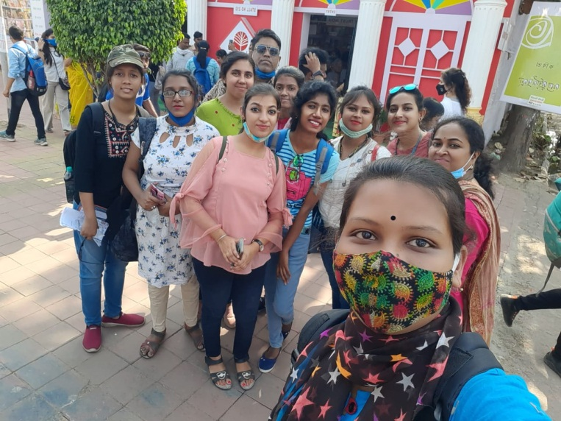

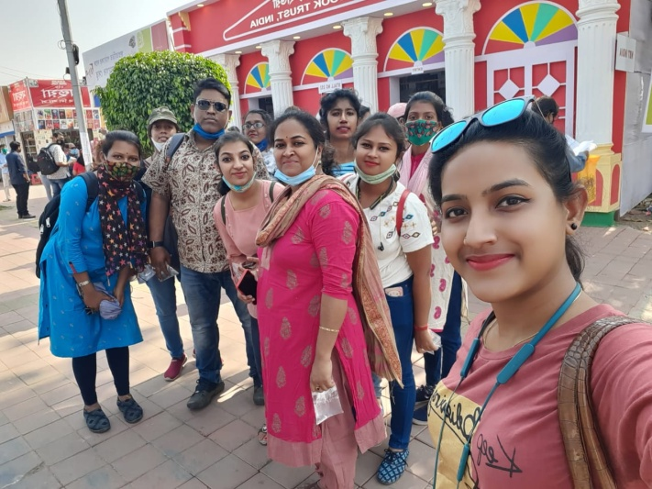
2. Extension lecture on “Psychological Counseling: An Approach to Students' Support System” (held on 29/07/2021)
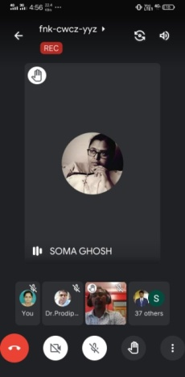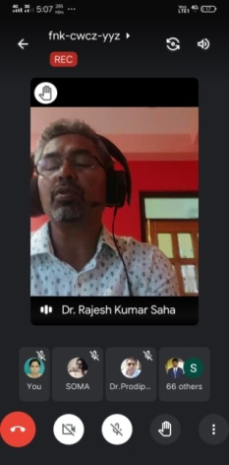
3. Extension lecture on “Role of Education for Social Change” (held on 03/08/2021)
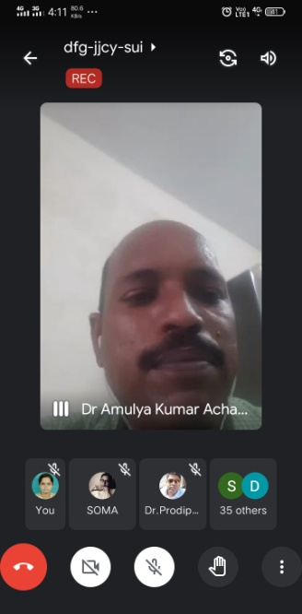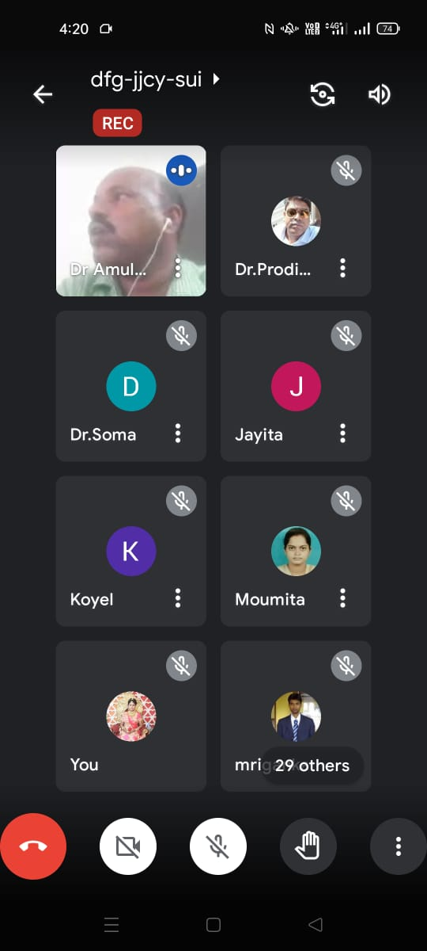
4. Extension lecture on “Evaluation in Education” (held on 19.04.2022)-
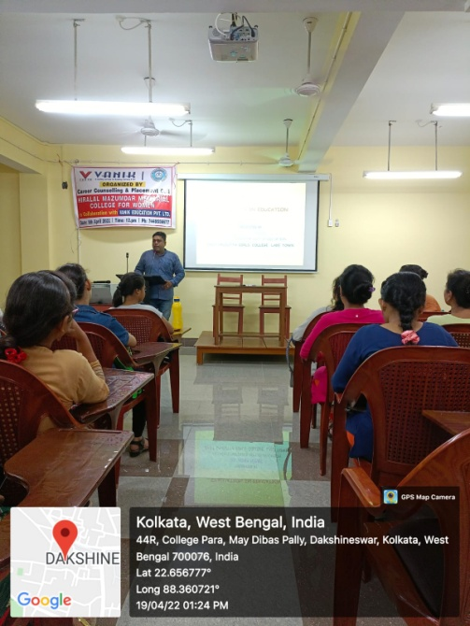
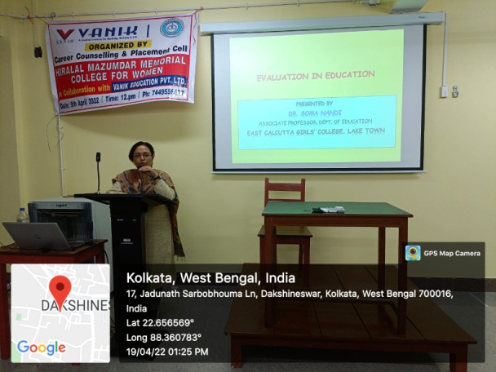

5. International Webinar on ‘Soft Skills Development For Successful Career’ (held on 23.5.22)-
