Hiralal Mazumdar Memorial College for Women
Departmental Events Organised by Department of EDUCATION 2022-23

DEPARTMENT | EVENTS | DATE | REMARKS
EDUCATION | 1. International Seminar on “ Education and COVID 19: Understanding the Impact” | 12.09.2022 | Organised by Department of Education, HMMCW in collaboration with DURS, BANGLADESH. Speakers were Dr. Soma Ghosh, G M Rakibul Islam, Nazmun Nahar Chaitee, Md Motier Rahman and others.
 | 2. A short Educational Tour to Jorasanko, Kolkata | 14.09.2022 | Participants: Five teachers and about 19 students of 3rd and 5th Semester of Education Department and Dept. of Political Science.
 | 3. A short Educational Tour to Birth place of Sarat Chandra Chattopadhyay and Bandel Church | 04.11.2022 | Participants: Four teachers and about 9 students of 3rd Semester of Education Department.
 | 4. PPT presentation by the students of the Dept. of Education. | 14.11.2022 | Participants: 3rd and 5th Semester Honours students of the Department of Education presented PPT slides on different topics of their own choices in the seminar room of the college.
 | 5. Extension lecture on “Prevention and Remedial Measures of Visual Impairment”, delivered by Anirban Mukherjee, Assistant Teacher, Kaswara Yeasin Mondal Sikshaniketan, Kaswara,Polba,Hooghly.WB | 28.03.2023 | Organised by Department of Education, HMMCW
 | 6. One Day National Level Seminar on “Educational Problems of Backward Class Students (SC,ST)” | 16.05.2023 | Organised by Department of Education, HMMCW in collaboration with IQAC, HMMCW. The main speaker was Padma Shri Dr. Jagadish Chandra Halder
 | 7. Extension lecture on “Inclusive Education” to the students of Dept. of Education, Sree Chaitanya College, Habra as a part of Faculty Exchange Programme | 16.06.2023 | Organised by Dept. of Education, Sree Chaitanya College, Habra and Dept. of Education, H.M.M. College for Women. Delivered by Dr. Prodip Das, Assistant Professor, Dept. of Education, H.M.M. College for Women.
 | 8. Extension lecture on “Slow Learner” to the students of Dept. of Education, H.M.M. College for Women as a part of Faculty Exchange Programme | 24.06.2023 | Organised by Dept. of Education, Basirhat College and Dept. of Education, H.M.M. College for Women. Delivered by Ria Barua, Assistant Professor, Dept. of Education, Basirhat College.
 | 9. Extension lecture on “Educational Management” to the students of Dept. of Education, H.M.M. College for Women as a part of Faculty Exchange Programme | 28.06.2023 | Organised by Dept. of Education, Sree Chaitanya Mahavidyalaya and Dept. of Education, H.M.M. College for Women. Delivered by Shatabdi Chakroborty, SACT & HOD, Dept. of Education, Sree Chaitanya Mahavidyalaya

- International Seminar on “ Education and COVID 19: Understanding the Impact” on 12th September 2022
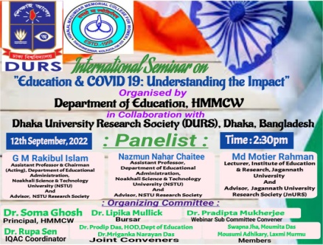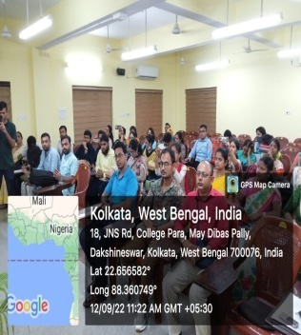

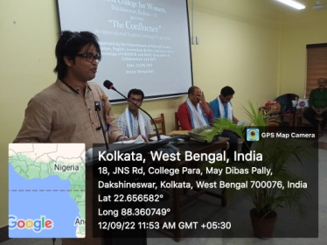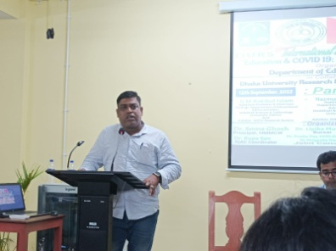

- A short Educational Tour to Jorasanko, Kolkata on 14.09.2022
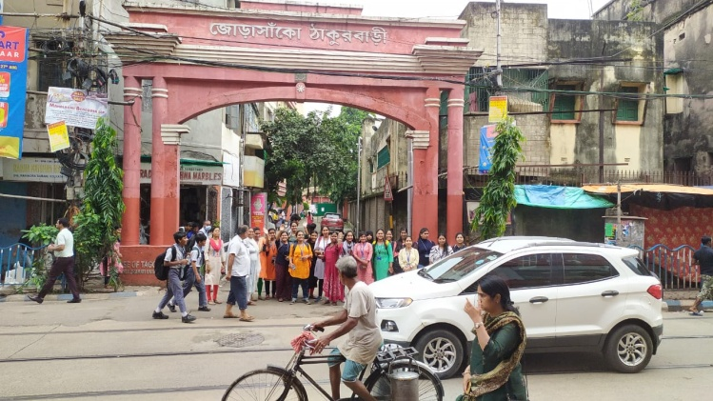
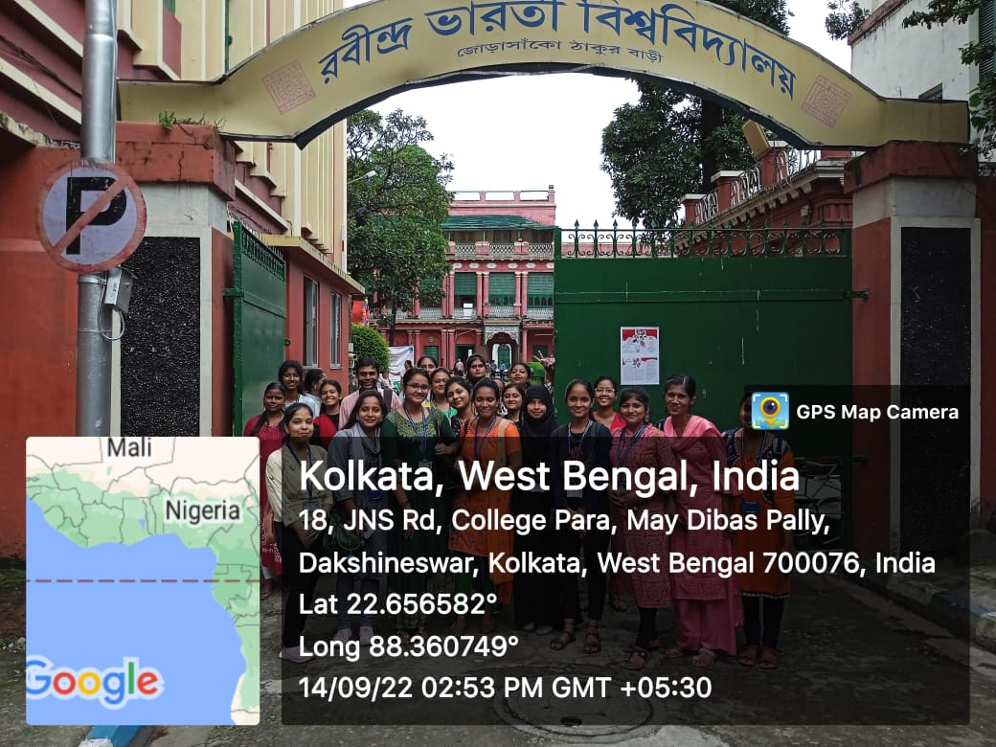

- A short Educational Tour to Birth place of Sarat Chandra Chattopadhyay and Bandel Church on 04.11.22
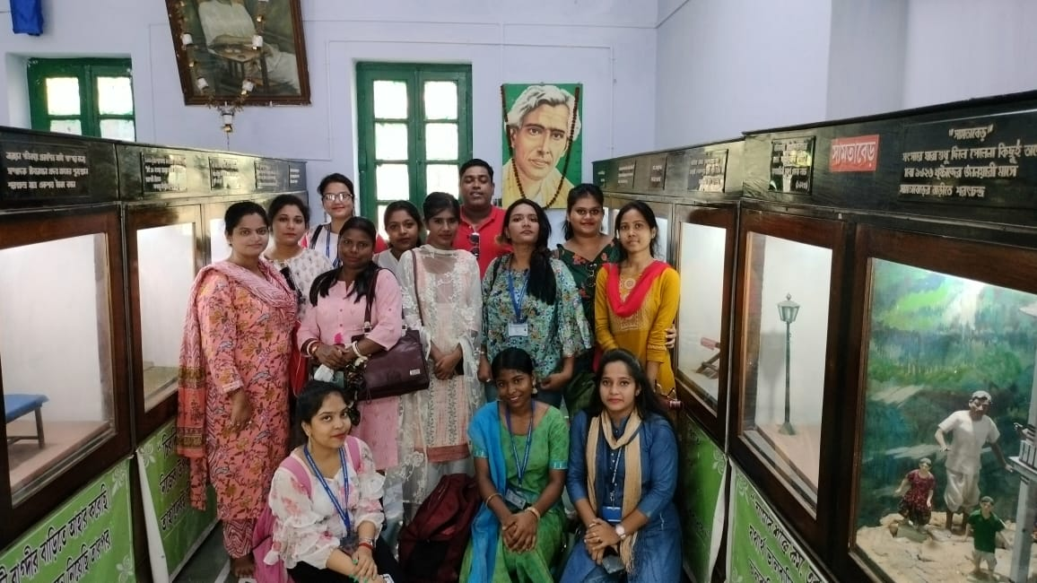

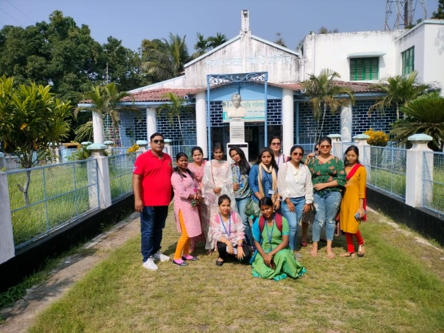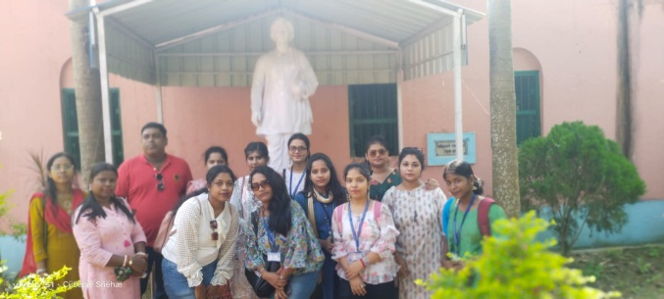

- PPT presentation by the students of the Dept. of Education on 14.11.22
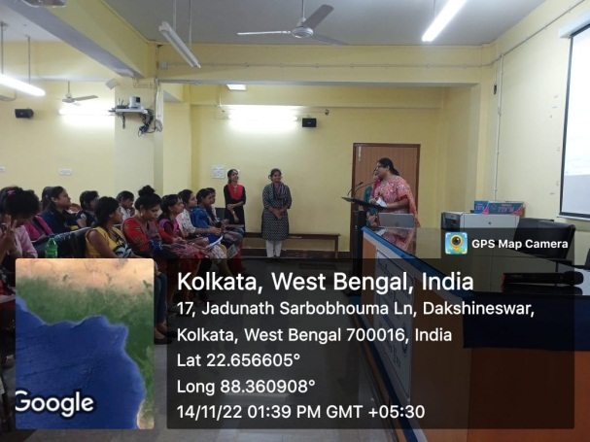
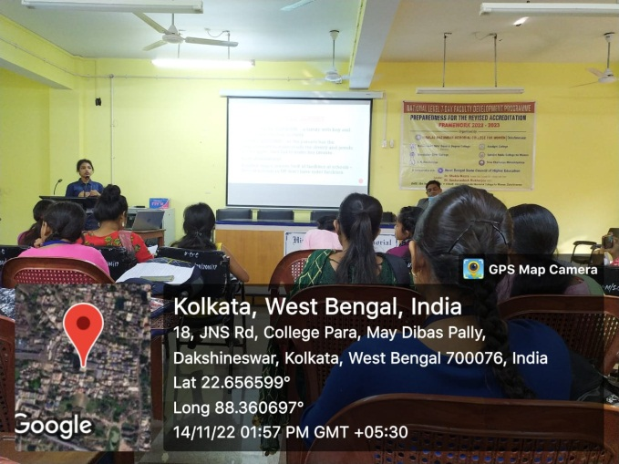

- Extension lecture on “Prevention and Remedial Measures of Visual Impairment”, delivered by Anirban Mukherjee on 28.03.2023
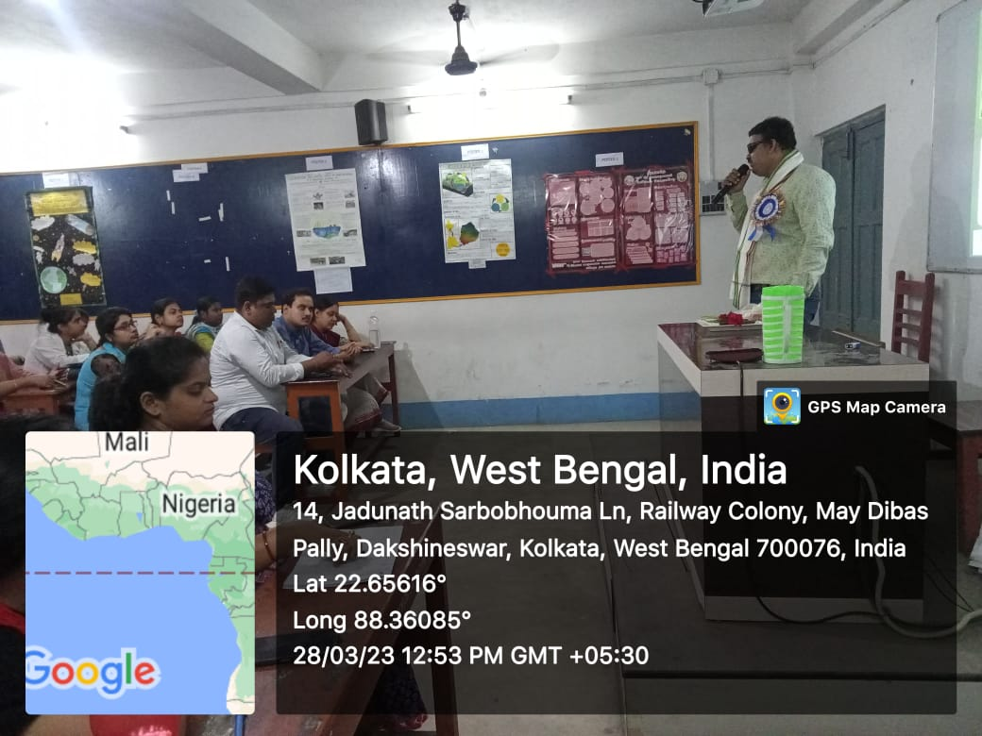
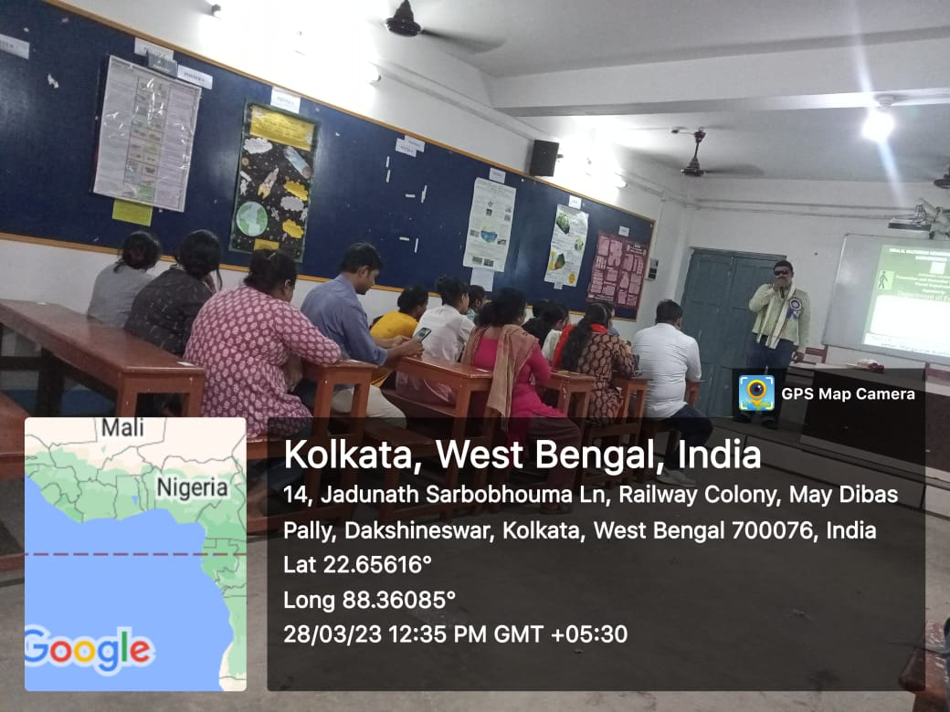

- One Day National Level Seminar on “Educational Problems of Backward Class Students (SC,ST)” on 16.05.2023.

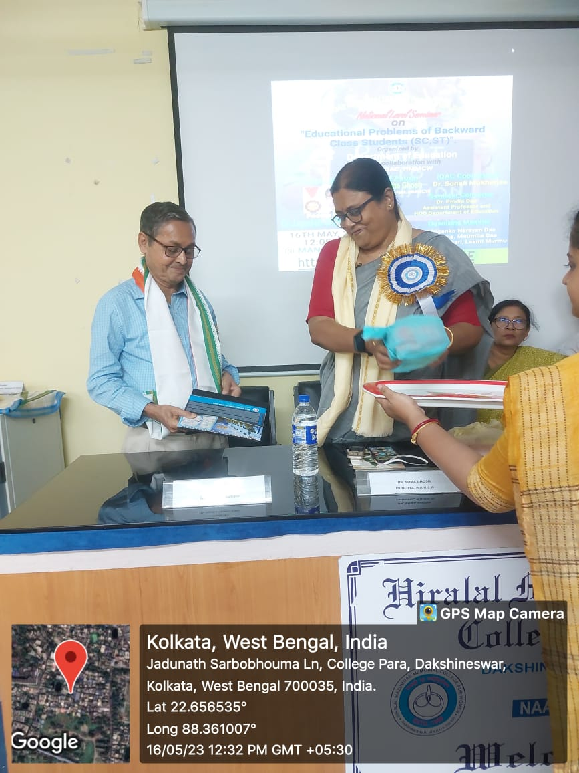
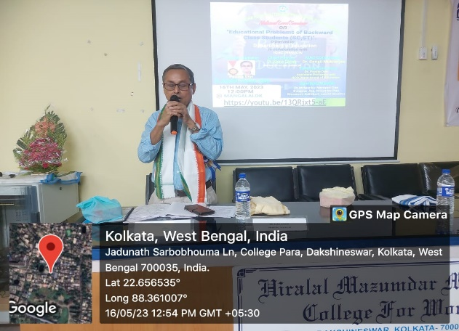

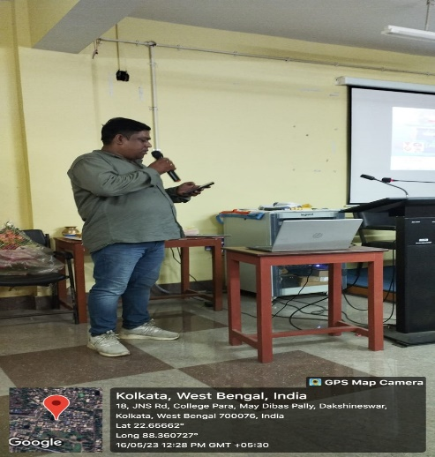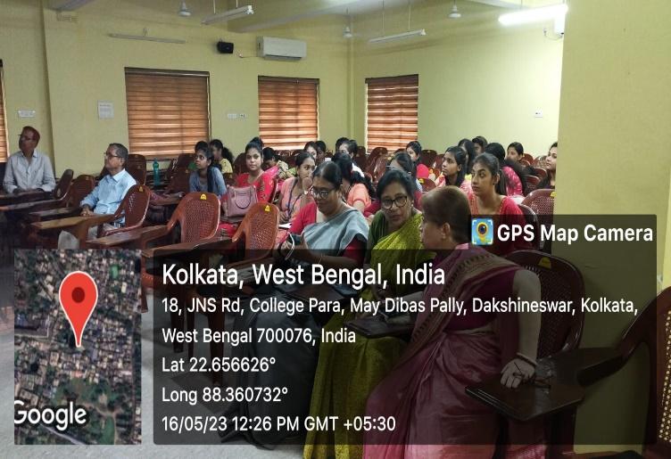

- Extension lecture on “Inclusive Education” to the students of Dept. of Education, Sree Chaitanya College, Habra as a part of Faculty Exchange Programme on 16.06.2023

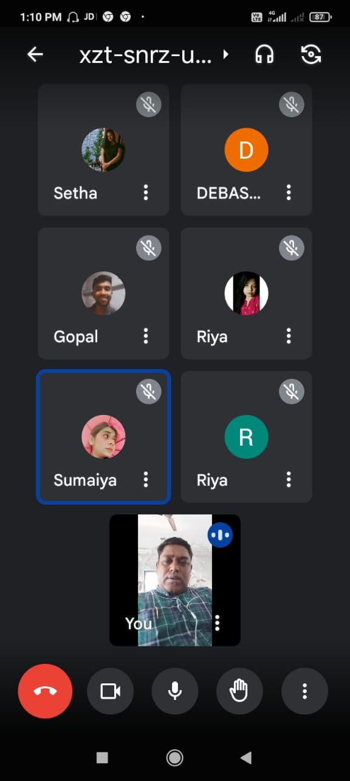

- Extension lecture on “Slow Learner” to the students of Dept. of Education, H.M.M. College for Women as a part of Faculty Exchange Programme on 24.06.2023

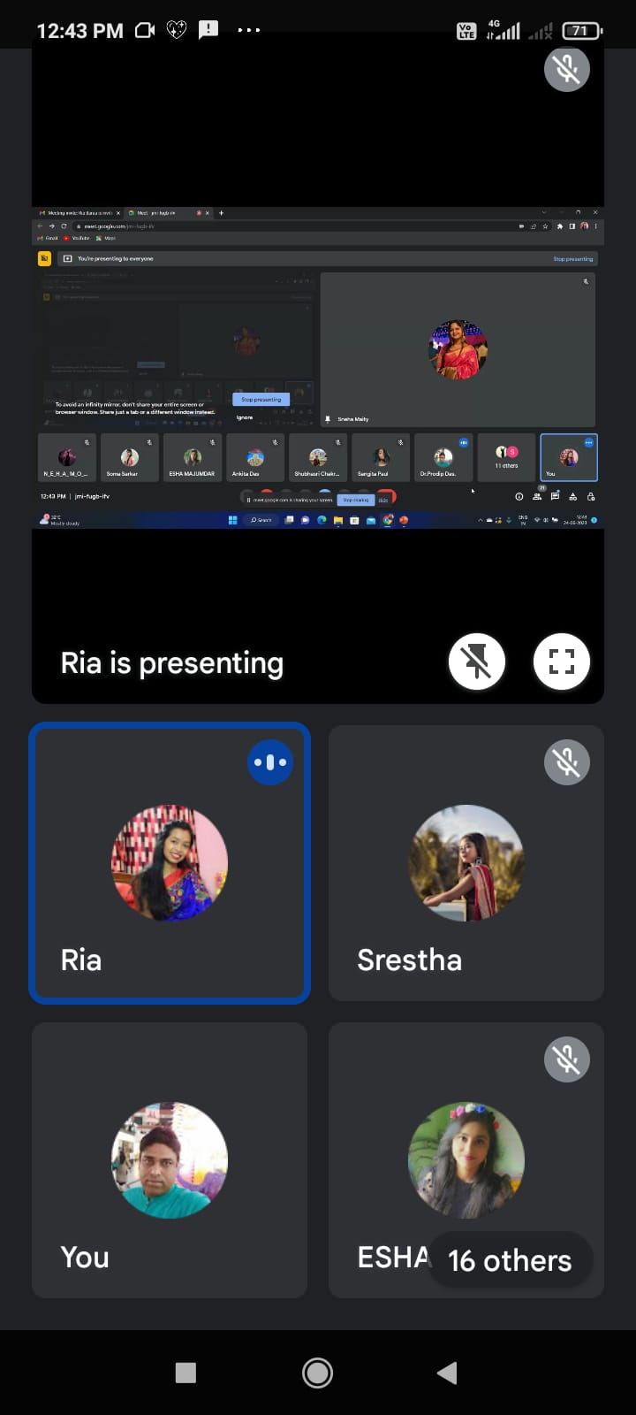

- Extension lecture on “Educational Management” to the students of Dept. of Education, H.M.M. College for Women as a part of Faculty Exchange Programme on 28.06.2023

