Hiralal Mazumdar Memorial College for Women
Departmental Events Organised by Department of EDUCATION 2022-23

DEPARTMENT | EVENTS | DATE | REMARKS
EDUCATION | 1. International Seminar on “ Education and COVID 19: Understanding the Impact” | 12.09.2022 | Organised by Department of Education, HMMCW in collaboration with DURS, BANGLADESH. Speakers were Dr. Soma Ghosh, G M Rakibul Islam, Nazmun Nahar Chaitee, Md Motier Rahman and others.
 | 2. One Day National Level Seminar on “Educational Problems of Backward Class Students (SC,ST)” | 16.05.2023 | Organised by Department of Education, HMMCW in collaboration with IQAC, HMMCW. The main speaker was Padma Shri Dr. Jagadish Chandra Halder

- International Seminar on “ Education and COVID 19: Understanding the Impact” on 12th September 2022
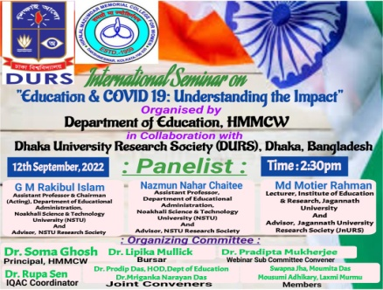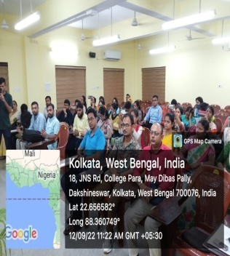

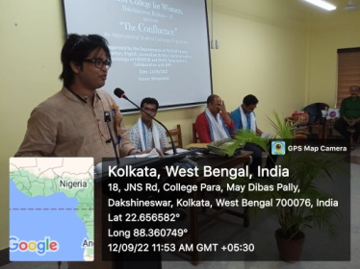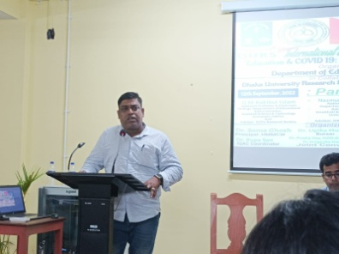

- One Day National Level Seminar on “Educational Problems of Backward Class Students (SC,ST)” on 16.05.2023.

