EVENT ALBUM FORMAT
(PLEASE MAKE SEPARATE FILES FOR EACH SESSION)
HMM College for Women

SESSION: July 2020-June 2021
DEPARTMENT: Education
EVENT NAME | DATE | NO.OF PARTICIPANTS | DESCRIPTION
International Webinar on "Mahatma Gandhi's Philosophy on Education and Peace Building" | 17.07. 2020 | 361 | Organized by Mahatma Gandhi Global Peace Forum in collaboration with Department of Education, Hiralal Mazumdar Memorial College For Women

CORRESPONDING PHOTOS WITH EVENT NAME:

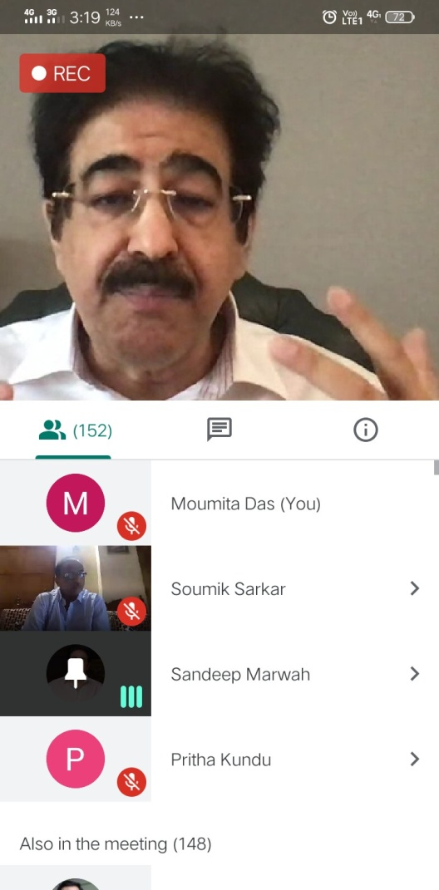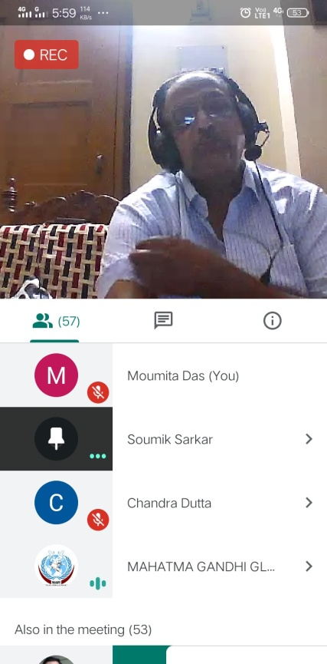
International Webinar on "Mahatma Gandhi's Philosophy on Education and Peace Building" (held on 17.07. 2020)

