History Departmental Events : 2022-2023

Date of the Event | Nature of the Event | No. of Participants | Resource Person | Outcome of the Event
5.8.2022 | Farewell Programme of 6th Semester students of History Dept. | 65 | NA | This event increased camaraderie between the students and teachers and also encouraged spirit of teamwork among students.
14.8.2022 | International Webinar of History Dept. based on theme of Trauma of Partition of India | 73 | Prof. Parthasarathi Bhaumik ( Associate Professor at Tokyo University of Foreign Studies). | Explored many unknown facts of India’s Partition which demands much discussion.
25.11.2022 | World Heritage Week celebration and poster presentations of students of History Department. | 45 | NA | Enhanced consciousness of students about glorious past of India and the world ; also paved the path for exchange of cultural ideas.
12.5.2023 | Dakshineshwar Project presentation | 38 | NA | Explored history of Dakshineshwar from ancient to modern era and encouraged students for further research work on the theme – Prachinotter Sandhane o Adhunikotar avimukhe rupantorito Dakshineshwar.
16.5.2023 | Interdisciplinary Lecture on Indian Constitution and Women’s Rights. | 35 | Principal of HMMCW- DR. Soma Ghosh | Enhancement of knowledge and academic enrichment of students of History Dept. occurred on various aspects of Indian Constitution and women’s Rights.

Photos of event of 5.8.2022 :-
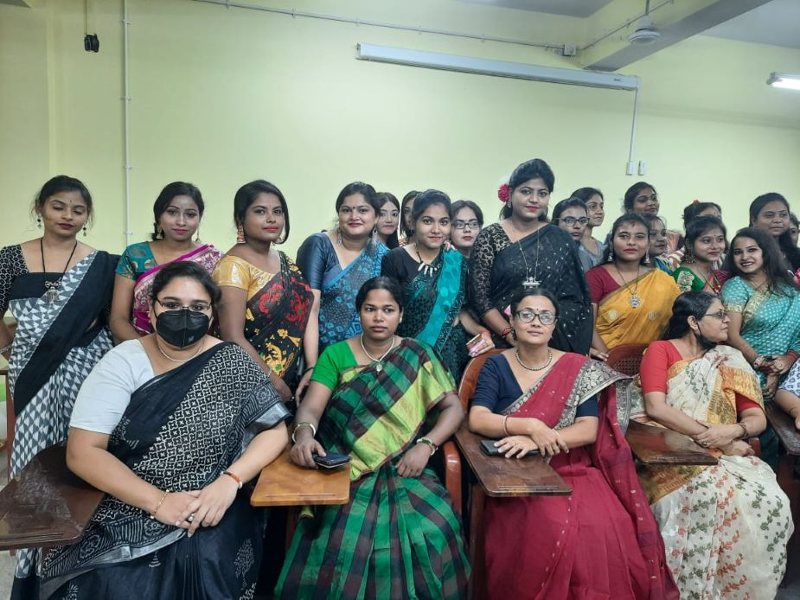

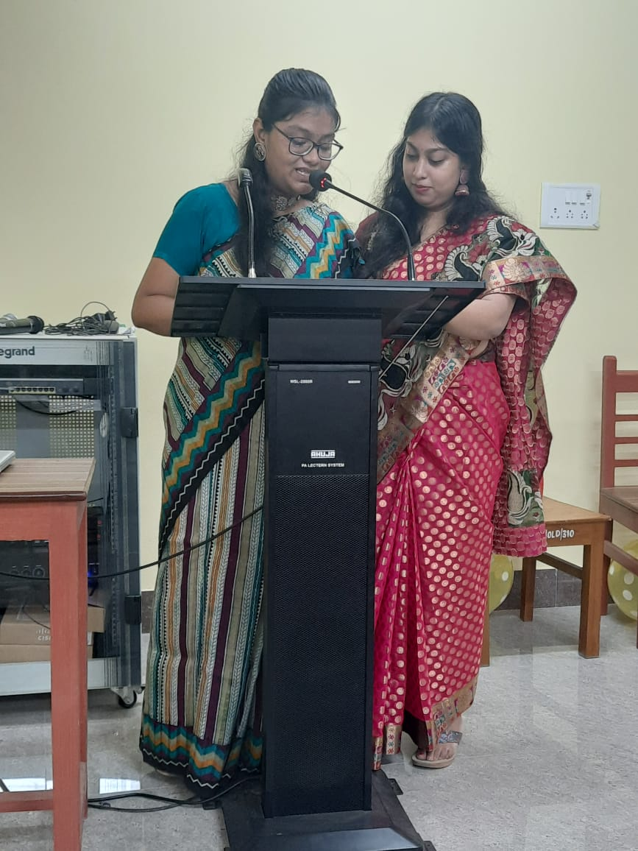
Photos of event of 14.8.2022 :-

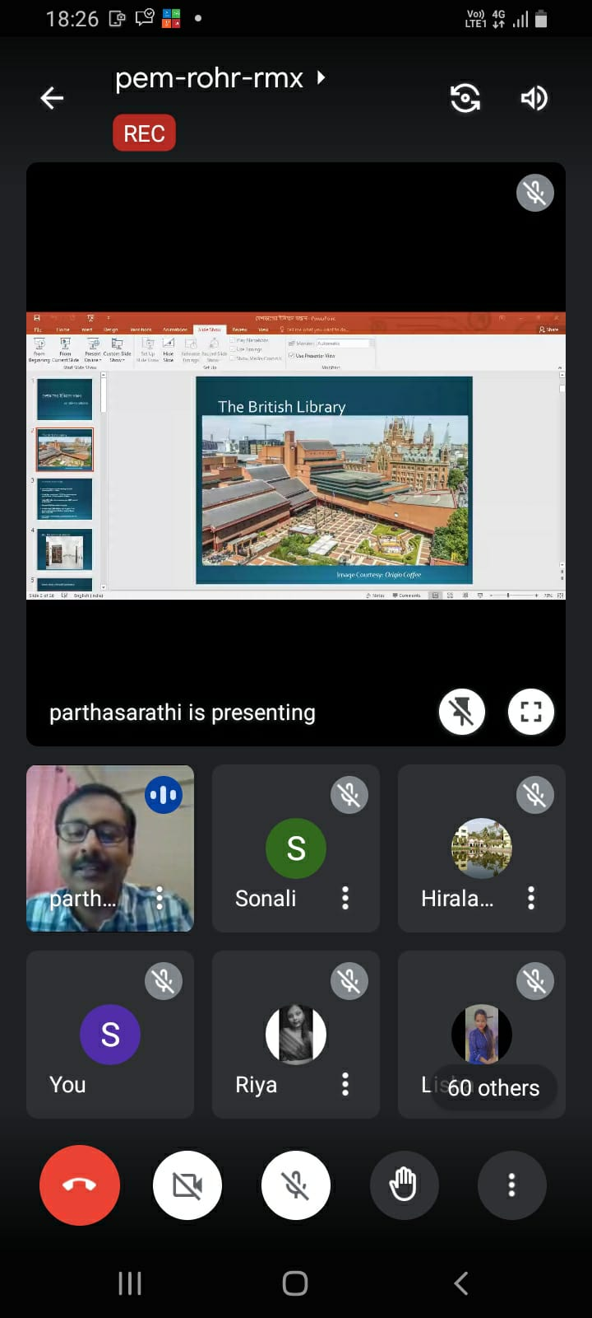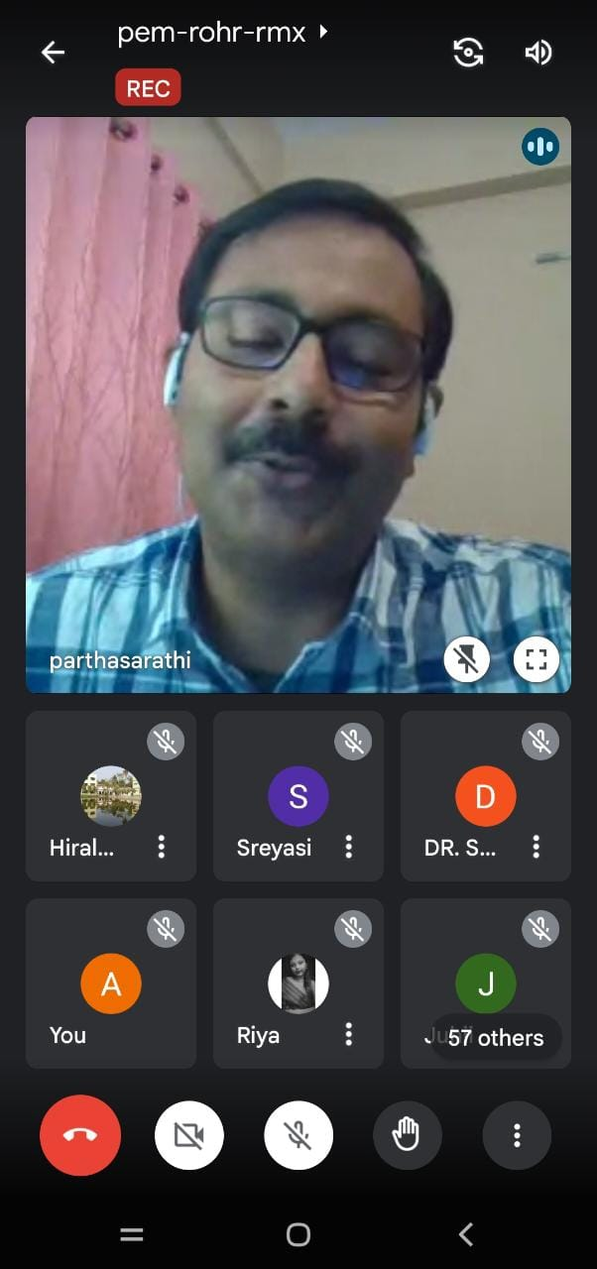

Photos of event of 25.11.2022 :- 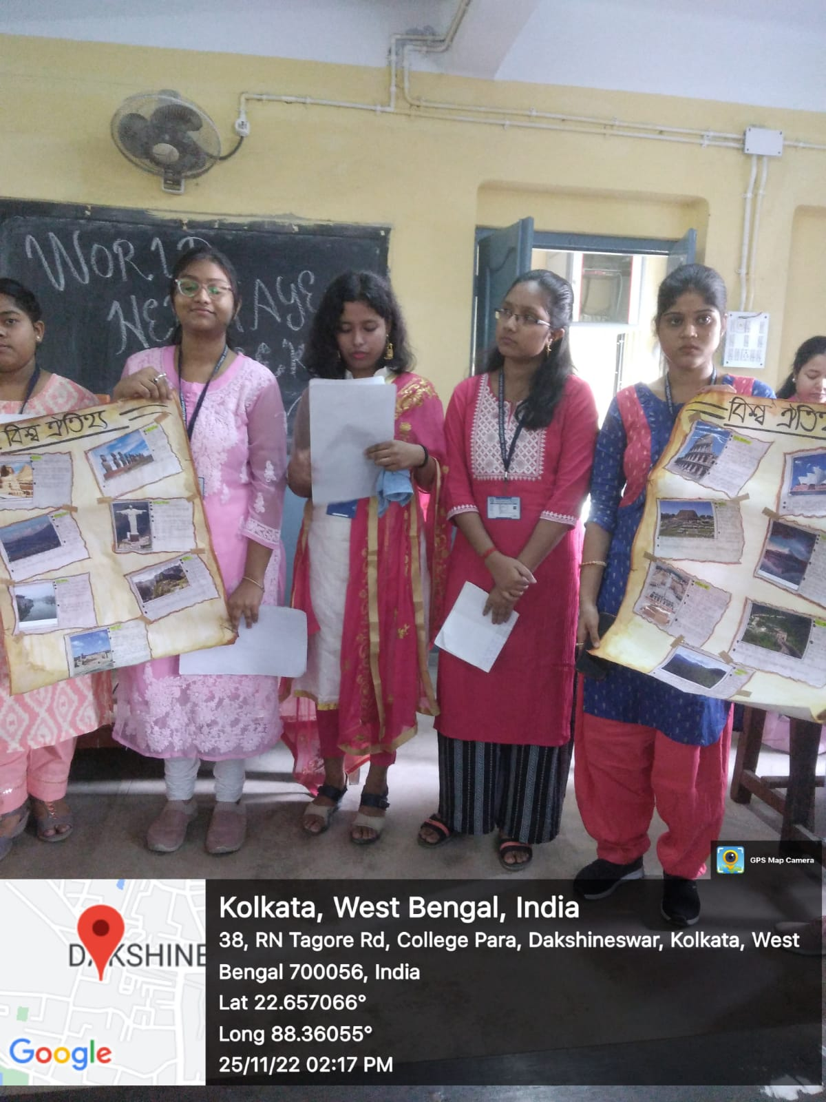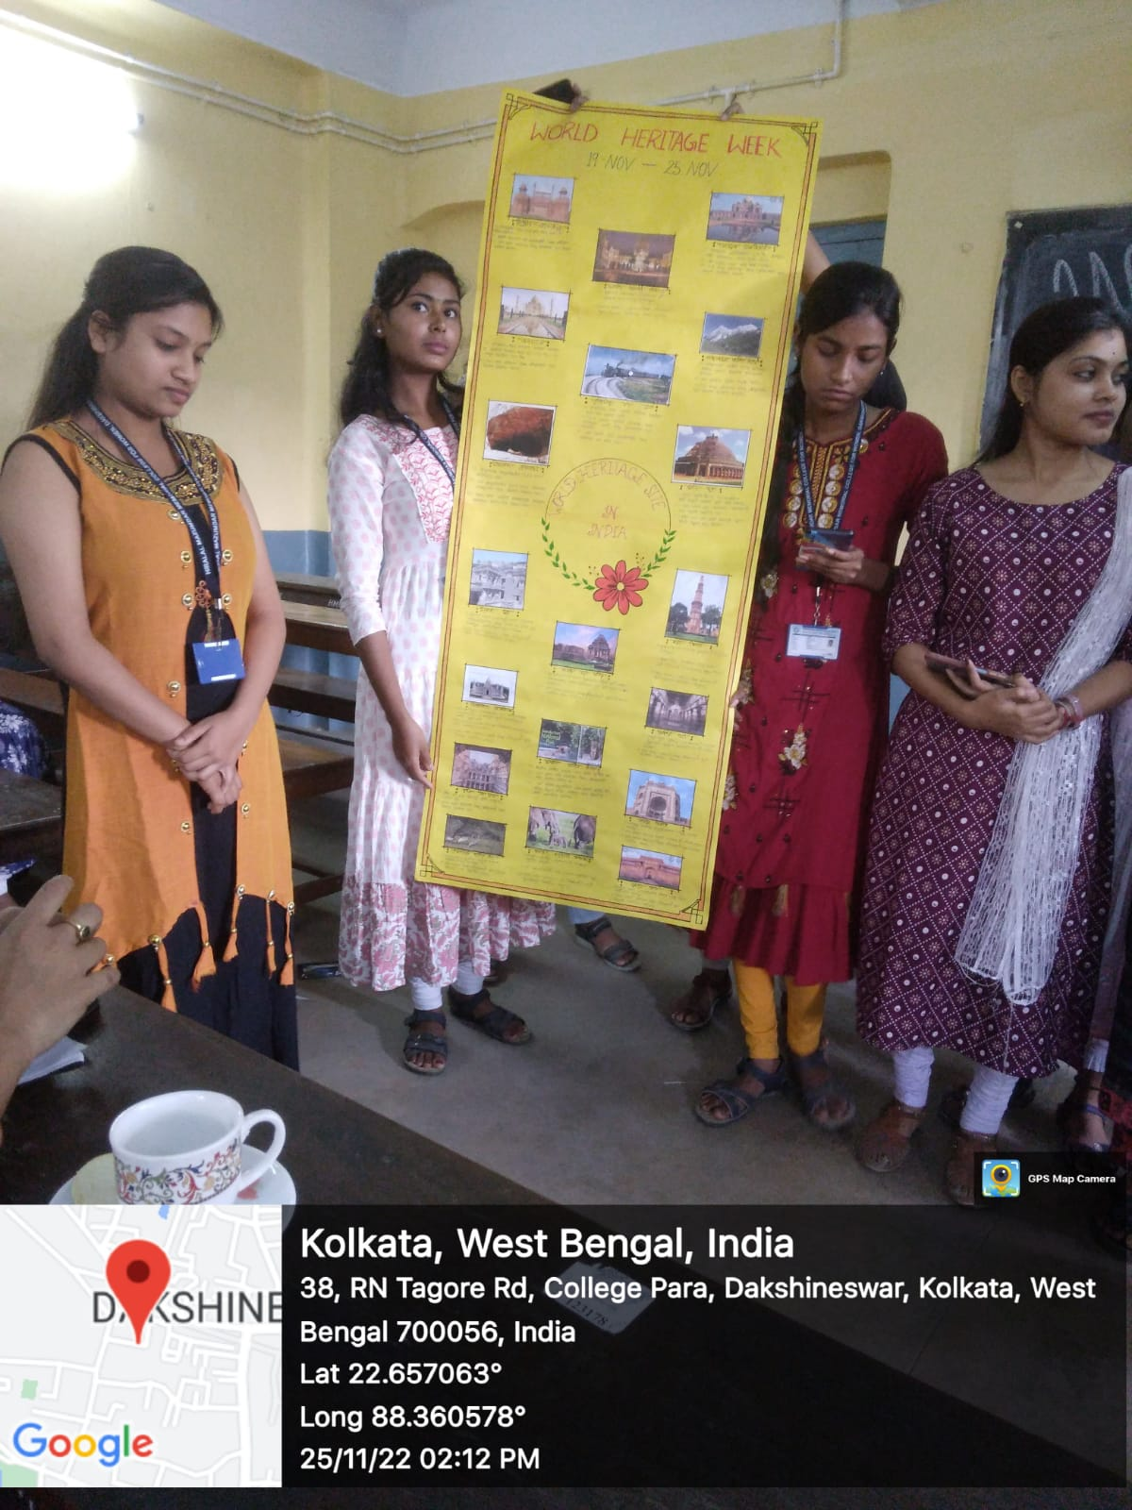
Photos of event of 12.5.2023 :- 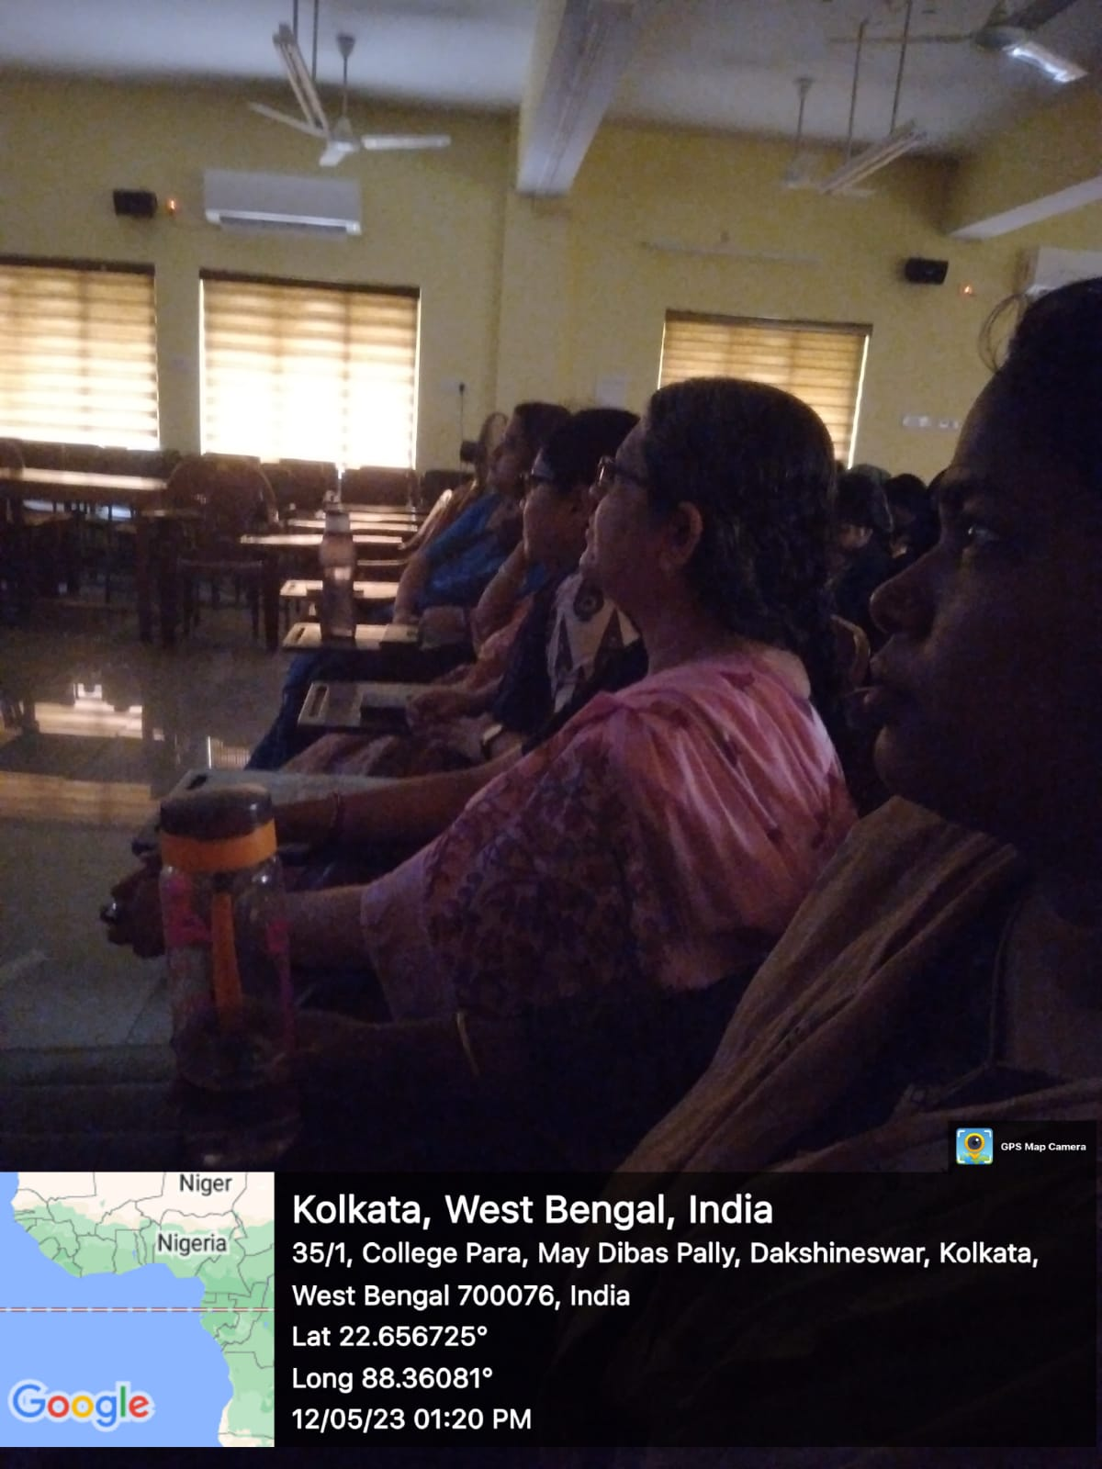

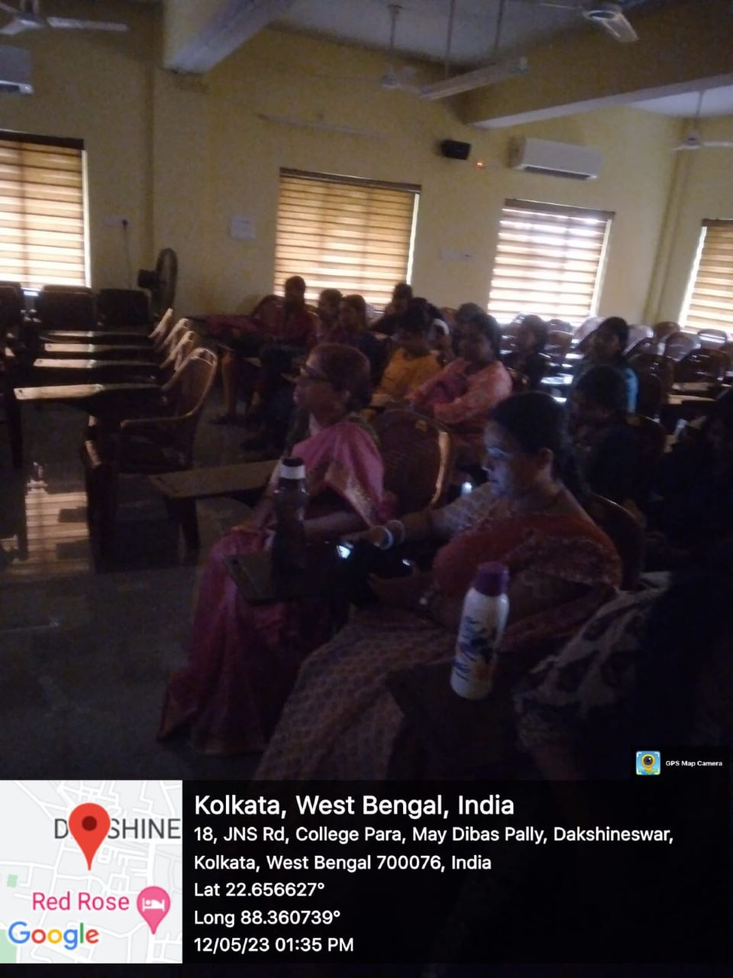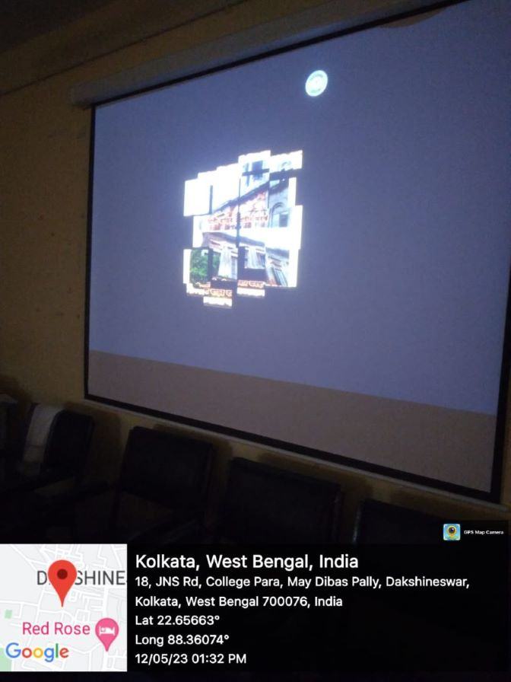

Photos of event of 16.5.2023 :- 