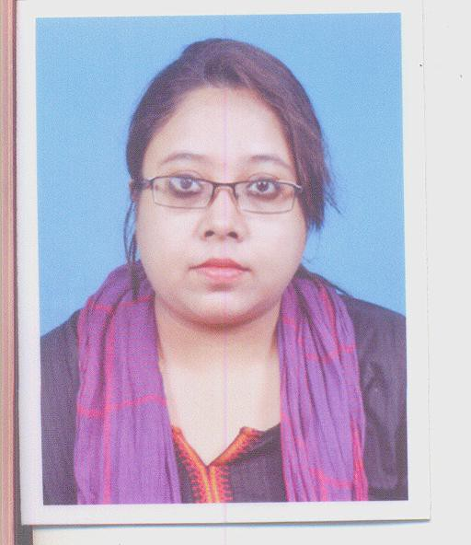
Photograph

Name: SHRABONI MAZUMDAR

Designation: SACT

Teaching Area: C o l o n i a l P o s t C o l o n i a l g e n r e , D r a m a S h a k e s p e a r e , G e n d e r a n d W o m e n ' S t u d i e s
Teaching Experience: HMM COLLEGE FOR WOMEN SINCE 2010. Teaching Experience -18 years.and eight months.
Part Time Teacher Women's College. English Teacher in Din Bosco Lilluah. Research Area: CULTURE AND GENDER
Title of the thesis under. Ph D programme: PhD not yet awarded MPhil Completed and awarded. PhD - On Minority Studies.
Post-Doctoral Research:NA

Publications:

Title | Name | Departmen | Name | Year of | ISSN | Link to the recognition in
of | of the | t of the | of | publicatio | Numbe | UGC enlistment of the
pape  r | author/  s | teacher | journa  l | n | r | Journal /Digital Object Identifier (doi) number
 |  |  |  |  |  | Link to | Link to | Is it
 |  |  |  |  |  | websit | article / | liste
 |  |  |  |  |  | e of the | paper / | d in
 |  |  |  |  |  | Journal | abstrac | UGC
 |  |  |  |  |  |  | t of the | Care
 |  |  |  |  |  |  | article | list

Sl. N  o. | Nam e of the teac her | Title of the book/cha pters published | Titl e of the pap er | Title of the proceedi ngs of the conferen ce | Name of the confere nce | National  / Internati onal | Year of publicat ion | ISBN  number of the proceed ing | Affiliati ng Institut e at the time of publicat ion | Name of the publis her

Seminars, Symposiums, Leadership programmes attended:
- Oral presentation: workshop and presentation on Research Methodology- Asiatic Society. Kolkata.
- Many Faces of Colonial and Post Colonial Literature. DRS SAP UNIVERSITY OF CALCUTTA. 2004.
- XXXXIV All India English Teachers Conference - 2001
- New Collectivity of Belongingness- Siddhu Kanu University. 2018
- Assisted in Written Assignment Osmania University.Dept of English. Post Graduate Students. 2004 - 2006
- Poster presentation:

Leadership programme attended: worked as Free lance Journalist- Prasar Bharati. AIR KOLKATA for women magazine.

Administrative Experiences:
Member of Career Councelling Cell HMM College for Women. Assisted as Narrator of Criteria 4 NAAC

Membership of Professional bodies: Core Member Life long Sahitya Parishad Kolkata Chapter. Member of ISS.
MEMBER OF HISTORY CONGRESS.

Others:
Administrative experiences outside the College:

