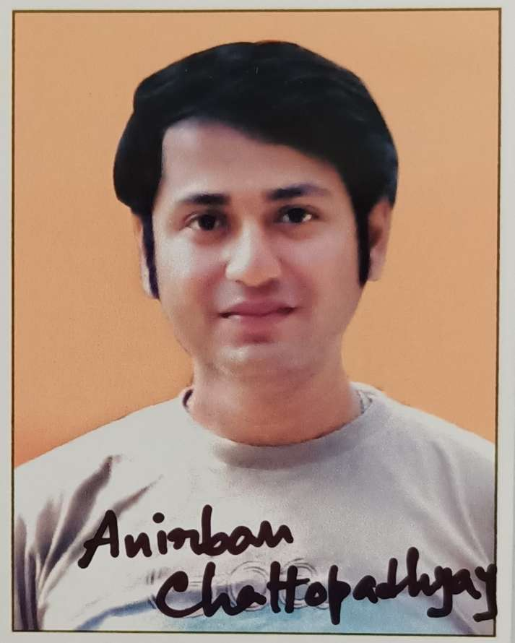

Photograph

Name: Anirban Chattopadhyay
Designation: SACT 2
Qualification: M.A, Ph.D(probationary)
Email: animusician@gmail.com

Teaching Area: Join as a guest lecturer(Music) from 2013 and as a SACT 2 from January 2020 to till now in H.M.M college for women. Vocal teacher of SHRUTINANDAN from 2007 to till now.
Teaching Experience: 10 years

Research Area: Indian Classical Music

Title of the thesis under Ph D programme: 'Tagore's view in the applied field of Hindustani Rga-Raginis'
Post-Doctoral Research: N.A

Publications:

Title of paper | Name of the author/s | Department of the teacher | Name of journal | Year of publication | ISSN Number | Link to the recognition in UGC enlistment of the Journal /Digital Object Identifier (doi) number
 |  |  |  |  |  | Link to website of the Journal | Link to article / paper / abstract of the article | Is it listed in UGC Care list
 |  | Music | Wisdom speakes | 2019 | 2456-5121

Sl. No. | Name of the teacher | Title of the book/chapters published | Title of the paper | Title of the proceedings of the conference | Name of the conference | National / International | Year of publication | ISBN number of the proceeding | Affiliating Institute at the time of publication | Name of the publisher

Seminars, Symposiums, Leadership programmes attended:
*COVID 19 golbal health calamities, International webiner 2019-20.

*Jiboner pothe Sangee, International webiner 2020-21

- Oral presentation: N.A

Poster presentation: N.A

Leadership programme attended: N.A

Administrative Experiences: N.A

Membership of Professional bodies: N.A

Others:
Administrative experiences outside the College: N.A

