Photograph

Name: DEBI BHATTACHARYA
Designation: SACT I
Qualification: M.SC, B. ED, NET (UGC)
Email: mailmedebi1986@gmail.com
Teaching Area: Geomorphology, Applied Geography, Environmental Geography
Teaching Experience: 12 Years

Research Area: Environmental Geography

Title of the thesis under Ph D programme: Footprint Analysis of Greywater Resource (Pursuing)
Post-Doctoral Research: N.A

Publications:

Title of paper | Name of the author/s | Department of the teacher | Name of journal | Year of publication | ISSN Number | Link to the recognition in UGC enlistment of the Journal /Digital Object Identifier (doi) number
 |  |  |  |  |  | Link to website of the Journal | Link to article / paper / abstract of the article | Is it listed in UGC Care list
Environmental Awareness Vis-à-vis Activities: Inconsistence in Daily Life (A Special Case Study at Khardah, North 24 Parganas, West Bengal) | Debi Bhattacharya | Geography | International Journal of Science and Research | 2022 | 2319-7064 | International Journal of Science and Research (IJSR): Qualis CAPES Approved, Call for Paper | Environmental Awareness Vis-A-Vis Activities: Inconsistence in Daily Life (A Special Case Study at Khardah, North 24 PARGANAS, West Bengal) (ijsr.net) | Others

Seminars, Symposiums attended:
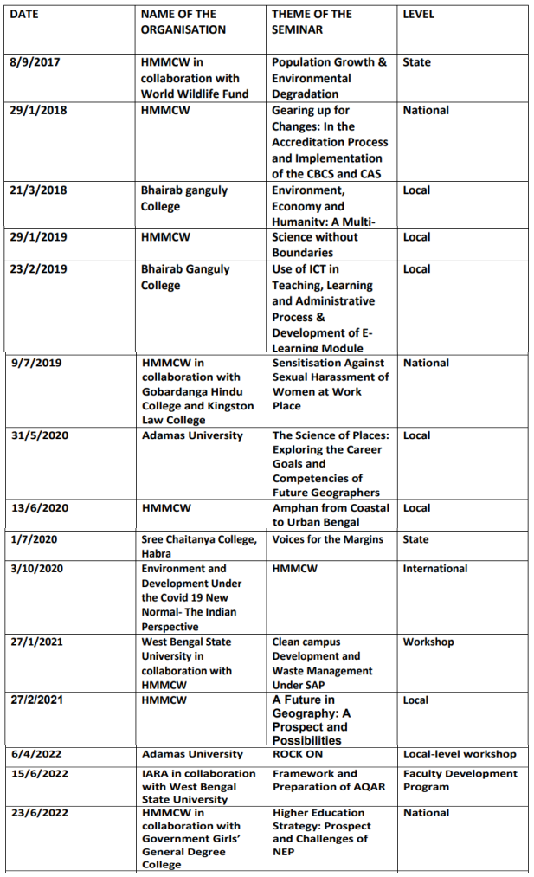

- Oral presentation:

- “Environmental Awareness Vis-à-vis Activities: Inconsistence in Daily Life (A Special Case Study at Khardah, North 24 Parganas, West Bengal)” in the seminar, titled “Environment and Sustainability” organized by Anthropological Survey of India in 2018.

- “Greywater Recycling: A Case Study at Madhyamgram, West Bengal” in the “Global Summit, 2022” conference by Adamas University in 2022.

- “Greywater Footprint: A Bibliometric Analysis” in the International Conference by Adamas University in 2023.

Administrative Experiences:

Involved in Uchho Shiksha Portal And NAAC-related work in HMMCW.

