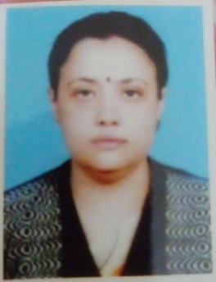

Name: Mrs.Maitrayee Mukherjee
Designation: State Aided College Teacher
Qualification: M.A. , B.ed
Email: maitrayeemukherjee@hmmcw.in
Teaching Area: Sufism
Teaching Experience: 14 years
Seminars, Symposiums, Leadership programmes attended:
1.Pandamic in History
2.Bhakti movement
3.kavir and Meera
4.understanding Gandhi
5.Some concerns and misconception about the ICC
6.Gender Senitization and awareness
7. Communal politics and partion of India in 1947
8.Jogot Moder Sober Kori Ongikar
Leadership programme attended: Staff Development Program
Administrative Experiences: Question paper setting, Departmental administrative work, Exam invigilation in NSOU and IGNOU
Membership of Professional bodies: Member , Museum Conservation Committee

