DBMS Database Models
A Database model defines the logical design and structure of a database and defines how data will be stored, accessed and updated in a database management system. While the Relational Model is the most widely used database model, there are other models too:
- Hierarchical Model
- Network Model
- Entity-relationship Model
- Relational Model

Hierarchical Model
This database model organises data into a tree-like-structure, with a single root, to which all the other data is linked. The heirarchy starts from the Root data, and expands like a tree, adding child nodes to the parent nodes.
In this model, a child node will only have a single parent node.
This model efficiently describes many real-world relationships like index of a book, recipes etc.
In hierarchical model, data is organised into tree-like structure with one one-to-many relationship between two different types of data, for example, one department can have many courses, many professors and of-course many students.
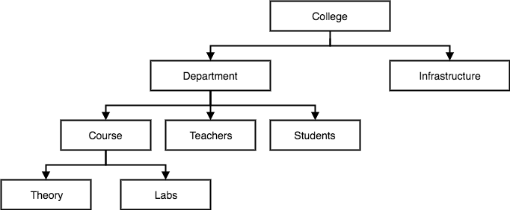

Network Model
This is an extension of the Hierarchical model. In this model data is organised more like a graph, and are allowed to have more than one parent node.
In this database model data is more related as more relationships are established in this database model. Also, as the data is more related, hence accessing the data is also easier and fast. This database model was used to map many-to-many data relationships.
This was the most widely used database model, before Relational Model was introduced.
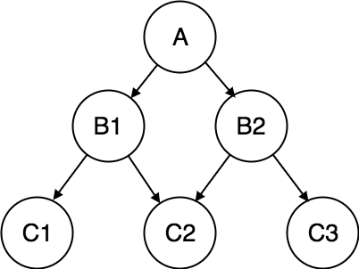

Entity-relationship Model
In this database model, relationships are created by dividing object of interest into entity and its characteristics into attributes.
Different entities are related using relationships.
E-R Models are defined to represent the relationships into pictorial form to make it easier for different stakeholders to understand.
This model is good to design a database, which can then be turned into tables in relational model(explained below).
Let's take an example, If we have to design a School Database, then Student will be an entity with attributes name, age, address etc. As Address is generally complex, it can be another entity with attributes street name, pincode, city etc, and there will be a relationship between them.
Relationships can also be of different types. To learn about E-R Diagrams in details, click on the link.
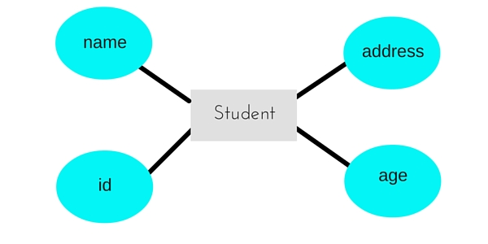

Relational Model
In this model, data is organised in two-dimensional tables and the relationship is maintained by storing a common field.
This model was introduced by E.F Codd in 1970, and since then it has been the most widely used database model, infact, we can say the only database model used around the world.
The basic structure of data in the relational model is tables. All the information related to a particular type is stored in rows of that table.
Hence, tables are also known as relations in relational model.
In the coming tutorials we will learn how to design tables, normalize them to reduce data redundancy and how to use Structured Query language to access data from tables.
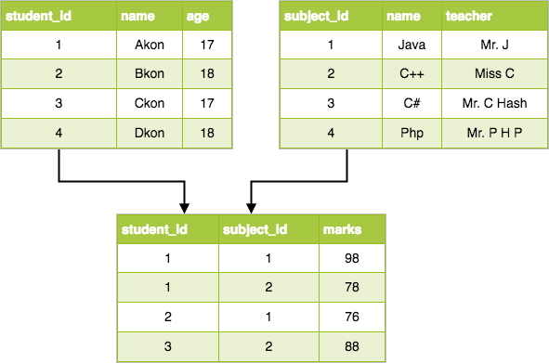

ER Model: Entity and Entity Set
Considering the above example, Student is an entity, Teacher is an entity, similarly, Class, Subjectetc are also entities.
An Entity is generally a real-world object which has characteristics and holds relationships in a DBMS.
If a Student is an Entity, then the complete dataset of all the students will be the Entity Set

ER Model: Attributes
If a Student is an Entity, then student's roll no., student's name, student's age, student's gender etc will be its attributes.
An attribute can be of many types, here are different types of attributes defined in ER database model:
- Simple attribute: The attributes with values that are atomic and cannot be broken down further are simple attributes. For example, student's age.
- Composite attribute: A composite attribute is made up of more than one simple attribute. For example, student's address will contain, house no., street name, pincode etc.
- Derived attribute: These are the attributes which are not present in the whole database management system, but are derived using other attributes. For example, average age of students in a class.
- Single-valued attribute: As the name suggests, they have a single value.
- Multi-valued attribute: And, they can have multiple values.

ER Model: Keys
If the attribute roll no. can uniquely identify a student entity, amongst all the students, then the attribute roll no. will be said to be a key.
Following are the types of Keys:
- Super Key
- Candidate Key
- Primary Key
We have covered Keys in details here in Database Keys tutorial.

ER Model: Relationships
When an Entity is related to another Entity, they are said to have a relationship. For example, A ClassEntity is related to Student entity, becasue students study in classes, hence this is a relationship.
Depending upon the number of entities involved, a degree is assigned to relationships.
For example, if 2 entities are involved, it is said to be Binary relationship, if 3 entities are involved, it is said to be Ternary relationship, and so on.

In the next tutorial, we will learn how to create ER diagrams and design databases using ER diagrams.

The Enhanced ER Model
As the complexity of data increased in the late 1980s, it became more and more difficult to use the traditional ER Model for database modelling. Hence some improvements or enhancements were made to the existing ER Model to make it able to handle the complex applications better.
Hence, as part of the Enhanced ER Model, along with other improvements, three new concepts were added to the existing ER Model, they were:
- Generalization
- Specialization
- Aggregration
Let's understand what they are, and why were they added to the existing ER Model.

Generalization
Generalization is a bottom-up approach in which two lower level entities combine to form a higher level entity. In generalization, the higher level entity can also combine with other lower level entities to make further higher level entity.
It's more like Superclass and Subclass system, but the only difference is the approach, which is bottom-up. Hence, entities are combined to form a more generalised entity, in other words, sub-classes are combined to form a super-class.

For example, Saving and Current account types entities can be generalised and an entity with name Account can be created, which covers both.
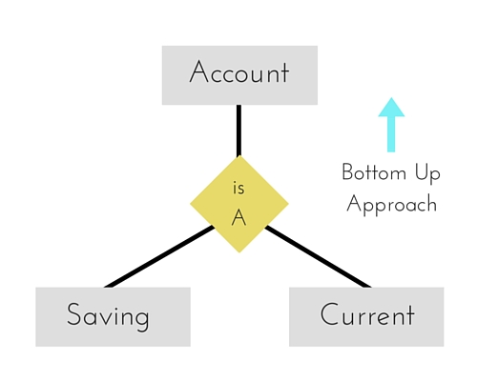

Specialization
Specialization is opposite to Generalization. It is a top-down approach in which one higher level entity can be broken down into two lower level entity. In specialization, a higher level entity may not have any lower-level entity sets, it's possible.
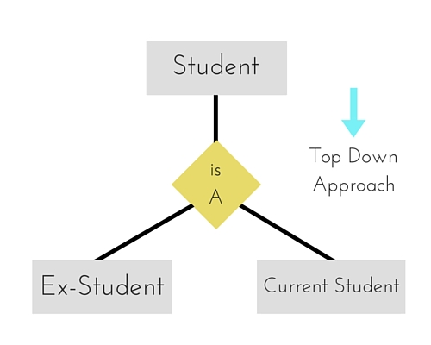

Aggregration
Aggregration is a process when relation between two entities is treated as a single entity.

In the diagram above, the relationship between Center and Course together, is acting as an Entity, which is in relationship with another entity Visitor. Now in real world, if a Visitor or a Student visits a Coaching Center, he/she will never enquire about the center only or just about the course, rather he/she will ask enquire about both.
