STUDY MATERIAL
Semester – II (GENERAL) PAPER - II, unit – 3
Prepared by Sri Rabi Sankar Das, Department of Botany, Hiralal Mazumdar Memorial College for Women, Dakshineswar
EDGE EFFECT
DEFINITION :-
In ecology, edge effects are changes in population or community structures that occurs at the boundary of two or more habitats.
TYPES OF EDGE EFFICT :-
- INHERENT :- natural features stabilize the border location.
- INDUCED :- Transient natural disturbances (e.g. – fire or flood) or human related activities , subject border to successional changes over time.
- NARROW :- one habitat abruptly ends and another begins (e.g. – an agricultural field)
- WIDE :- A large distance separates the borders of two clearly and purely definable habitats based on their physical conditions and vegetation.
- CONVOLUTED :- The border is non – linear.
- PERFORATED :- The border has gaps that host other habitats.
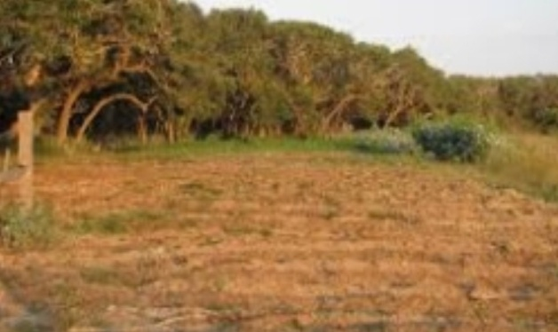
Fig :- Edge Effect Fig : - Edge Effect
IMPORTANCE OF EDGE EFFECT:-
1. As the edge effects increases, the boundary habitat allows greater Varity of plant and animal species and causes greater biodiversity.
2. Edge effects also apply to succession, when vegetation spreads rather than losing to competitors. Different species are suited either to the edges or to central section of the habitat, resulting in cusses of succession.
3. Edges serves as energy traps as they are the points where materials, nutrients and organisms flow across ecosystems, and there is increased cycling of materials and nutrients at the edges.

EXAMPLE:-

In costal zones, mangroves vegetation is best example of edge effect.

