Database is a collection of related data and data is a collection of facts and figures that can be processed to produce information.
A database management system stores data in such a way that it becomes easier to retrieve, manipulate, and produce information.

Characteristics
Traditionally, data was organized in file formats. DBMS was a new concept then, and all the research was done to make it overcome the deficiencies in traditional style of data management. A modern DBMS has the following characteristics −
- Real-world entity − A modern DBMS is more realistic and uses real-world entities to design its architecture. It uses the behavior and attributes too. For example, a school database may use students as an entity and their age as an attribute.
- Relation-based tables − DBMS allows entities and relations among them to form tables. A user can understand the architecture of a database just by looking at the table names.
- Isolation of data and application − A database system is entirely different than its data. A database is an active entity, whereas data is said to be passive, on which the database works and organizes. DBMS also stores metadata, which is data about data, to ease its own process.
- Less redundancy − DBMS follows the rules of normalization, which splits a relation when any of its attributes is having redundancy in values. Normalization is a mathematically rich and scientific process that reduces data redundancy.
- Consistency − Consistency is a state where every relation in a database remains consistent. There exist methods and techniques, which can detect attempt of leaving database in inconsistent state. A DBMS can provide greater consistency as compared to earlier forms of data storing applications like file-processing systems.
- Query Language − DBMS is equipped with query language, which makes it more efficient to retrieve and manipulate data. A user can apply as many and as different filtering options as required to retrieve a set of data. Traditionally it was not possible where file-processing system was used.

Entity
An entity can be a real-world object, either animate or inanimate, that can be easily identifiable. For example, in a school database, students, teachers, classes, and courses offered can be considered as entities. All these entities have some attributes or properties that give them their identity.
An entity set is a collection of similar types of entities. An entity set may contain entities with attribute sharing similar values. For example, a Students set may contain all the students of a school; likewise a Teachers set may contain all the teachers of a school from all faculties. Entity sets need not be disjoint.

Attributes
Entities are represented by means of their properties, called attributes. All attributes have values. For example, a student entity may have name, class, and age as attributes.
There exists a domain or range of values that can be assigned to attributes. For example, a student's name cannot be a numeric value. It has to be alphabetic. A student's age cannot be negative, etc.

Types of Attributes
- Simple attribute − Simple attributes are atomic values, which cannot be divided further. For example, a student's phone number is an atomic value of 10 digits.
- Composite attribute − Composite attributes are made of more than one simple attribute. For example, a student's complete name may have first_name and last_name.
- Derived attribute − Derived attributes are the attributes that do not exist in the physical database, but their values are derived from other attributes present in the database. For example, average_salary in a department should not be saved directly in the database, instead it can be derived. For another example, age can be derived from data_of_birth.
- Single-value attribute − Single-value attributes contain single value. For example − Social_Security_Number.
- Multi-value attribute − Multi-value attributes may contain more than one values. For example, a person can have more than one phone number, email_address, etc.
These attribute types can come together in a way like −
- simple single-valued attributes
- simple multi-valued attributes
- composite single-valued attributes
- composite multi-valued attributes

Entity-Set and Keys
Key is an attribute or collection of attributes that uniquely identifies an entity among entity set.
For example, the roll_number of a student makes him/her identifiable among students.
- Super Key − A set of attributes (one or more) that collectively identifies an entity in an entity set.
- Candidate Key − A minimal super key is called a candidate key. An entity set may have more than one candidate key.
- Primary Key − A primary key is one of the candidate keys chosen by the database designer to uniquely identify the entity set.

Relationship
The association among entities is called a relationship. For example, an employee works_at a department, a student enrolls in a course. Here, Works_at and Enrolls are called relationships.

Relationship Set
A set of relationships of similar type is called a relationship set. Like entities, a relationship too can have attributes. These attributes are called descriptive attributes.

Degree of Relationship
The number of participating entities in a relationship defines the degree of the relationship.
- Binary = degree 2
- Ternary = degree 3
- n-ary = degree

Mapping Cardinalities
Cardinality defines the number of entities in one entity set, which can be associated with the number of entities of other set via relationship set.
- One-to-one − One entity from entity set A can be associated with at most one entity of entity set B and vice versa.
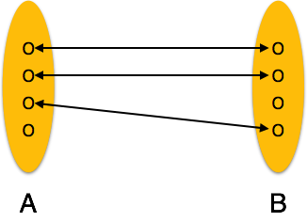
- One-to-many − One entity from entity set A can be associated with more than one entities of entity set B however an entity from entity set B, can be associated with at most one entity.
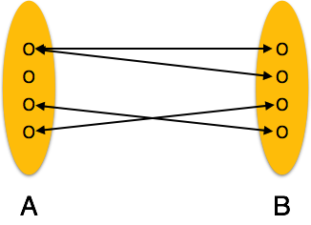
- Many-to-one − More than one entities from entity set A can be associated with at most one entity of entity set B, however an entity from entity set B can be associated with more than one entity from entity set A.
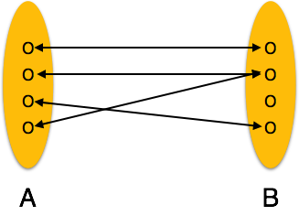
- Many-to-many − One entity from A can be associated with more than one entity from B and vice versa.
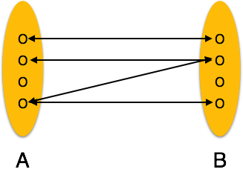
Let us now learn how the ER Model is represented by means of an ER diagram. Any object, for example, entities, attributes of an entity, relationship sets, and attributes of relationship sets, can be represented with the help of an ER diagram.

Entity
Entities are represented by means of rectangles. Rectangles are named with the entity set they represent.

Attributes
Attributes are the properties of entities. Attributes are represented by means of ellipses. Every ellipse represents one attribute and is directly connected to its entity (rectangle).
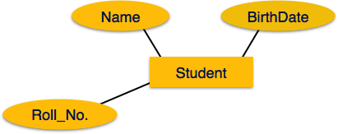
If the attributes are composite, they are further divided in a tree like structure. Every node is then connected to its attribute. That is, composite attributes are represented by ellipses that are connected with an ellipse.
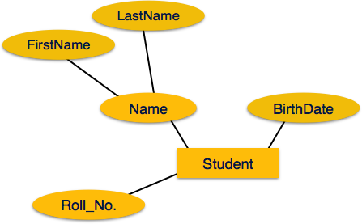
Multivalued attributes are depicted by double ellipse.
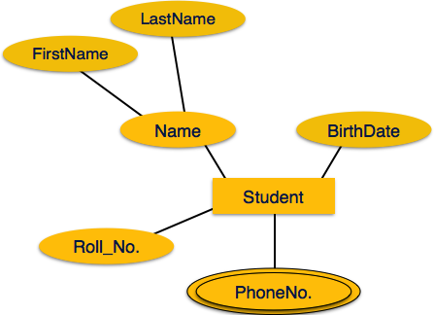
Derived attributes are depicted by dashed ellipse.
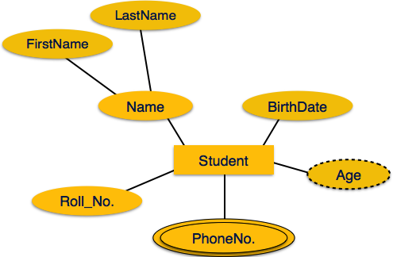

Relationship
Relationships are represented by diamond-shaped box. Name of the relationship is written inside the diamond-box. All the entities (rectangles) participating in a relationship, are connected to it by a line.

Binary Relationship and Cardinality
A relationship where two entities are participating is called a binary relationship. Cardinality is the number of instance of an entity from a relation that can be associated with the relation.
- One-to-one − When only one instance of an entity is associated with the relationship, it is marked as '1:1'. The following image reflects that only one instance of each entity should be associated with the relationship. It depicts one-to-one relationship.
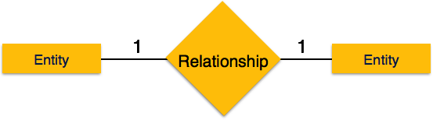
- One-to-many − When more than one instance of an entity is associated with a relationship, it is marked as '1:N'. The following image reflects that only one instance of entity on the left and more than one instance of an entity on the right can be associated with the relationship. It depicts one-to-many relationship.
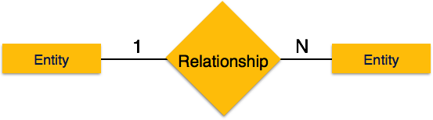
- Many-to-one − When more than one instance of entity is associated with the relationship, it is marked as 'N:1'. The following image reflects that more than one instance of an entity on the left and only one instance of an entity on the right can be associated with the relationship. It depicts many-to-one relationship.
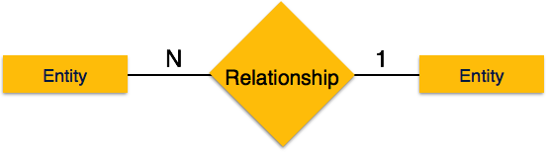
- Many-to-many − The following image reflects that more than one instance of an entity on the left and more than one instance of an entity on the right can be associated with the relationship. It depicts many-to-many relationship.
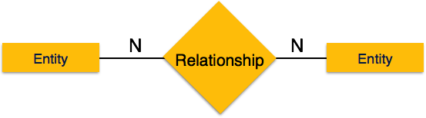

Participation Constraints
- Total Participation − Each entity is involved in the relationship. Total participation is represented by double lines.
- Partial participation − Not all entities are involved in the relationship. Partial participation is represented by single lines.
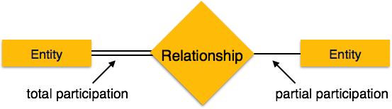

Generalization
As mentioned above, the process of generalizing entities, where the generalized entities contain the properties of all the generalized entities, is called generalization. In generalization, a number of entities are brought together into one generalized entity based on their similar characteristics. For example, pigeon, house sparrow, crow and dove can all be generalized as Birds.
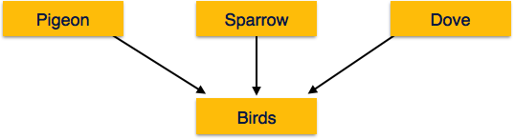

Specialization
Specialization is the opposite of generalization. In specialization, a group of entities is divided into sub-groups based on their characteristics. Take a group ‘Person’ for example. A person has name, date of birth, gender, etc. These properties are common in all persons, human beings. But in a company, persons can be identified as employee, employer, customer, or vendor, based on what role they play in the company.
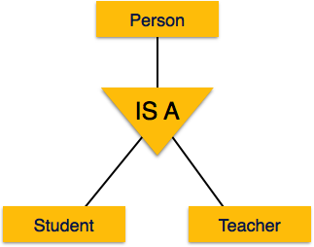
Similarly, in a school database, persons can be specialized as teacher, student, or a staff, based on what role they play in school as entities.

Inheritance
We use all the above features of ER-Model in order to create classes of objects in object-oriented programming. The details of entities are generally hidden from the user; this process known as abstraction.
Inheritance is an important feature of Generalization and Specialization. It allows lower-level entities to inherit the attributes of higher-level entities.
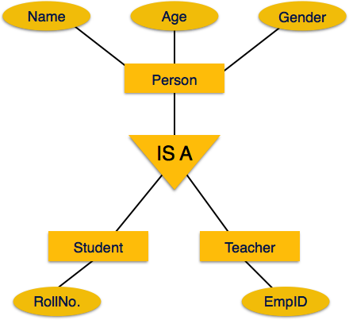
For example, the attributes of a Person class such as name, age, and gender can be inherited by lower-level entities such as Student or Teacher.

Functional Dependency
Functional dependency (FD) is a set of constraints between two attributes in a relation. Functional dependency says that if two tuples have same values for attributes A1, A2,..., An, then those two tuples must have to have same values for attributes B1, B2, ..., Bn.
Functional dependency is represented by an arrow sign (→) that is, X→Y, where X functionally determines Y. The left-hand side attributes determine the values of attributes on the right-hand side.

Armstrong's Axioms
If F is a set of functional dependencies then the closure of F, denoted as F⁺, is the set of all functional dependencies logically implied by F. Armstrong's Axioms are a set of rules, that when applied repeatedly, generates a closure of functional dependencies.
- Reflexive rule − If alpha is a set of attributes and beta is_subset_of alpha, then alpha holds beta.
- Augmentation rule − If a → b holds and y is attribute set, then ay → by also holds. That is adding attributes in dependencies, does not change the basic dependencies.
- Transitivity rule − Same as transitive rule in algebra, if a → b holds and b → c holds, then a → c also holds. a → b is called as a functionally that determines b.

Trivial Functional Dependency
- Trivial − If a functional dependency (FD) X → Y holds, where Y is a subset of X, then it is called a trivial FD. Trivial FDs always hold.
- Non-trivial − If an FD X → Y holds, where Y is not a subset of X, then it is called a non-trivial FD.
- Completely non-trivial − If an FD X → Y holds, where x intersect Y = Φ, it is said to be a completely non-trivial FD.

Normalization
If a database design is not perfect, it may contain anomalies, which are like a bad dream for any database administrator. Managing a database with anomalies is next to impossible.
- Update anomalies − If data items are scattered and are not linked to each other properly, then it could lead to strange situations. For example, when we try to update one data item having its copies scattered over several places, a few instances get updated properly while a few others are left with old values. Such instances leave the database in an inconsistent state.
- Deletion anomalies − We tried to delete a record, but parts of it was left undeleted because of unawareness, the data is also saved somewhere else.
- Insert anomalies − We tried to insert data in a record that does not exist at all.
Normalization is a method to remove all these anomalies and bring the database to a consistent state.

First Normal Form
First Normal Form is defined in the definition of relations (tables) itself. This rule defines that all the attributes in a relation must have atomic domains. The values in an atomic domain are indivisible units.
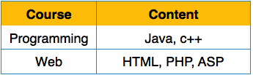
We re-arrange the relation (table) as below, to convert it to First Normal Form.
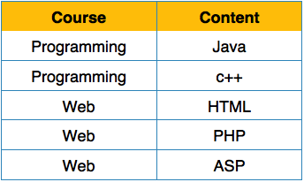
Each attribute must contain only a single value from its pre-defined domain.

Second Normal Form
Before we learn about the second normal form, we need to understand the following −
- Prime attribute − An attribute, which is a part of the prime-key, is known as a prime attribute.
- Non-prime attribute − An attribute, which is not a part of the prime-key, is said to be a non-prime attribute.
If we follow second normal form, then every non-prime attribute should be fully functionally dependent on prime key attribute. That is, if X → A holds, then there should not be any proper subset Y of X, for which Y → A also holds true.
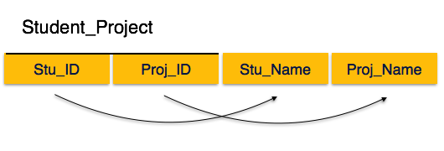
We see here in Student_Project relation that the prime key attributes are Stu_ID and Proj_ID. According to the rule, non-key attributes, i.e. Stu_Name and Proj_Name must be dependent upon both and not on any of the prime key attribute individually. But we find that Stu_Name can be identified by Stu_ID and Proj_Name can be identified by Proj_ID independently. This is called partial dependency, which is not allowed in Second Normal Form.
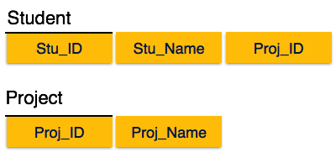
We broke the relation in two as depicted in the above picture. So there exists no partial dependency.

Third Normal Form
For a relation to be in Third Normal Form, it must be in Second Normal form and the following must satisfy −
- No non-prime attribute is transitively dependent on prime key attribute.
- For any non-trivial functional dependency, X → A, then either −
  - X is a superkey or,
  - A is prime attribute.
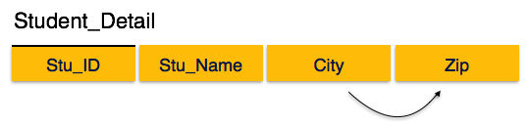
We find that in the above Student_detail relation, Stu_ID is the key and only prime key attribute. We find that City can be identified by Stu_ID as well as Zip itself. Neither Zip is a superkey nor is City a prime attribute. Additionally, Stu_ID → Zip → City, so there exists transitive dependency.
To bring this relation into third normal form, we break the relation into two relations as follows −
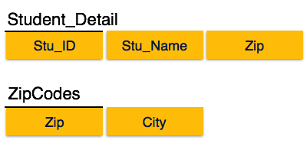

Boyce-Codd Normal Form
Boyce-Codd Normal Form (BCNF) is an extension of Third Normal Form on strict terms. BCNF states that −
- For any non-trivial functional dependency, X → A, X must be a super-key.
In the above image, Stu_ID is the super-key in the relation Student_Detail and Zip is the super-key in the relation ZipCodes. So,
Stu_ID → Stu_Name, Zip
and
Zip → City
Which confirms that both the relations are in BCNF.

