Report of Departmental Debate competition program held on 06/06/23 organised by the Dept. of Hindi

Respected Principal Madam,
I am submitting short report about Departmental Debate competition programme organised by Hindi Dept. of H.M.M College for Women held on dated 06/06/2023. Time span was 12.30 p.m onwards in the college campus.The topic of debate was “ भक्तिकालीन मीराबाई का जीवन परिचय”.Total eighteen students participated in the competition. The participants were divided into two groups to debate on the mentioned topic.
Reema Gupta (Department of Hindi) played role of Moderator in the Debate competition. Miss. Aatrayi Bhattacharya( faculty of History Dept )was present there too. Winners of debate competition were awarded by Prof. Dibakanta Jha( HOD of Sanskrit Dept.)on 8/6/23.Special Thanks goes to Dr.Soma Ghosh Principal of HMM College for Women for her co-operation.Some picture attached here. Regards. –

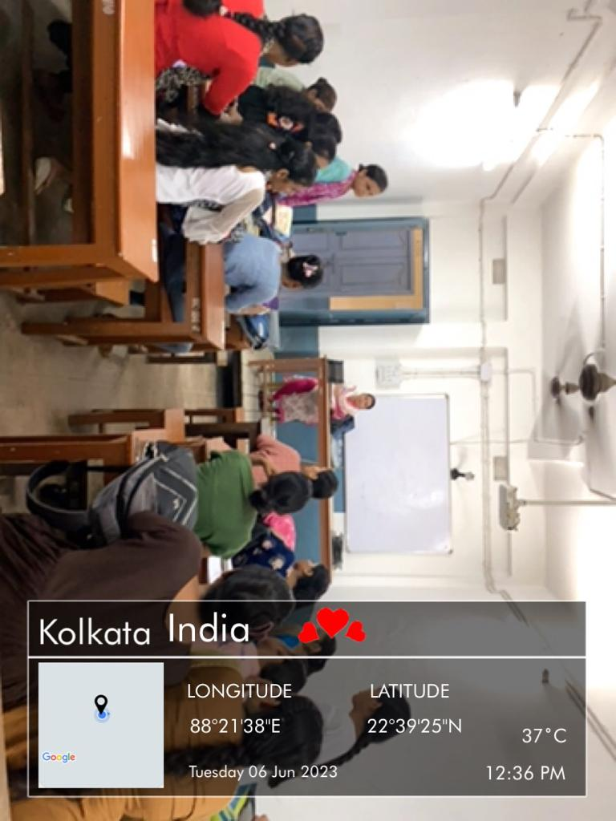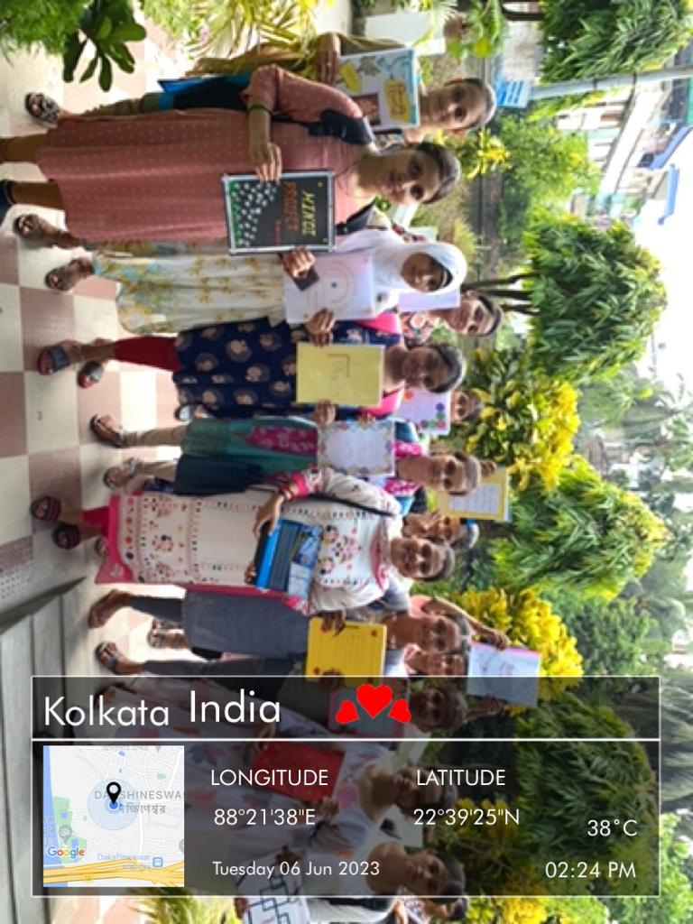

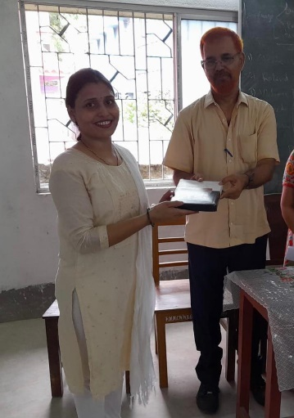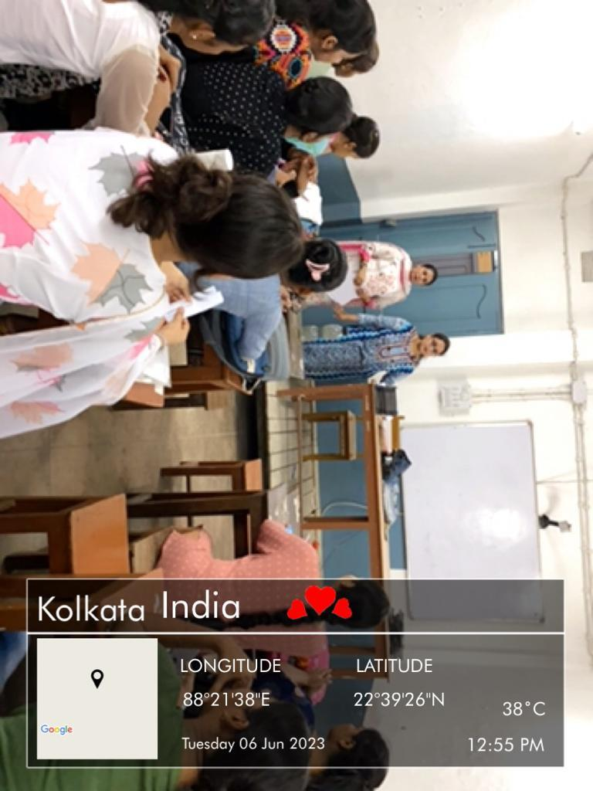

Dr.Soma Ghosh
_______________________
Principal signature Reema Gupta
Facilitator of Hind department

