EVENT ALBUM FORMAT
(PLEASE MAKE SEPARATE FILES FOR EACH SESSION)
HMM College for Women

SESSION: July 2019-June 2020
DEPARTMENT: Education
EVENT NAME | DATE | NO.OF PARTICIPANTS | DESCRIPTION
One day National Webinar On 'Implication Yoga in Era of Pandemic' | 21-06-2020 | 193 | Organized by the Department of Education ,HMMCW
Two day National e-conclave on "Online Education Pedagogy in Modern Management of Higher Education & Business Studies" | 28th -29th June, 2020 | 108 | Jointly organized by the Department of MBA,NBU and Department of Education and IQAC,HMMCW

CORRESPONDING PHOTOS WITH EVENT NAME:

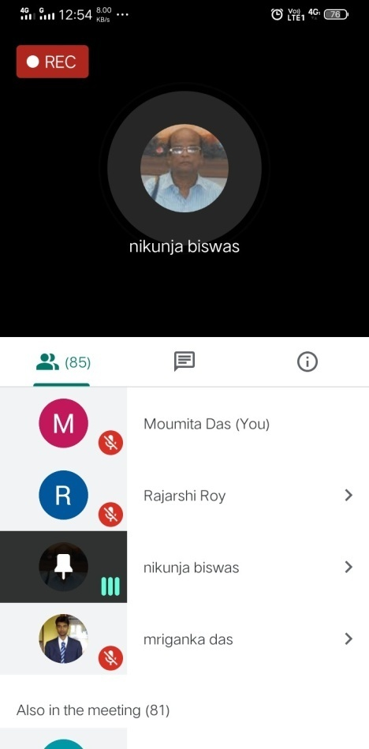
Two day National e-conclave on "Online Education Pedagogy in Modern Management of Higher Education & Business Studies" (held on 28th -29th June, 2020).
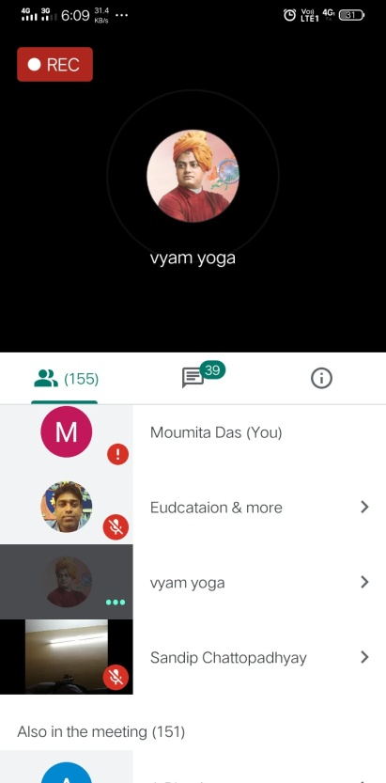
One day National Webinar On 'Implication Yoga in Era of Pandemic' (held on 21-06-2020)
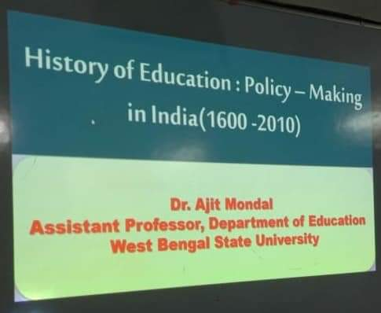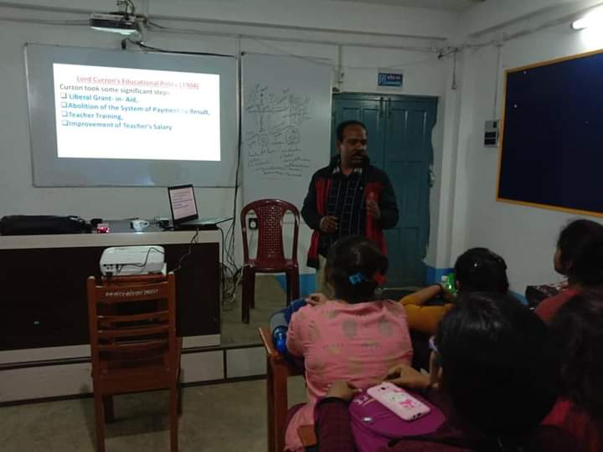
Extension lecture on "History of Education: Policy Making in India (1600-2010)" (held on 11-02-2020)

