Hiralal Mazumdar Memorial College for Women
Extension lectures organised by Department of EDUCATION 2021-22

DEPARTMENT | EVENTS | DATE | REMARKS
 | Extension lecture on "Role of education for social change". | 03.08.2021 | Delivered by Dr. Amulya Kumar Acharya, Associate Professor and Head, PG Department of Education, Fakir Mohan University, Odisha. No. of participants was about 45.
 | Extension lecture on "Rabindranath's Notion of Nationalism" | 23.03.2022 | Delivered by Prof. Sabita Chowdhury, jointly organised by Dept. of Political Science, History and Education, HMMCW
 | Extension lecture on "Gandhian Notion of Human Rights" | 10.12.2021 | Delivered by Prof. Rajib Ranjan Giri, Rajdhani College, University of New Delhi. Jointly organised by Dept. of Political Science, Hindi and Education, HMMCW
 | Extension lecture on “Psychological Counselling: An Approach to Students’ Support System” | 29.07.2021 | Delivered by Dr. Rajesh Kumar Saha, Assistant Professor, Department of Education, Rabindra Bharati University. Organised by Dept. of Education, HMMCW. No. of participants was about 36.
 | Extension lecture on “Evaluation in Education” | 19.04.2022 | Delivered by Dr. Soma Nandi, Associate Professor, Department of Education, East Calcutta Girls’ College. Organised by Dept. of Education, HMMCW. No of students present was 49.

1. Extension lecture on “Psychological Counseling: An Approach to Students' Support System” (held on 29/07/2021)
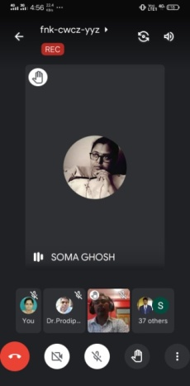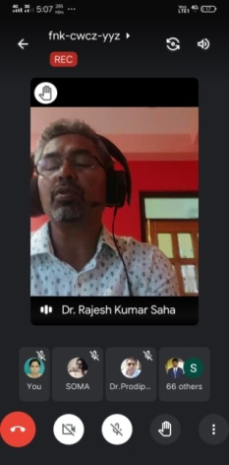
2. Extension lecture on “Role of Education for Social Change” (held on 03/08/2021)
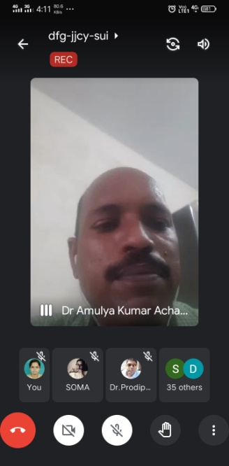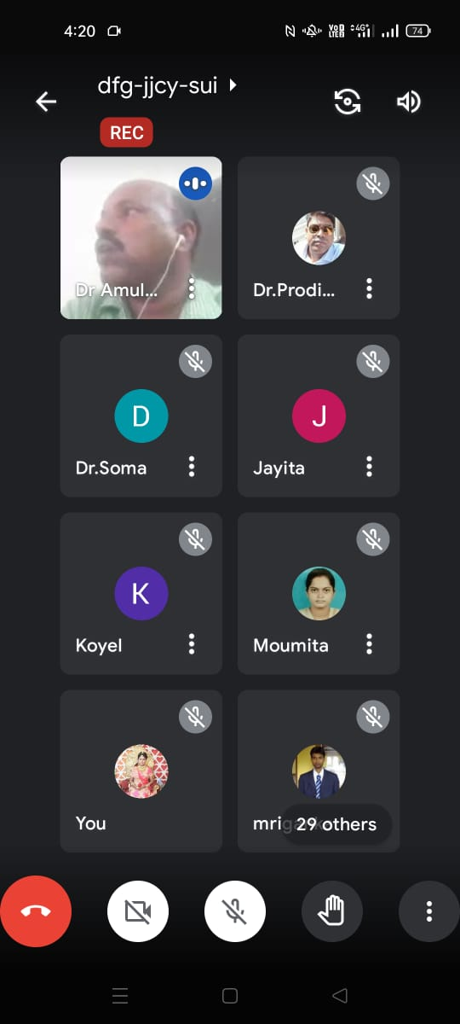
3. Extension lecture on “Evaluation in Education” (held on 19.04.2022)-
