**HIRALAL MAZUMDAR MEMORIAL COLLEGE FOR WOMEN**

**DEPARTMENT OF BOTANY**

**Seminar/ Workshop Report 2024-25**

**REPORT ON STUDENTS' SEMINAR**

The Department of Botany, Hiralal Mazumdar Memorial College for Women, organized a students' seminar on August 6th, 2024. The seminar was held in the departmental room, C-216.

The seminar commenced at noon, where students of 2nd semester major and minor participated, delivering presentations on relevant topics aligned with their syllabus (BOTDSC202T and BOTCOR202T). Under the guidance of faculty members, students prepared and presented their academic work, showcasing their knowledge and research skills. Each participant also submitted a hard copy of their topic.

The seminar aimed to:

1. Enhance students' presentation and communication skills

2. Encourage in-depth learning and research

3. Foster academic excellence and confidence

The seminar was successfully completed, with active participation from all students of 2nd semester major and minor. The Department of Botany appreciates the efforts of the students and faculty members who contributed to the success of this event.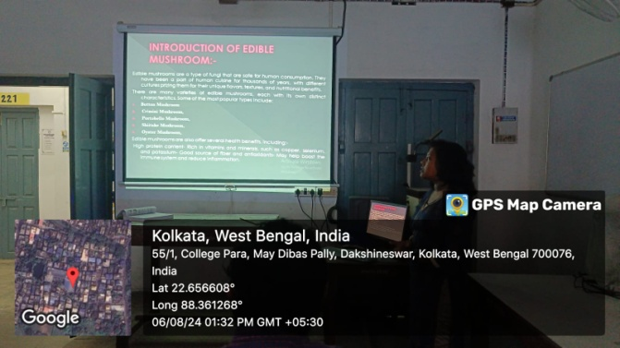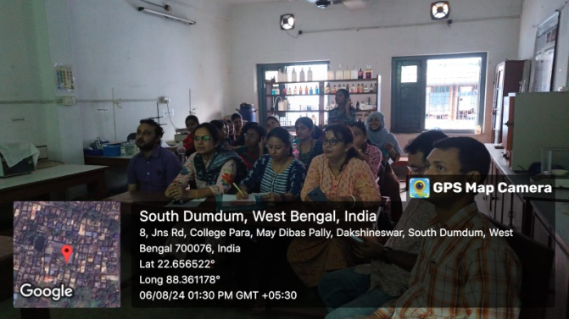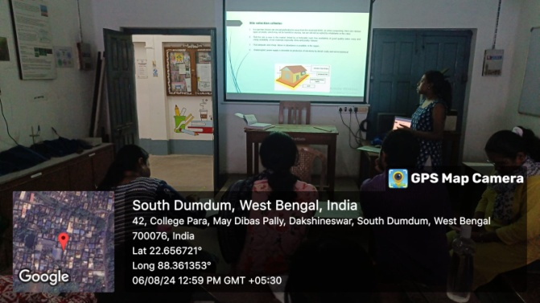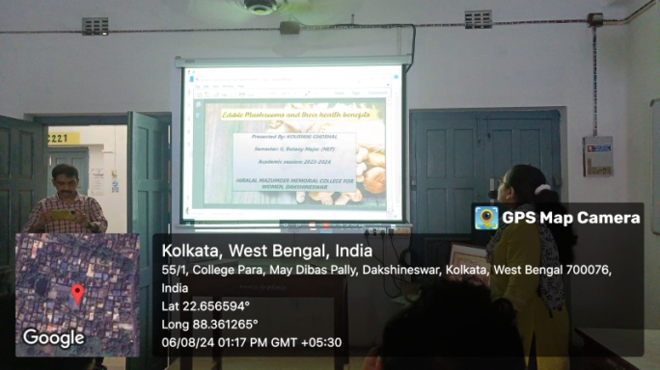

**WORKSHOP ON ECO-FRIENDLY RAKHI MAKING**

The workshop on eco-friendly Rakhi making was organized by the Department of Botany with the Green Club at Hiralal Mazumdar Memorial College for Women in Dakshineswar on 9th August, 2024 at 12 noon onwards in the venue of the college campus. It started at 10 am. Here, many students of our college, mainly the students interested in art and craft, participated and prepared the eco-friendly Rakhi under the guidance of Smt. Munmun Kundu. Ultimately, they successfully prepared a lot of Eco-friendly Rakhi, and nowadays these types of Rakhi have a great significance as there were no pollution effect and do not cause any harmful effect on the environment after the use of Rakhi.

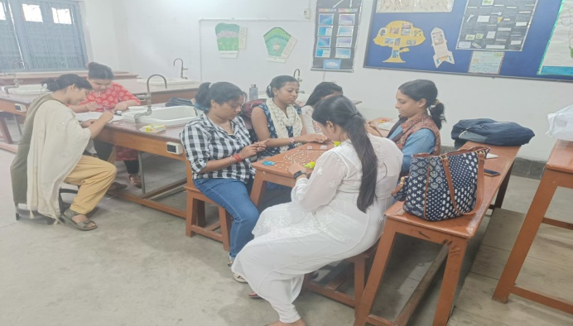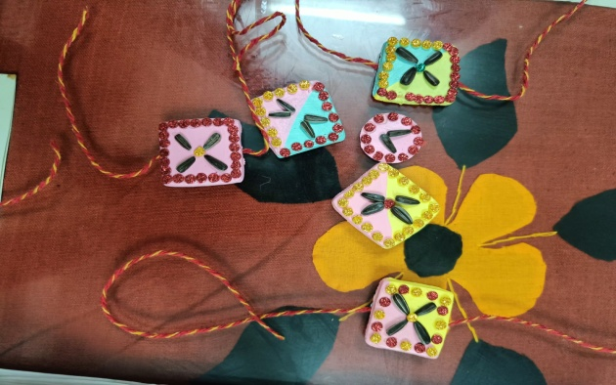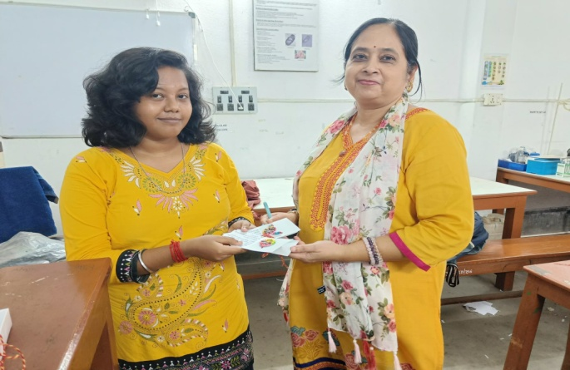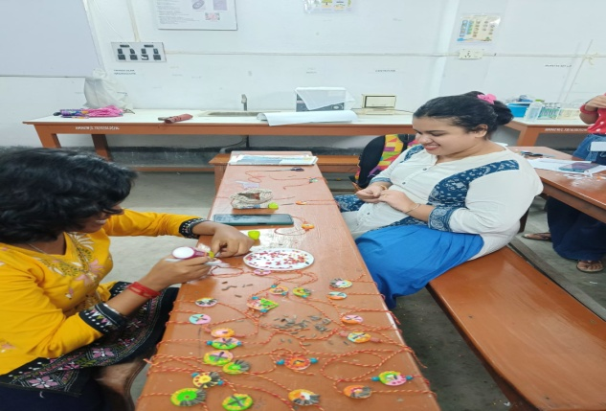

**REPORT ON HANDS-ON TRAINING ON HERBARIUM TECHNIQUE**

The Department of Botany, Hiralal Mazumdar Memorial College for Women, Dakshineswar, in collaboration with the Department of Botany, Sarojini Naidu College for Women, organized a hands-on training program on Herbarium Technique on August 13, 2024, at noon.

The training program consisted of two phases:

1. Theoretical Session: Dr. Namrata Shanu Gupta delivered a comprehensive lecture on herbarium techniques, providing students with a foundational understanding of the subject.

2. Hands-on Training: Smt. Munmun Kundu conducted the practical session, guiding students through the process of preparing and preserving plant specimens.

Students from both colleges participated in the program, including: - 2nd semester Major and Minor

- 4th semester Hons, - 1st semester Minor

The program aimed to:

1. Equip students with practical skills in herbarium techniques

2. Enhance understanding of plant taxonomy and classification

3. Foster research and documentation skills

The hands-on training program on Herbarium Technique was a resounding success, providing students with valuable theoretical knowledge and practical experience. The Department of Botany extends its gratitude to Dr. Namrata Shanu Gupta and Smt. Munmun Kundu for their expertise and contributions to the program.

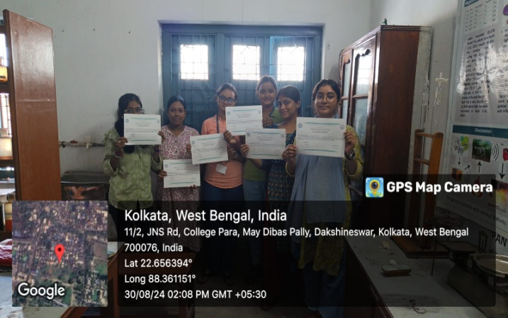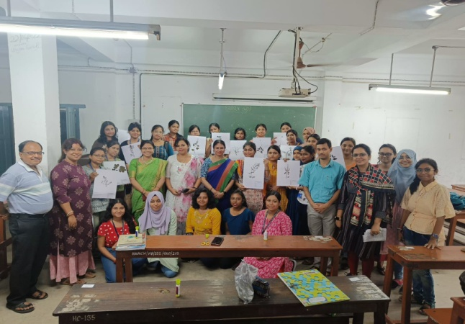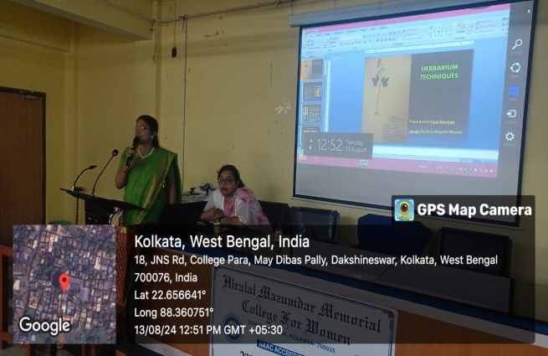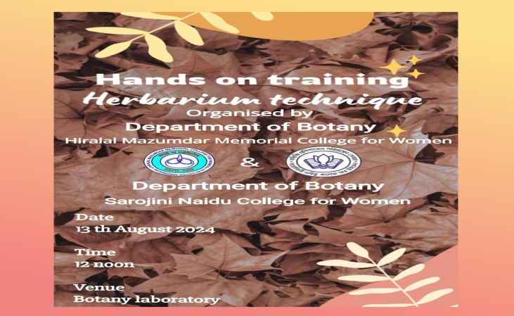

**REPORT ON STUDENT'S SEMINAR**

The Department of Botany, Hiralal Mazumdar Memorial College for Women, organized a students’ seminar on April 11th and 12th, 2025. The seminar was held in the departmental room, C-216.

The seminar commenced at approximately 1:00. Students of 3rd semester minor participated enthusiastically, delivering valuable presentations on selected topics from the syllabus (BOTHSEC202M, Semester-III Minor). Under the guidance of faculty members, students prepared and presented their topics using LCD projectors in PPT format. Each participant also submitted a hard copy of their presentation.

The seminar aimed to:

1. Enhance students' presentation skills

2. Encourage in-depth learning of specific topics

3. Foster research and critical thinking abilities

The seminar was a resounding success, showcasing students' knowledge and creativity. The Department of Botany commends the participants for their efforts and congratulates them on their achievements. The faculty members' guidance played a pivotal role in making this event a success.

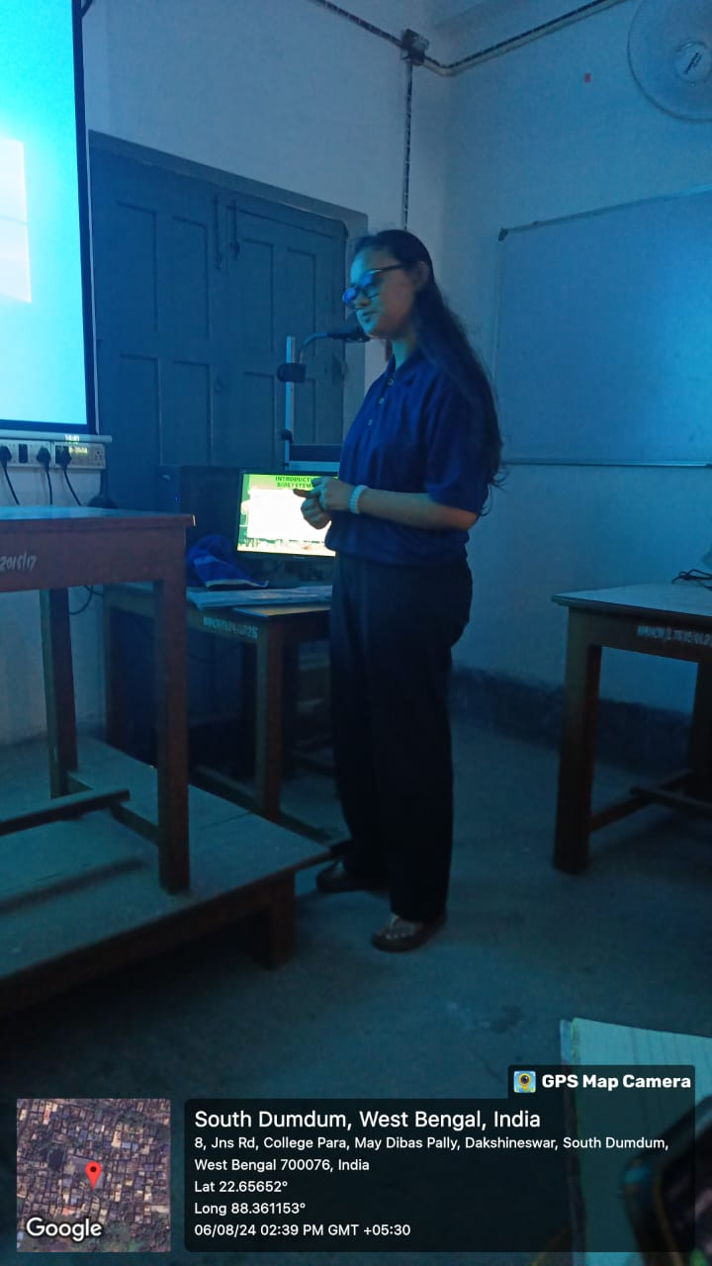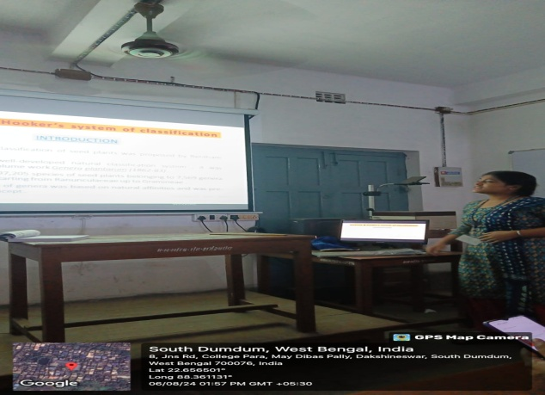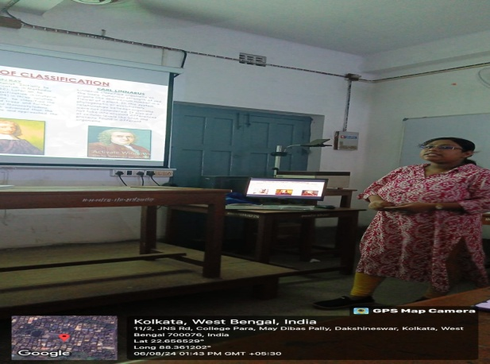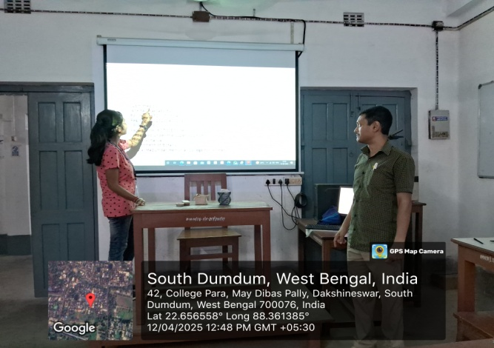

**HERBAL ABIR MAKING WORKSHOP**

An Herbal Abir Making Workshop was organized by the Department of Physiology, Chemistry and Botany in collaboration with IQAC, Incubation Centre and Entrepreneurial Development Cell of the College on 21ST February, 2025 from noon. This workshop was conducted by the Paschimbanga Bigyan Mancha at the College premises. The workshop aimed to promote eco-friendly natural colors for Holi. The event started with an awareness session highlighting the harmful effects of synthetic abir on health and the environment. Experts from Paschimbanga Bigyan Mancha explained the benefits of herbal colors. The participants learned about natural ingredients used for making abir: Such as Yellow and Orange Marigold flowers for Yellow and Orange colored Abirs, respectively, rose petals for Pink, Butterfly Pea flowers for Blue, and Spinach for Green colored Abirs. Arrowroot powder was used as a base for a smooth texture. The incorporation of food color and natural essences in herbal abir enhanced its vibrancy and fragrance while ensuring safety for skin and the environment. Natural food-grade colors were used to intensify the shades of herbal abir. They are non-toxic, skin-friendly, and biodegradable, making them safer alternatives to synthetic dyes. The demonstration showed how to dry, grind, and mix these ingredients to create vibrant shades. Students actively participated in preparing herbal abir in small groups

The workshop successfully enhanced scientific awareness and encouraged students to adopt eco-friendly practices. Many students expressed interest in learning and promoting herbal abir in future Holi events. Students planned to distribute these herbal colors (abirs) in the community before Holi, promoting a safe and sustainable celebration.

