HIRALAL MAZUMDAR MEMORIAL COLLEGE FOR WOMEN DAKSHINESWER

EVENT ALBUM

(FROM 2023 JULY -PRESENT)

DEPARTMENT OF FOOD AND NUTRITION

SESSION: JULY 2023-JUNE 2024

|  |  |  |  |
| --- | --- | --- | --- |
| **EVENT NAME** | **DATE** | **NO. OF**  **PARTICIPANTS** | **DESCRIPTION** |
| 1. **2DAYS STUDENT SEMINAR** | **12.7.2023**  **13.7.2023** | **39** | **A 2 Days Student’s Seminar Were Organized By The Department Of Food And Nutrition . 39 4th Sem Food And Nutrition Honours Student Present Their Power Point Slides On Different Topic Of Nutrition Education Along With Different Chart/Models/Poster . Its An Initiative To**  **Spread Awareness on Nutrition To The Common People** |
| **2. NATIONAL NUTRITION MONTH CELEBRATION 2023** | **3.10.2023** | **APPROX 80** | **An interactive state level seminar was organised . Theme of “Poshaan Maah” was “ SUPHOSHIT BHARAT, SAKSAR BHARAT, SHAKSAT BHARAT”. Resource person was Dr. Annya Bhowmik , Clinical Dietitian.**  **Topic :- Millet Nutrition** |
| **3.DEPARTMENTAL FRESHERS AND FAREWELL PROGRAMME AND INTERACTION OF ALUMNI STUDENTS 2023**  **4.PRE DURGAPUJA FOOD EXHIBITION**  **5. Healthy Food exhibition during NAAC visit Day 1**  **6. EXTENSION LECTURE ON ORAL AND COLON CANCER AND ITS NUTRITIONAL MANAGEMENT** | **4.10.23**  **17.10.2023**  **18.12.2023**  **17.5.2024** | **Approx 100**  **APPROX 70**  **38**  **APPROX 40** | **Interaction of the alumni student 2023 passout batch with present student.**  **An one day pre Durga puja food exhibition was organized by students of the Department of Food and Nutrition at college premises on different nutritionally modified street food of Kolkata on 17.10.2023 . Students of 1st 3rd and 5th Sem gave food stall and sell it. All the faculty members and NTS and institutional students of the institution participated. Overall, it was a very much interactive and joyful programme.**  **A one-day food exhibition was arranges during NAAC Day 1 visit on “FOUR FOOD GROUPS” as a part of syllabus of 1st Sem NEP major. All 1st Sem student prepared and displayed different food items with special emphasis on Millets as this year is known as INTERNATIONAL YEAR OF MILLETS. Students also served some of prepared items with the NAAC peer team members.**  **A extension lecture was organized for 4th sem Food and nutrition hons students on 17.5.2024 on ORAL AND COLON CANCER AND ITS NUTRITIONAL MANAGEMENT. Speaker was DIETITIAN RESHMA RAY, Senior clinical Nutritionist TATA MEDICAL CENTRE KOLKATA.** |

CORRESPONDING PHOTOS WITH EVENT NAME:

STUDENTS SEMINAR 2023

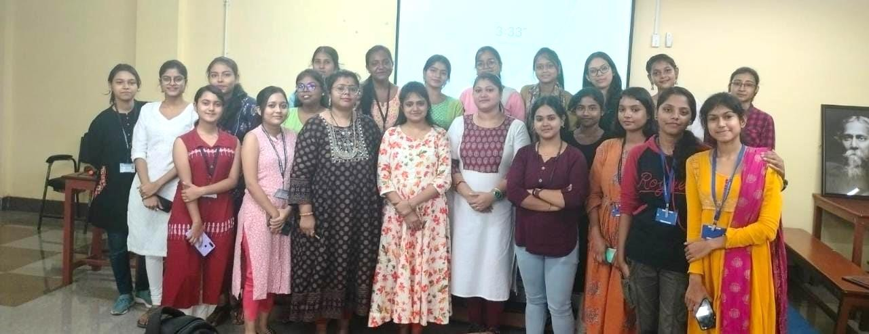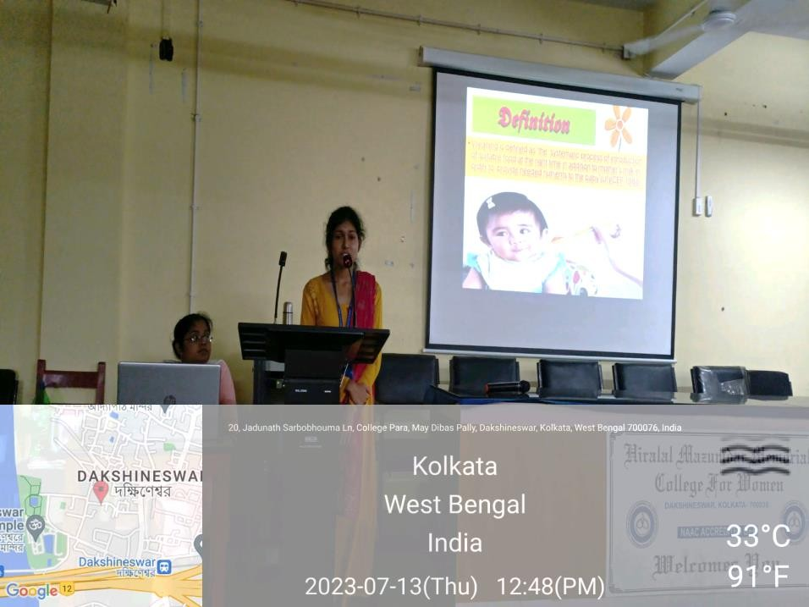

**National Nutrition Month 2023**

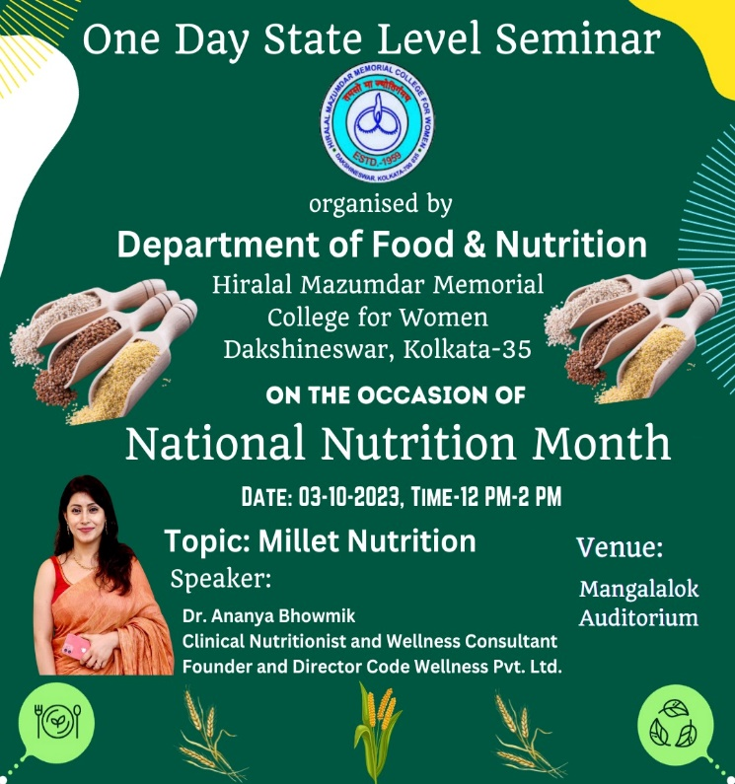

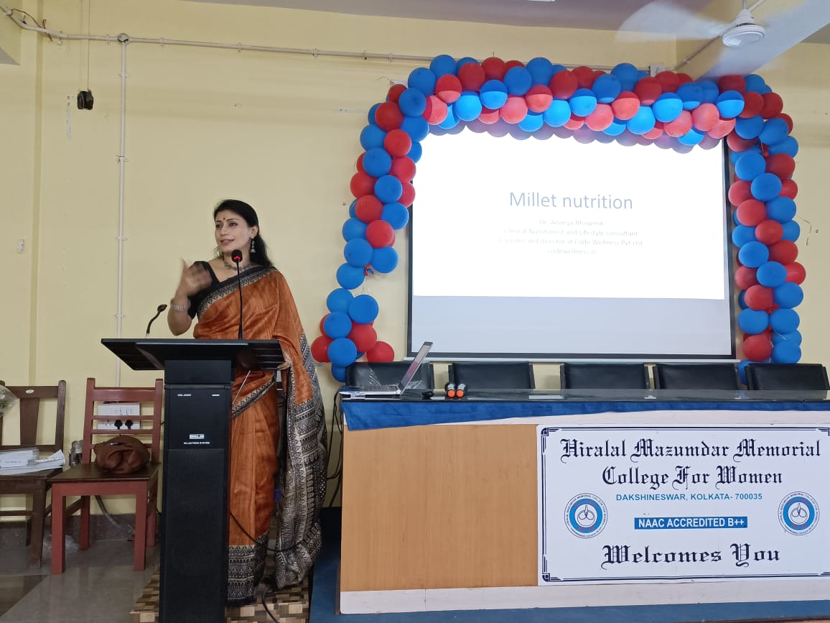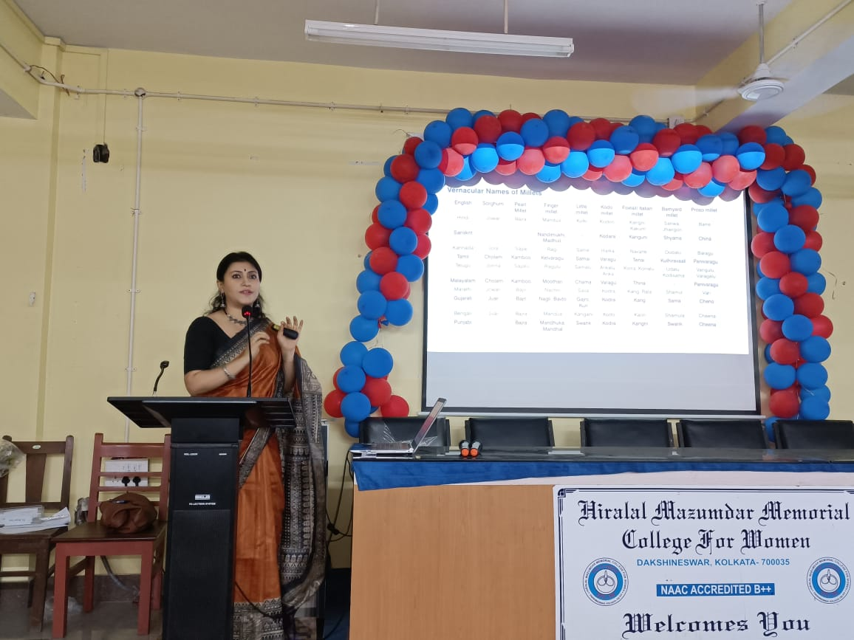

**DEPARTMENTAL FRESHERS AND FAREWELL PROGRAMME**

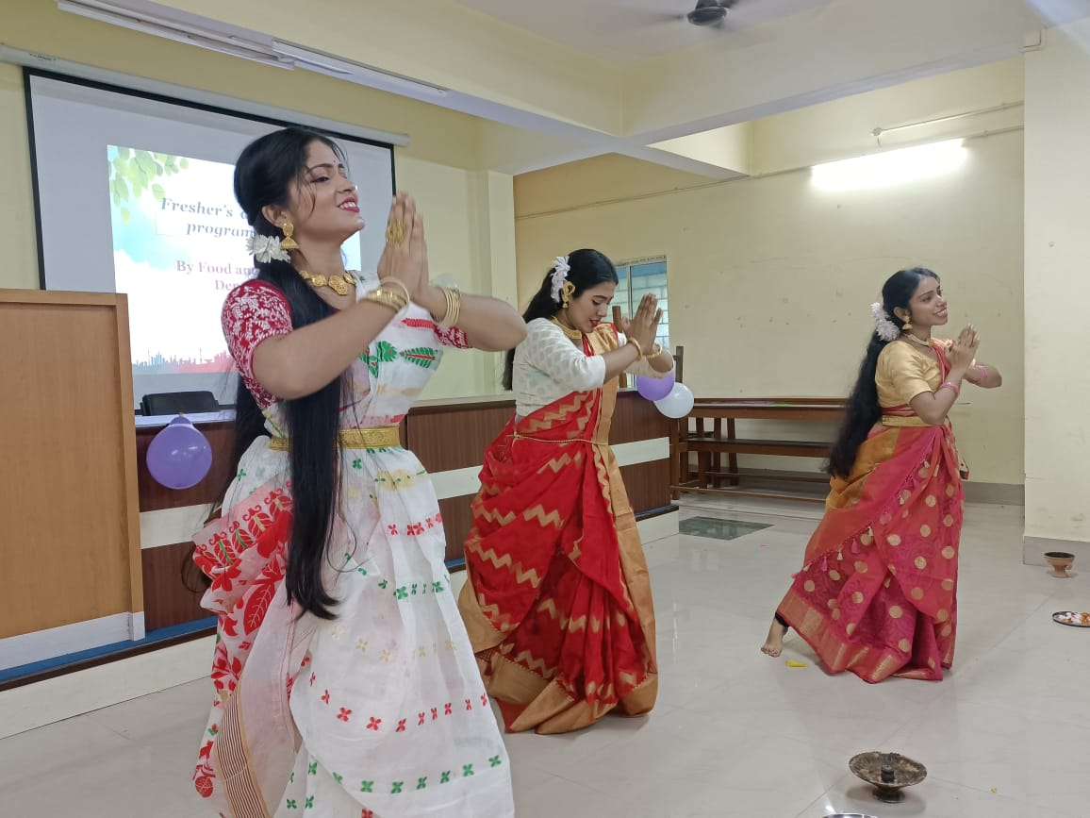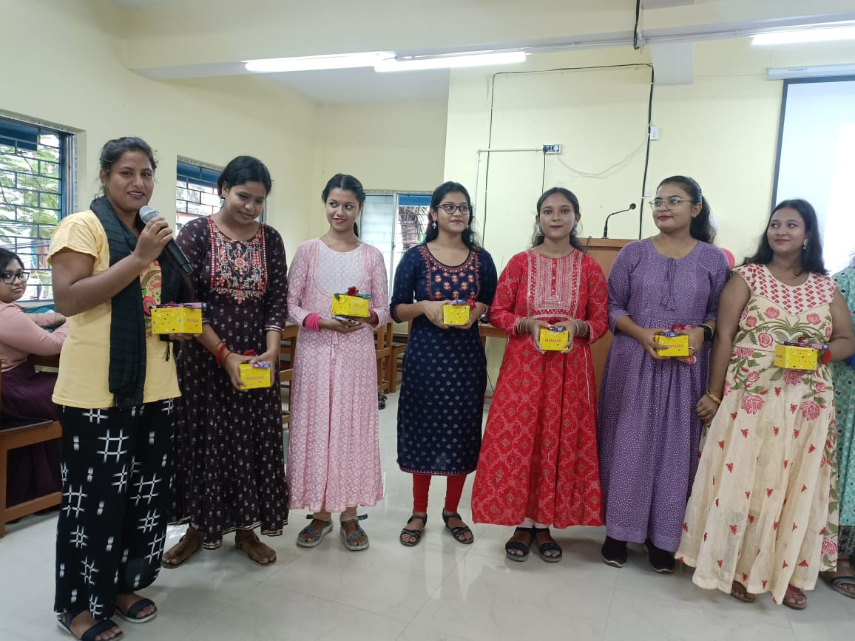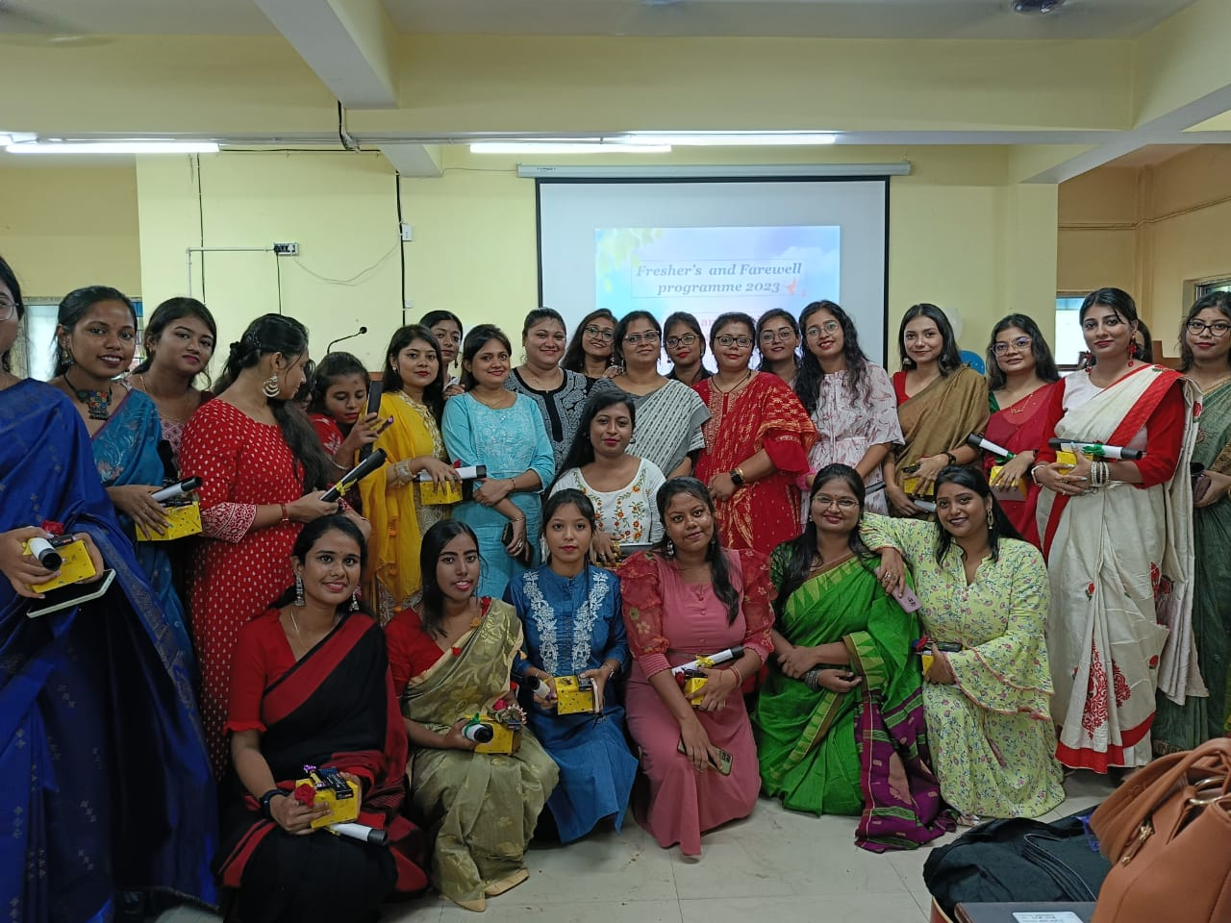

**PRE DURGAPOOJA FOOD EXHIBITION 2023**

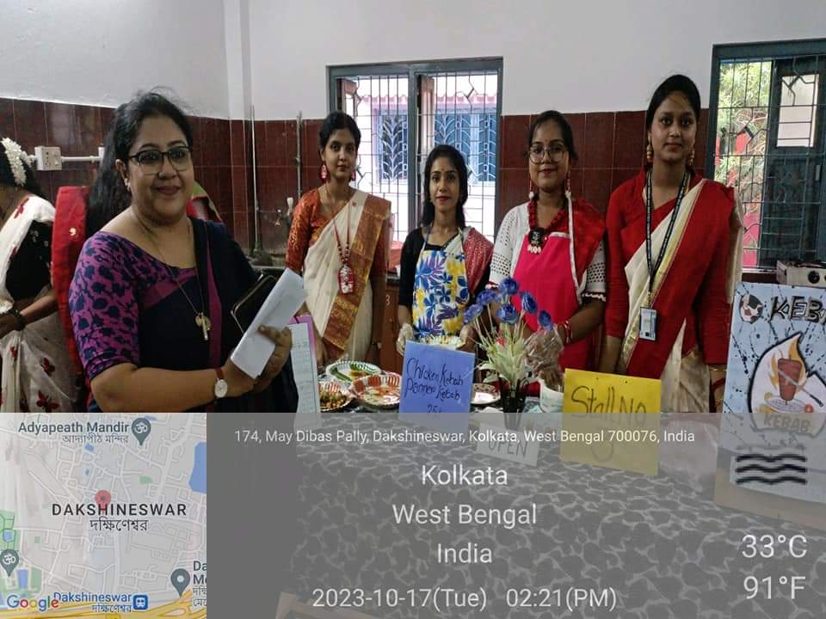

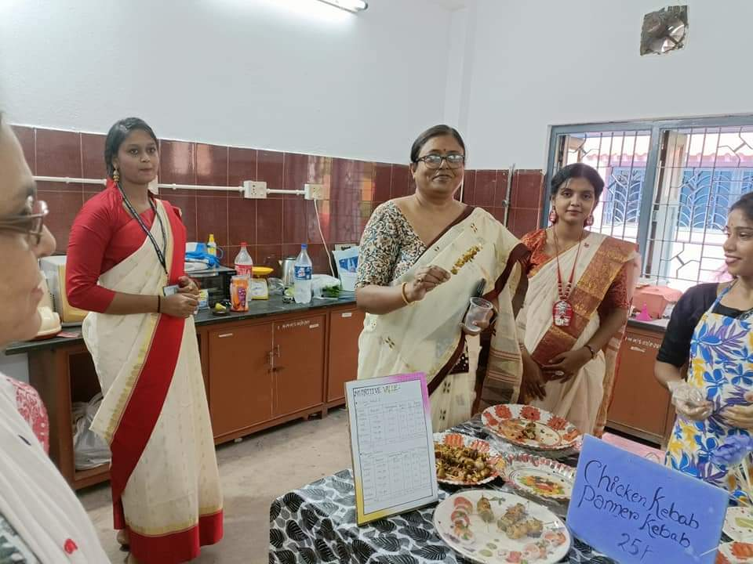

**FOOD EXHIBITION DURING NAAC VISIT**

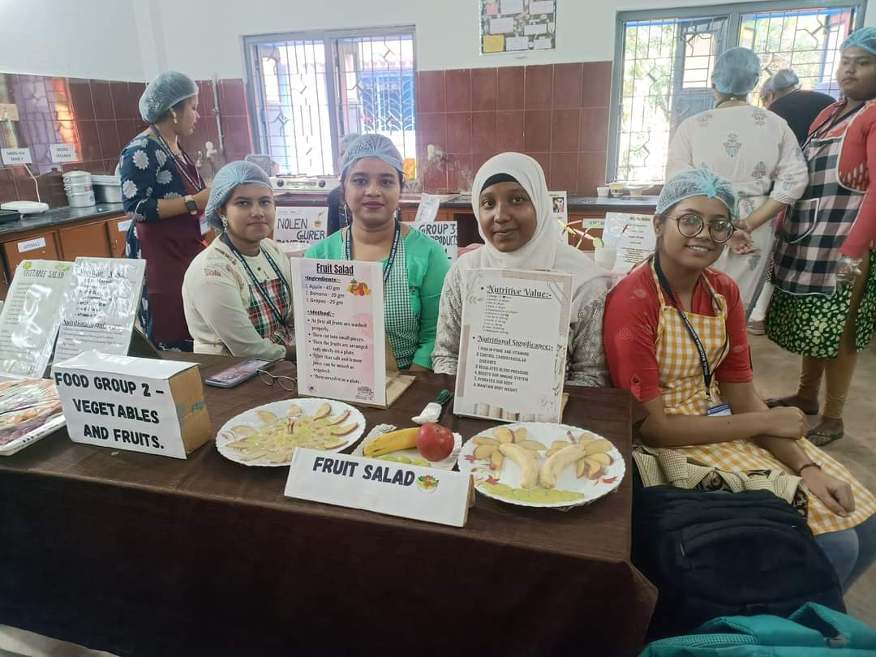

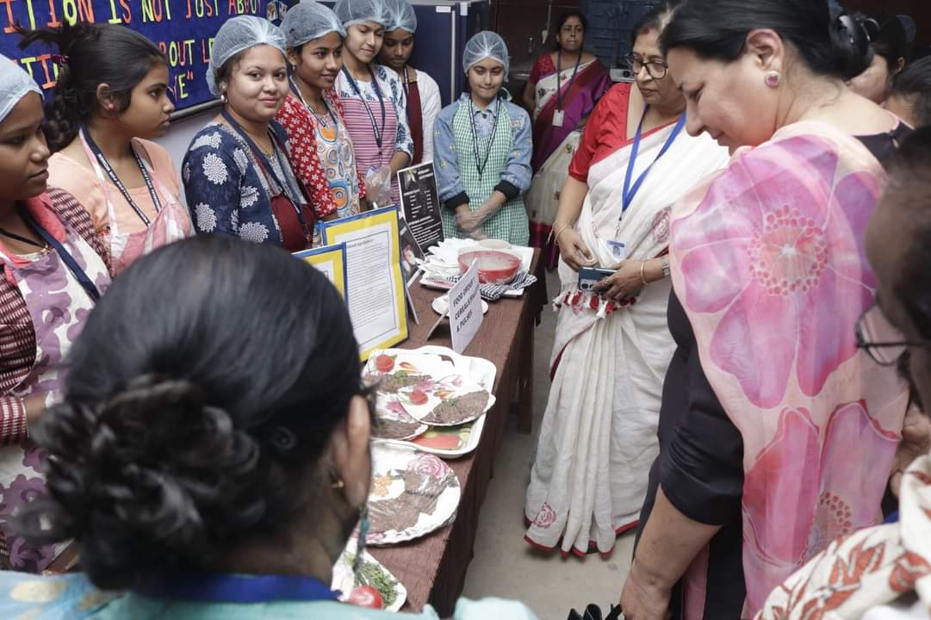

**EXTENSION LECTURE ON ORAL N COLON CANCER**