Photograph

Name: Piyali Mitra 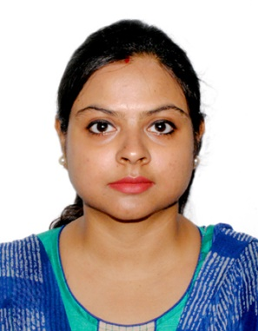
Designation: SACT-II
Qualification: M.A.
Email: piyalimitra@hmmcw.in

Teaching Area: Sociology
Teaching Experience: 10 yrs 3 months

Research Area: Social Exclusion

Title of the thesis under Ph D programme: NA
Post-Doctoral Research: NA

Publications:

Title of paper | Name of the author/s | Department of the teacher | Name of journal | Year of publication | ISSN Number | Link to the recognition in UGC enlistment of the Journal /Digital Object Identifier (doi) number
 |  |  |  |  |  | Link to website of the Journal | Link to article / paper / abstract of the article | Is it listed in UGC Care list
Sl. No. | Name of the teacher | Title of the book/chapters published | Title of the paper | Title of the proceedings of the conference | Name of the conference | National / International | Year of publication | ISBN number of the proceeding | Affiliating Institute at the time of publication | Name of the publisher
1 | Piyali Mitra | Signifying Values- A realm of Socio-Philosophical Understanding | The study of Indian Values – Celebration of Changed and Unchanged | Signifying Values- A realm of Socio-Philosophical Understanding | UGC Sponsored national Seminaer on Signifying Values- A realm of Socio-Philosophical Understanding | National | 2017 | 978-93-84106-86-7 | Prasanta Chandra Mahalanobis Mahavidyalaya | Levant Books
2 | Piyali Mitra | The Journey of Childhood and Intersectionality | Intersectionality of Childhood – The Social Story of the Slum Children of Kolkata | The Journey of Childhood and Intersectionality | Childhood and Intersectionality in the Indian Context | National | 2020 | 978-81-949068-7-2 | H.M.M. College for Women | Avenel Press
3 | Piyali Mitra | Gender: An Urge for Deconstruction | Bengali TV Soaps and their Gender Cliches- An Analysis of Contemporary Households in Kolkata. | The ICSSR-Sponsored National Level Symposium of “Gender Sensitisation” | The ICSSR-Sponsored National Level Symposium of “Gender Sensitisation” | National | 2022 | 9-788195-771622 | H.M.M. College for Women | Imprint publication

Seminars, Symposiums, Leadership programmes attended:

- Oral presentation: 1. Social Exclusion and Intolerance in Educational Institutions in Present Day Society- Organised by West Bengal State University, Dept. of Sociology (30th – 31st of March, 2016)
2. The study of Indian Values – Celebration of Changed and Unchanged – Organised by Prasanta Chandra Mahalanobis Mahavidyalaya, Dept. of Sociology and Philosophy (9th – 10th of December, 2016)
3. Margins of Marginalised: Social Story of the Slum Girl Children - Organised by University of Gour Banga, Dept. of Sociology (2nd – 3rd February, 2017).
4. Marginalisation of the Marginalised in Everyday life – Organised by Indian Sociological Society (27th – 29th of December, 2018)

Poster presentation: NA

Leadership programme attended: NIL

Administrative Experiences: NA
Membership of Professional bodies: NIL

Others:
Administrative experiences outside the College: NIL

