Congestion Control Algorithm
When too many packets are present in (a part of) the subnet, performance degrades. This situation is called congestion.
Factors Causing Congestion
- Packet arrival rate exceeds the outgoing link capacity.
- Insufficient memory to store arriving packets
- Bursty traffic
- Slow processor

General Principles of Congestion Control
The two approaches of congestion Control are :
- Open loop: try to prevent congestion occurring by good design
- Closed-loop: monitor the system to detect congestion, pass this information to where action can be taken, and adjust system operation to correct the problem (detect,feedback and correct).

Leaky Bucket
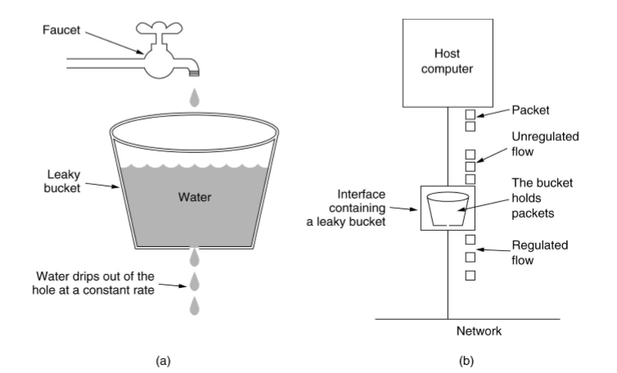Figure : Leaky Bucket Algorithm
- Imagine a bucket with a small hole in the bottom.
- No matter the rate at which water enters the bucket, the outflow is at a constant rate, when there is any water in the bucket and zero when the bucket is empty.
- Also, once the bucket is full, any additional water entering it spills over the sides and is lost.
- The same idea can be applied to packets, as shown in Fig. (b).
- Conceptually, each host is connected to the network by an interface containing a leaky bucket, that is, a finite internal queue.
- If a packet arrives at the queue when it is full, the packet is discarded. In other words, if one or more processes within the host try to send a packet when the maximum number is already queued, the new packet is unceremoniously discarded.

The Token Bucket Algorithm
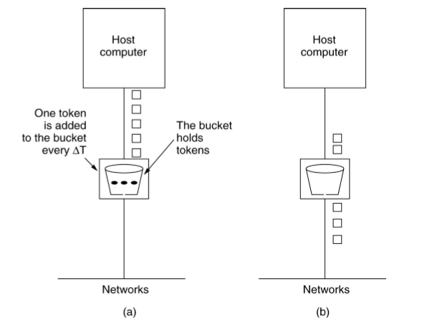Token Bucket Algorithm
- For many applications, it is better to allow the output to speed up somewhat when large bursts arrive, so a more flexible algorithm is needed, preferably one that never loses data.
- One such algorithm is the token bucket algorithm.
- Tokens arrive at the constant rate in the token bucket.
- If the bucket is full, tokens are discarded.
- A packet from the buffer can be taken out only if a token in the token bucket can be drawn.
- The token bucket algorithm provides a different kind of traffic shaping than that of the leaky bucket algorithm. The leaky bucket algorithm does not allow idle hosts to save up permission to send large bursts later.
- The token bucket algorithm does allow saving, up to the maximum size of the bucket, n. This property means that bursts of up to n packets can be sent at once, allowing some burstiness in the output stream and giving the faster response to sudden bursts of input.

Reference

