How is data put on radio waves?
There are two common ways to put information in a radio wave, and you've likely run into them yourself. They are called A.M. and F.M. just like the two choices you've always known are on a radio. To understand these two ways of sending information it is important to know that radio waves, by themselves, have very regular patterns. Generally they keep the same amplitude or frequency all the time. (Amplitude is the "height" of the radio wave, frequency is how close the waves are to each other.)
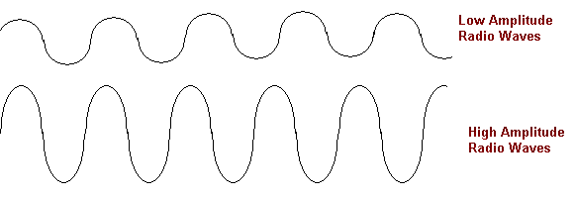
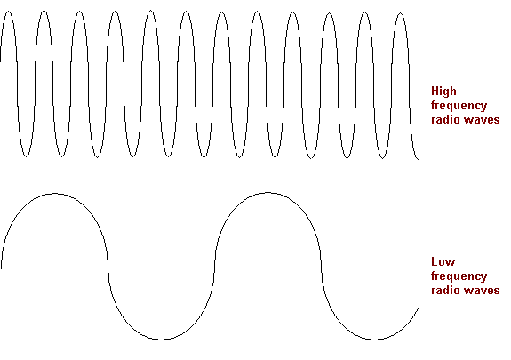

A.M. stands for amplitude modulation. In this method, the information is put into a radio wave by varying the amplitude. For example, if all we wanted to do was send 1's and 0's, we could have just two different levels of amplitude that correspond to these numbers--1 being high, 0 being low.
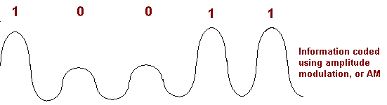
F.M. stands for frequency modulation. This time the amplitude is kept constant, it is the frequency that is varied..
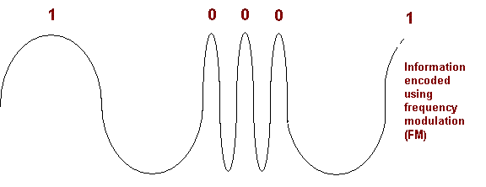

VSAT :
VSATs stand for very small aperture terminals and are used for providing one-way or two-way data broadcasting services, point-to-point voice services and one way video broadcasting services.
VSAT networks are ideal for centralized networks with a central host and a number of geographically dispersed terminals. Typical examples are small and medium businesses with a central office, banking institutions with branches all over the country, reservation and airline ticketing systems etc.
VSATs offer various advantages like wide geographical area coverage, high reliability, low cost, independence from terrestrial communication infrastructure, flexible network configurations etc. However it suffer from a major problem of delay between transmission and reception of data(around 250ms) due to the use of GEO satellites
VSAT Network:
- The ground segment of a typical VSAT network consists of a high performance hub Earth station and a large number of low performance terminals referred to as VSATs.
- The space segment comprises GEO satellites acting as communication links between the hub station and the VSAts.
- A typical VSAT network is shown below.
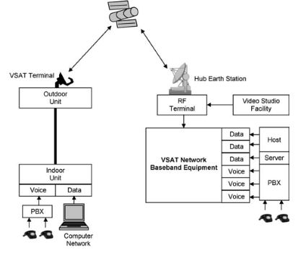
A typical VSAT network
- VSATs employ a high performance central station so that the various remote stations can be simpler and smaller in design, thus enabling the VSAT networks to be extremely economical and flexible.
- The hub station is usually a large, high performance Earth Station comprising an outdoor antenna (with a diameter of between 6 to 9 metres) for transmission, RF terminals for providing a wideband uplink of one digital carrier per network, base band equipment comprising modems, multiplexers and encoders, a control centre for managing the network and various kinds of interfacing equipment to support a wide variety of terrestrial links.
- These terrestrial links connect the hub station to the head office or to the data processing centre from where the data have to be broadcasted.
- In the case of bidirectional networks, the outdoor antenna is also configured for reception of signals and the RF equipment comprises several narrowband downlink channels for reception from various remote VSATs.
- VSATs are smaller and simpler in design as compared to the hub centre and comprise an outdoor antenna (0.5 to 2.4m diameter), an RF terminal comprsing an LNB (low noise block) for reception and baseband equipment. The also comprise an up-converter and power amplifier for uplinking in the case of bidirectional networks.
- VSAT networks employ either C band or Ku band. The sharing problem is less severe at the Ku band.
- VSATs are generally used for carrying digital signals. Binary phase shift keying(BPSK) or Quadrature phase shift keying modulation schemes with forward error correction using Viterbi or sequential decoding technique are

