STUDY MATERIAL
Semester – II (GENERAL) PAPER - II, UNIT - 3
Prepared by Sri Rabi Sankar Das, Department of Botany, Hiralal Mazumdar Memorial College for Women, Dakshineswar

ECOTONE
DEFINITION:-
In nature there is a zone of transition, or tension in which the conditions for each of the adjacent communities become more adverse, and there is usually an intermixing of species from both the communities. Such a region presenting a situation of special ecological interest is known as an ecotone or a tension zone.
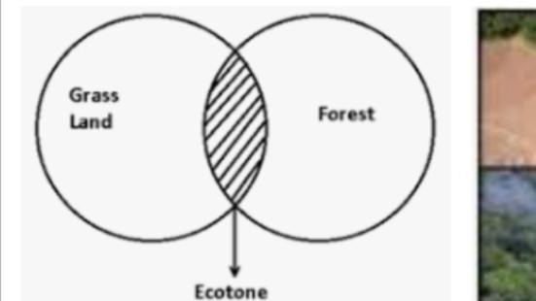
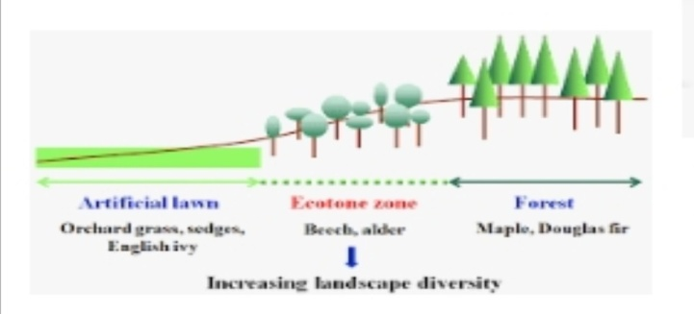
FEATURES OF ECOTONE:-
- It is the transition zone between two major communities.
- The ecotone is colonized by the species that are commonly found in the species that are commonly found in the communities on both the sides, as well as by some versatile species of plant and animals.
- It has sufficiently greater number of species,
- The unique general feature of ecotone is the density of most species is higher than that in the neighboring communities. This is known as principle of edges.
- There has no sharp boundaries, gradual changes occurs in ecotone regions.

EXAMPLE :-
- The border between forest and grass land
- The bank of stream running through a meadow
- Intermediate zone between two major land or aquatic communities.

