STUDY MATERIAL
Semester – II (Hons) CC - IV, unit – 5
Prepared by Sri Rabi Sankar Das, Department of Botany, Hiralal Mazumdar Memorial College for Women, Dakshineswar
Reproduction of Equisetum sp

The plant Equisetum sp perform reproduction by both vegetative mode and the production of spores.
- Vegetative propagation :-
- By tuber formation :-
In some species the branches primordial on rhizome remain short and develop into round or ovoid tuber. When detached from parent rhizome each tuber grow into a new plant.
- By branch primordial :-
Every branch of rhizome bear performed branch primordial which can developed in to a new subterranean and aerial branches. The older portion of the deep seated rhizome may decay setting free the branches. Each branch with the help of preformed branch primordial developed in to a new plant.

- Reproduction by the formation of spore:-
Equisetum is a homosporous species which shows the incipient heterospory. The sporangia are borne on the sporangiophores which are terminal in position.

Strobilus:-
- It consists of a central thick axis which bears a number of densely crowed T – shaped peltate scales called the sporangiophores.
- Sporangiophores are arranged on the axis in successive whorls alternating with one another.
Sporangiophores:-
- It has two regions – (a) a small proximal cylindrical and stalk like
portion attached at right angle to the cone
(b) A shield shaped pelted disc attached to the
Distal or outer end of the stem.

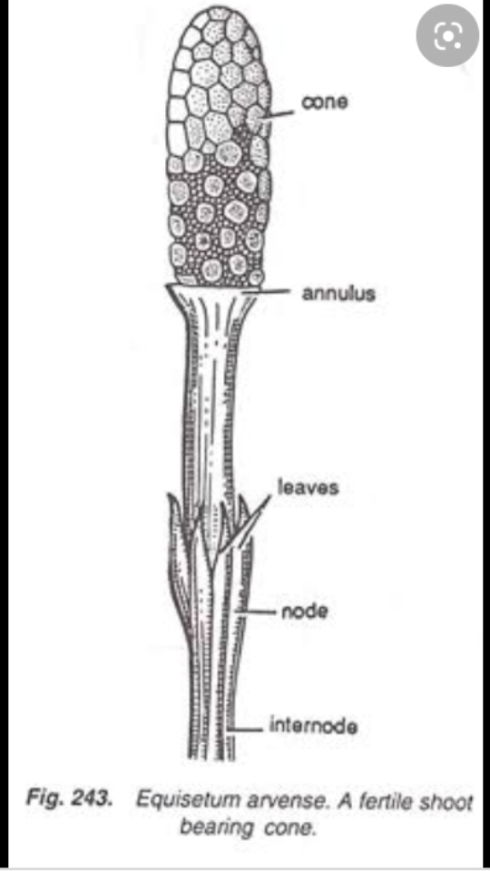
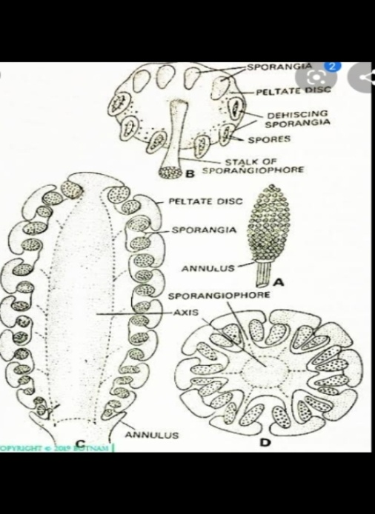
Fig – mature sporangiophore Fig – L.S. & T.S. of sporangiophore

- The peltate disc bears on its under surface close to its edge, a ring of several usually 5 – 10 sac like pendent sporangia.
- They extend inward towards the axis of the cone and fill all the space that is left between it and the sporangiophores
- The peltate heads fit closely together so that the sporangia are concealed.
- At the base of cone, the central axis bears a ring like outgrowth called the annulus. It is a protective structure.

Sporangia :-
- A mature sporangia is an elongated sac like structure.
- It contains a large number of haploid spores and the spores are equal in size as it is homosporous.
- The mature sporangia has a single layer of wall cells. The cell walls of this layer are spirally theakened.
- A young sporangium has 2 – 4 layered thick walled.
- The innermost wall layer is derived from the outermost sporogenous cells and is called tapetum.
- Sporangia contain both the spores and elaters.
Spores and elaters :-
- The mature spores are round and contain numerous chloroplasts.
- Each spore contain a thick spore wall differentiated into four layers outermost epispore, middle perispore, third exospores and innermost endospore or endosporium.
- The elaters are developed on the outer spore wall and spirally wrapped around the spores
- Elaters are hygroscopic and remain coiled around the spore in moist air. When dry the elaters help in spore dispersal.

