STUDY MATERIAL
Semester – II (Hons) CC - IV , unit - 5
Prepared by Sri Rabi Sankar Das, Department of Botany, Hiralal Mazumdar Memorial College for Women, Dakshineswar
REPRODUCTION OF SELAGINELLA
(A)VEGETATIVE REPRODUCTION
- FRAGMENTATION :-
It found in such species which grow in humid conditions. In this case the trailing branches developed adventitious branches and later form the parent plant.
Eg. – selaginella rupestris
- TUBER :-
They are formed underground. It appear towards the end of the growing seasons at the tip of underground branches that arise from the base of the stem. At the advent of favorable conditions this tuber germinate to produce a new plant. It bear rudimentary scales.
Eg _ selaginella abyssinica, selaginella chrysorrhizos
- RESTING BUDS :-
It developed at the end of some aerial branches at the close of monsoon season. In this region leaves are closely arranged and overlap each other and cover the growing point. Buds gives off rhizophores that bear roots at the tip and fix with soil. They grow into new individuals at the favorable condition.
(B)REPRODUCTION BY SPORES :-
STROBILUS :-
- It occur terminally on side branches.
- It contain numerous sporangia (microsporangia and macrosporangia)
MICROSPORANGIA :-
- It may be oval, reniform or spherical in shaped. It is smaller in size than macrosporangia.
- Its outline is smooth and regular with short multicellular stalk.
- Wall is two layered thick.
- Inner wall is tapetum which is nutritive in function and arises from the archesporial tissue.
- Tapetum encliose a large number of microspore mother cell which undergo meiosis and form microspore tetrads.
- One microsporangium contain 1500 – 2000 microspore.
MICROSPORE :-
- Each microspore is 0.015 – 0.06 mm in diameter.
- They are usually tetrahedral in shaped with rounded upper end.
- Every spore has a single nucleus surrounded by cytoplasm.
- It enclosed by two layered wall --- outer is exine and the inner is endine or nexine.
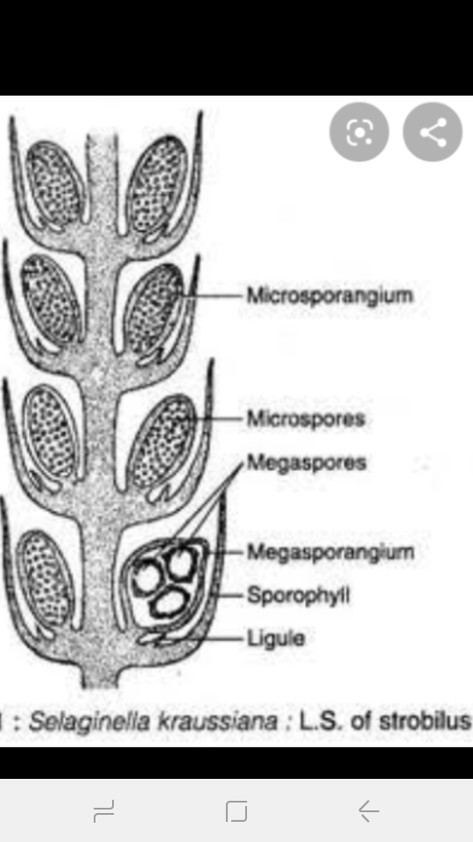
- Cytoplasm contain reserve food as oil globules.
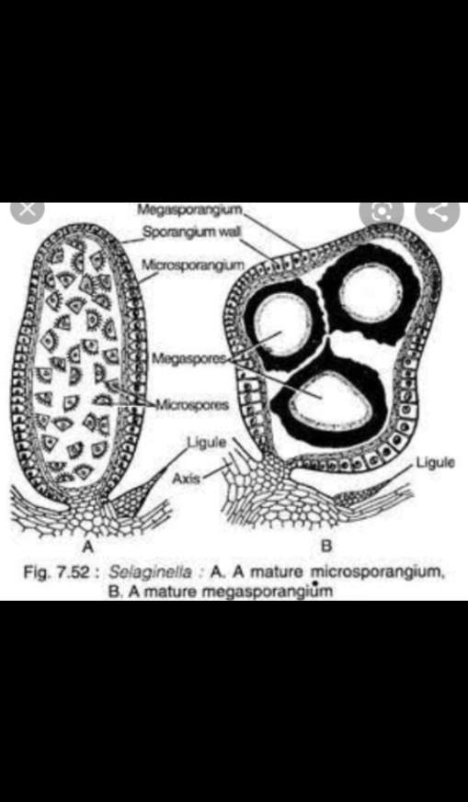
Fig – microsporangium & megasporangium Fig – L.S. of strobilus
MEGASPORANGIA :-
- It is large in size, four lobed, shortly stalked.
- It has a two layered wall and the third innermost layer is called tapetum.
- Out of all spore mother cells only one remains functional and divide meiotically to form tetrad of four haploid megaspore.

MEGASPORE :-
- They range in diameter from 1 – 5 mm.
- They are tetrahedral in shape.
- There is distinct triradiate ridge on the outer wall.
- They are unicellular and uninucleate.
- They have two wall – outer thick layer is exine and inner thin layer is endine.
- The outer layer composed of radially arranged rods called the columella that fused to form a layer called tegillum or tectum.

