Schedulers
Schedulers are special system software which handle process scheduling in various ways. Their main task is to select the jobs to be submitted into the system and to decide which process to run. Schedulers are of three types −
- Long-Term Scheduler
- Short-Term Scheduler
- Medium-Term Scheduler

Long Term Scheduler
It is also called a job scheduler. A long-term scheduler determines which programs are admitted to the system for processing. It selects processes from the queue and loads them into memory for execution. Process loads into the memory for CPU scheduling.
The primary objective of the job scheduler is to provide a balanced mix of jobs, such as I/O bound and processor bound. It also controls the degree of multiprogramming. If the degree of multiprogramming is stable, then the average rate of process creation must be equal to the average departure rate of processes leaving the system.
On some systems, the long-term scheduler may not be available or minimal. Time-sharing operating systems have no long term scheduler. When a process changes the state from new to ready, then there is use of long-term scheduler.

Short Term Scheduler
It is also called as CPU scheduler. Its main objective is to increase system performance in accordance with the chosen set of criteria. It is the change of ready state to running state of the process. CPU scheduler selects a process among the processes that are ready to execute and allocates CPU to one of them.
Short-term schedulers, also known as dispatchers, make the decision of which process to execute next. Short-term schedulers are faster than long-term schedulers.

Medium Term Scheduler
Medium-term scheduling is a part of swapping. It removes the processes from the memory. It reduces the degree of multiprogramming. The medium-term scheduler is in-charge of handling the swapped out-processes.
A running process may become suspended if it makes an I/O request. A suspended processes cannot make any progress towards completion. In this condition, to remove the process from memory and make space for other processes, the suspended process is moved to the secondary storage. This process is called swapping, and the process is said to be swapped out or rolled out. Swapping may be necessary to improve the process mix.

Comparison among Scheduler
S.N. | Long-Term Scheduler | Short-Term Scheduler | Medium-Term Scheduler
1 | It is a job scheduler | It is a CPU scheduler | It is a process swapping scheduler.
2 | Speed is lesser than short term scheduler | Speed is fastest among other two | Speed is in between both short and long term scheduler.
3 | It controls the degree of multiprogramming | It provides lesser control over degree of multiprogramming | It reduces the degree of multiprogramming.
4 | It is almost absent or minimal in time sharing system | It is also minimal in time sharing system | It is a part of Time sharing systems.
5 | It selects processes from pool and loads them into memory for execution | It selects those processes which are ready to execute | It can re-introduce the process into memory and execution can be continued.

Context Switch
A context switch is the mechanism to store and restore the state or context of a CPU in Process Control block so that a process execution can be resumed from the same point at a later time. Using this technique, a context switcher enables multiple processes to share a single CPU. Context switching is an essential part of a multitasking operating system features.
When the scheduler switches the CPU from executing one process to execute another, the state from the current running process is stored into the process control block. After this, the state for the process to run next is loaded from its own PCB and used to set the PC, registers, etc. At that point, the second process can start executing.
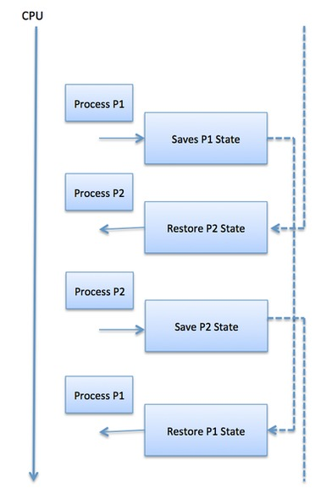
Context switches are computationally intensive since register and memory state must be saved and restored. To avoid the amount of context switching time, some hardware systems employ two or more sets of processor registers. When the process is switched, the following information is stored for later use.
- Program Counter
- Scheduling information
- Base and limit register value
- Currently used register
- Changed State
- I/O State information
- Accounting information
A Process Scheduler schedules different processes to be assigned to the CPU based on particular scheduling algorithms. There are six popular process scheduling algorithms which we are going to discuss in this chapter −
- First-Come, First-Served (FCFS) Scheduling
- Shortest-Job-Next (SJN) Scheduling
- Priority Scheduling
- Shortest Remaining Time
- Round Robin(RR) Scheduling
- Multiple-Level Queues Scheduling
These algorithms are either non-preemptive or preemptive. Non-preemptive algorithms are designed so that once a process enters the running state, it cannot be preempted until it completes its allotted time, whereas the preemptive scheduling is based on priority where a scheduler may preempt a low priority running process anytime when a high priority process enters into a ready state.

First Come First Serve (FCFS)
- Jobs are executed on first come, first serve basis.
- It is a non-preemptive, pre-emptive scheduling algorithm.
- Easy to understand and implement.
- Its implementation is based on FIFO queue.
- Poor in performance as average wait time is high.

Shortest Job Next (SJN)
- This is also known as shortest job first, or SJF
- This is a non-preemptive, pre-emptive scheduling algorithm.
- Best approach to minimize waiting time.
- Easy to implement in Batch systems where required CPU time is known in advance.
- Impossible to implement in interactive systems where required CPU time is not known.
- The processer should know in advance how much time process will take

Priority Based Scheduling
- Priority scheduling is a non-preemptive algorithm and one of the most common scheduling algorithms in batch systems.
- Each process is assigned a priority. Process with highest priority is to be executed first and so on.
- Processes with same priority are executed on first come first served basis.
- Priority can be decided based on memory requirements, time requirements or any other resource requirement.
Given: Table of processes, and their Arrival time, Execution time, and priority. Here we are considering 1 is the lowest priority.

Shortest Remaining Time
- Shortest remaining time (SRT) is the preemptive version of the SJN algorithm.
- The processor is allocated to the job closest to completion but it can be preempted by a newer ready job with shorter time to completion.
- Impossible to implement in interactive systems where required CPU time is not known.
- It is often used in batch environments where short jobs need to give preference.

Round Robin Scheduling
- Round Robin is the preemptive process scheduling algorithm.
- Each process is provided a fix time to execute, it is called a quantum.
- Once a process is executed for a given time period, it is preempted and other process executes for a given time period.
- Context switching is used to save states of preempted processes.

What is Thread?
A thread is a flow of execution through the process code, with its own program counter that keeps track of which instruction to execute next, system registers which hold its current working variables, and a stack which contains the execution history.
A thread shares with its peer threads few information like code segment, data segment and open files. When one thread alters a code segment memory item, all other threads see that.
A thread is also called a lightweight process. Threads provide a way to improve application performance through parallelism. Threads represent a software approach to improving performance of operating system by reducing the overhead thread is equivalent to a classical process.
Each thread belongs to exactly one process and no thread can exist outside a process. Each thread represents a separate flow of control. Threads have been successfully used in implementing network servers and web server. They also provide a suitable foundation for parallel execution of applications on shared memory multiprocessors. The following figure shows the working of a single-threaded and a multithreaded process.
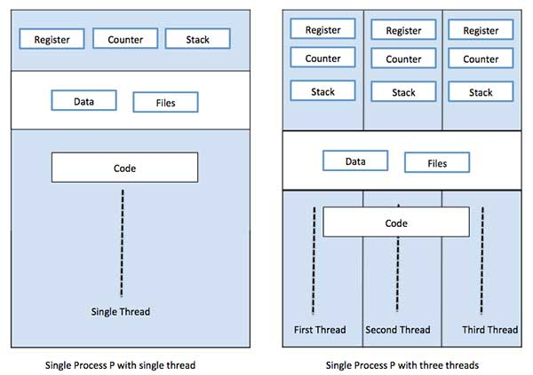

Difference between Process and Thread
S.N. | Process | Thread
1 | Process is heavy weight or resource intensive. | Thread is light weight, taking lesser resources than a process.
2 | Process switching needs interaction with operating system. | Thread switching does not need to interact with operating system.
3 | In multiple processing environments, each process executes the same code but has its own memory and file resources. | All threads can share same set of open files, child processes.
4 | If one process is blocked, then no other process can execute until the first process is unblocked. | While one thread is blocked and waiting, a second thread in the same task can run.
5 | Multiple processes without using threads use more resources. | Multiple threaded processes use fewer resources.
6 | In multiple processes each process operates independently of the others. | One thread can read, write or change another thread's data.

Advantages of Thread
- Threads minimize the context switching time.
- Use of threads provides concurrency within a process.
- Efficient communication.
- It is more economical to create and context switch threads.
- Threads allow utilization of multiprocessor architectures to a greater scale and efficiency.

Types of Thread
Threads are implemented in following two ways −
- User Level Threads − User managed threads.
- Kernel Level Threads − Operating System managed threads acting on kernel, an operating system core.

User Level Threads
In this case, the thread management kernel is not aware of the existence of threads. The thread library contains code for creating and destroying threads, for passing message and data between threads, for scheduling thread execution and for saving and restoring thread contexts. The application starts with a single thread.
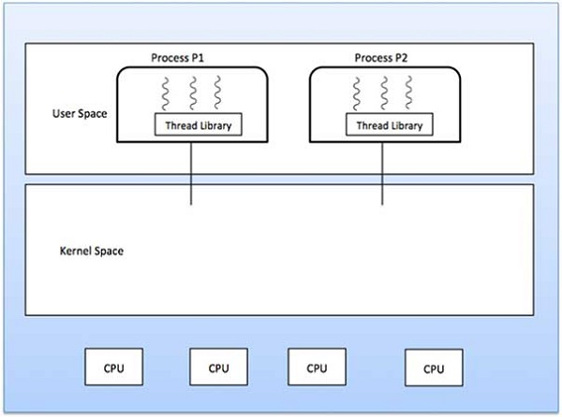

Advantages
- Thread switching does not require Kernel mode privileges.
- User level thread can run on any operating system.
- Scheduling can be application specific in the user level thread.
- User level threads are fast to create and manage.

Disadvantages
- In a typical operating system, most system calls are blocking.
- Multithreaded application cannot take advantage of multiprocessing.

Kernel Level Threads
In this case, thread management is done by the Kernel. There is no thread management code in the application area. Kernel threads are supported directly by the operating system. Any application can be programmed to be multithreaded. All of the threads within an application are supported within a single process.
The Kernel maintains context information for the process as a whole and for individuals threads within the process. Scheduling by the Kernel is done on a thread basis. The Kernel performs thread creation, scheduling and management in Kernel space. Kernel threads are generally slower to create and manage than the user threads.

Advantages
- Kernel can simultaneously schedule multiple threads from the same process on multiple processes.
- If one thread in a process is blocked, the Kernel can schedule another thread of the same process.
- Kernel routines themselves can be multithreaded.

Disadvantages
- Kernel threads are generally slower to create and manage than the user threads.
- Transfer of control from one thread to another within the same process requires a mode switch to the Kernel.

Multithreading Models
Some operating system provide a combined user level thread and Kernel level thread facility. Solaris is a good example of this combined approach. In a combined system, multiple threads within the same application can run in parallel on multiple processors and a blocking system call need not block the entire process. Multithreading models are three types
- Many to many relationship.
- Many to one relationship.
- One to one relationship.

Many to Many Model
The many-to-many model multiplexes any number of user threads onto an equal or smaller number of kernel threads.
The following diagram shows the many-to-many threading model where 6 user level threads are multiplexing with 6 kernel level threads. In this model, developers can create as many user threads as necessary and the corresponding Kernel threads can run in parallel on a multiprocessor machine. This model provides the best accuracy on concurrency and when a thread performs a blocking system call, the kernel can schedule another thread for execution.
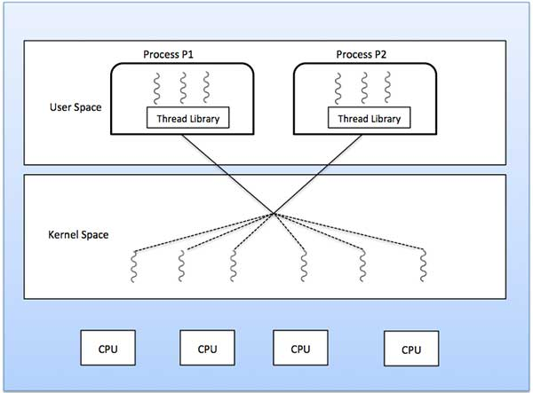

Many to One Model
Many-to-one model maps many user level threads to one Kernel-level thread. Thread management is done in user space by the thread library. When thread makes a blocking system call, the entire process will be blocked. Only one thread can access the Kernel at a time, so multiple threads are unable to run in parallel on multiprocessors.
If the user-level thread libraries are implemented in the operating system in such a way that the system does not support them, then the Kernel threads use the many-to-one relationship modes.
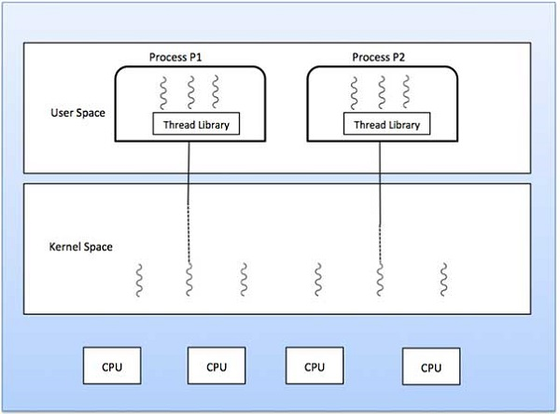

One to One Model
There is one-to-one relationship of user-level thread to the kernel-level thread. This model provides more concurrency than the many-to-one model. It also allows another thread to run when a thread makes a blocking system call. It supports multiple threads to execute in parallel on microprocessors.
Disadvantage of this model is that creating user thread requires the corresponding Kernel thread. OS/2, windows NT and windows 2000 use one to one relationship model.
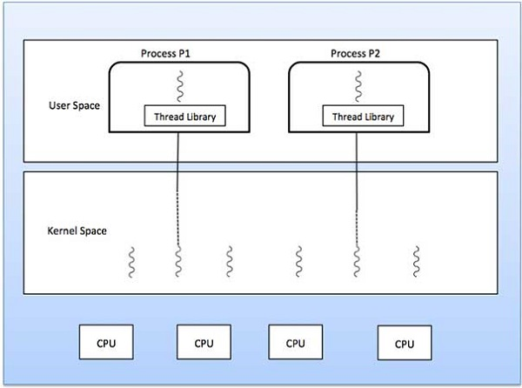

Difference between User-Level & Kernel-Level Thread
S.N. | User-Level Threads | Kernel-Level Thread
1 | User-level threads are faster to create and manage. | Kernel-level threads are slower to create and manage.
2 | Implementation is by a thread library at the user level. | Operating system supports creation of Kernel threads.
3 | User-level thread is generic and can run on any operating system. | Kernel-level thread is specific to the operating system.
4 | Multi-threaded applications cannot take advantage of multiprocessing. | Kernel routines themselves can be multithreaded.

Process Address Space
The process address space is the set of logical addresses that a process references in its code. For example, when 32-bit addressing is in use, addresses can range from 0 to 0x7fffffff; that is, 2^31 possible numbers, for a total theoretical size of 2 gigabytes.
The operating system takes care of mapping the logical addresses to physical addresses at the time of memory allocation to the program. There are three types of addresses used in a program before and after memory is allocated −
S.N. | Memory Addresses & Description
1 | Symbolic addresses  The addresses used in a source code. The variable names, constants, and instruction labels are the basic elements of the symbolic address space.
2 | Relative addresses  At the time of compilation, a compiler converts symbolic addresses into relative addresses.
3 | Physical addresses  The loader generates these addresses at the time when a program is loaded into main memory.
Virtual and physical addresses are the same in compile-time and load-time address-binding schemes. Virtual and physical addresses differ in execution-time address-binding scheme.
The set of all logical addresses generated by a program is referred to as a logical address space. The set of all physical addresses corresponding to these logical addresses is referred to as a physical address space.
The runtime mapping from virtual to physical address is done by the memory management unit (MMU) which is a hardware device. MMU uses following mechanism to convert virtual address to physical address.
- The value in the base register is added to every address generated by a user process, which is treated as offset at the time it is sent to memory. For example, if the base register value is 10000, then an attempt by the user to use address location 100 will be dynamically reallocated to location 10100.
- The user program deals with virtual addresses; it never sees the real physical addresses.

Static vs Dynamic Loading
The choice between Static or Dynamic Loading is to be made at the time of computer program being developed. If you have to load your program statically, then at the time of compilation, the complete programs will be compiled and linked without leaving any external program or module dependency. The linker combines the object program with other necessary object modules into an absolute program, which also includes logical addresses.
If you are writing a Dynamically loaded program, then your compiler will compile the program and for all the modules which you want to include dynamically, only references will be provided and rest of the work will be done at the time of execution.
At the time of loading, with static loading, the absolute program (and data) is loaded into memory in order for execution to start.
If you are using dynamic loading, dynamic routines of the library are stored on a disk in relocatable form and are loaded into memory only when they are needed by the program.

Static vs Dynamic Linking
As explained above, when static linking is used, the linker combines all other modules needed by a program into a single executable program to avoid any runtime dependency.
When dynamic linking is used, it is not required to link the actual module or library with the program, rather a reference to the dynamic module is provided at the time of compilation and linking. Dynamic Link Libraries (DLL) in Windows and Shared Objects in Unix are good examples of dynamic libraries.

Swapping
Swapping is a mechanism in which a process can be swapped temporarily out of main memory (or move) to secondary storage (disk) and make that memory available to other processes. At some later time, the system swaps back the process from the secondary storage to main memory.
Though performance is usually affected by swapping process but it helps in running multiple and big processes in parallel and that's the reason Swapping is also known as a technique for memory compaction.

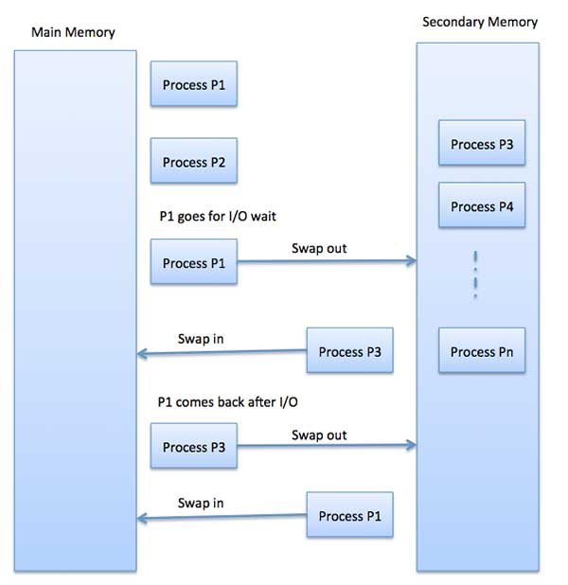Fragmentation
As processes are loaded and removed from memory, the free memory space is broken into little pieces. It happens after sometimes that processes cannot be allocated to memory blocks considering their small size and memory blocks remains unused. This problem is known as Fragmentation.
Fragmentation is of two types −
S.N. | Fragmentation & Description
1 | External fragmentation  Total memory space is enough to satisfy a request or to reside a process in it, but it is not contiguous, so it cannot be used.
2 | Internal fragmentation  Memory block assigned to process is bigger. Some portion of memory is left unused, as it cannot be used by another process.
The following diagram shows how fragmentation can cause waste of memory and a compaction technique can be used to create more free memory out of fragmented memory −
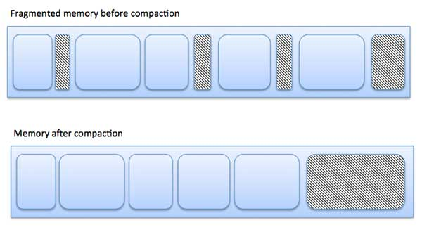
External fragmentation can be reduced by compaction or shuffle memory contents to place all free memory together in one large block. To make compaction feasible, relocation should be dynamic.
The internal fragmentation can be reduced by effectively assigning the smallest partition but large enough for the process.

Paging
A computer can address more memory than the amount physically installed on the system. This extra memory is actually called virtual memory and it is a section of a hard that's set up to emulate the computer's RAM. Paging technique plays an important role in implementing virtual memory.
Paging is a memory management technique in which process address space is broken into blocks of the same size called pages (size is power of 2, between 512 bytes and 8192 bytes). The size of the process is measured in the number of pages.
Similarly, main memory is divided into small fixed-sized blocks of (physical) memory called frames and the size of a frame is kept the same as that of a page to have optimum utilization of the main memory and to avoid external fragmentation.

Address Translation
Page address is called logical address and represented by page number and the offset.
Logical Address = Page number + page offset
Frame address is called physical address and represented by a frame numberand the offset.
Physical Address = Frame number + page offset
A data structure called page map table is used to keep track of the relation between a page of a process to a frame in physical memory.
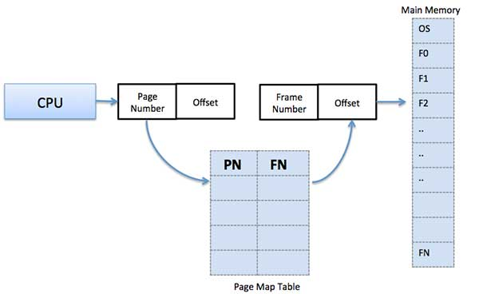
When the system allocates a frame to any page, it translates this logical address into a physical address and create entry into the page table to be used throughout execution of the program.
When a process is to be executed, its corresponding pages are loaded into any available memory frames. Suppose you have a program of 8Kb but your memory can accommodate only 5Kb at a given point in time, then the paging concept will come into picture. When a computer runs out of RAM, the operating system (OS) will move idle or unwanted pages of memory to secondary memory to free up RAM for other processes and brings them back when needed by the program.
This process continues during the whole execution of the program where the OS keeps removing idle pages from the main memory and write them onto the secondary memory and bring them back when required by the program.

Advantages and Disadvantages of Paging
Here is a list of advantages and disadvantages of paging −
- Paging reduces external fragmentation, but still suffer from internal fragmentation.
- Paging is simple to implement and assumed as an efficient memory management technique.
- Due to equal size of the pages and frames, swapping becomes very easy.
- Page table requires extra memory space, so may not be good for a system having small RAM.

Segmentation
Segmentation is a memory management technique in which each job is divided into several segments of different sizes, one for each module that contains pieces that perform related functions. Each segment is actually a different logical address space of the program.
When a process is to be executed, its corresponding segmentation are loaded into non-contiguous memory though every segment is loaded into a contiguous block of available memory.
Segmentation memory management works very similar to paging but here segments are of variable-length where as in paging pages are of fixed size.
A program segment contains the program's main function, utility functions, data structures, and so on. The operating system maintains a segment map table for every process and a list of free memory blocks along with segment numbers, their size and corresponding memory locations in main memory. For each segment, the table stores the starting address of the segment and the length of the segment. A reference to a memory location includes a value that identifies a segment and an offset.
