REPORT OF EXCURSION/ STUDY TOUR BY DEPARTMENT OF ZOOLOGY

YEAR: 2018
PLACE: DOOARS, WEST BENGAL
DATE: 18TH FEBRUARY TO 22ND FEBRUARY, 2018
STUDENTS/ BATCH: 2ND YEAR HON’S (1+1+1) SYSTEM-19 STUDENTS
TEACHERS: DR. INDRAJIT BISWAS, SMT. JAYASHREE SHIT
NTS: SHRI SAMAR KUMAR DAS

Students of Zoology hons’ visited Dooars and adjoining areas of Gorumara National Park, Buxa Tiger Reserve, Jayanti for studying animal behaviour of peacock dance at Gorumara National Park, habit and ecology of species at Jayanti river-bed and visited Butterfly garden at Jayanti for their partial fulfillment of hons’ course.
LIST OF STUDENTS:
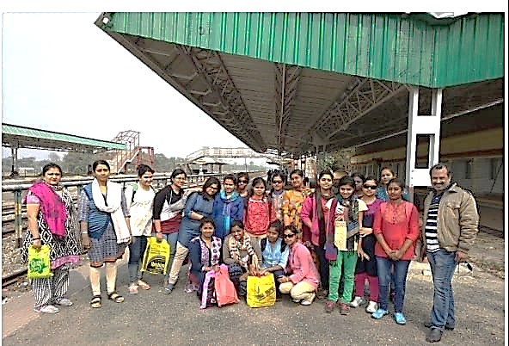
- SIMA SANTRA
- SUPARNA MANNA
- JAYEE GANGULY
- BIDISHA MANDAL
- SUDESNA BHATTACHARJEE
- SAYANEE ROY
- SUPARNA CHOUDHURY
- SWAGATA MAL
- TIYASA ROY
- MOUSUMI NASKAR
- SWATI BANERJEE
- CHANDRIMA ADAK
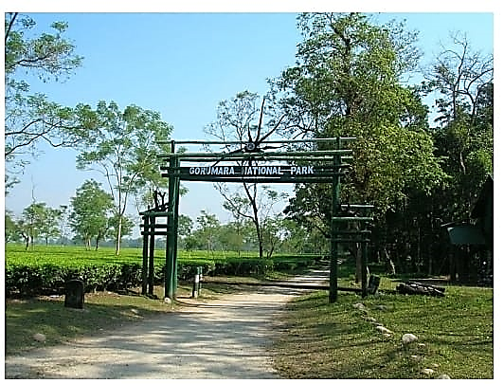
- ANWESHA CHAKRABORTY
- SAHELI PAUL
- SHILPA BERA
- SWARNALI GHOSH
- PAYEL DAS
- SMRITILEKHA DAS
- CHANDRIKA MUKHERJEE

