EXCURSION(FIELD TOUR)

HMM College for Women

SESSION: July 2018-June 2019
DEPARTMENT: Education
EVENT NAME | DATE | NO.OF PARTICIPANTS | DESCRIPTION
Educational excursion | From 10.11.2018 to 13.11.2018 | 12 | Visit to Benaras for Educational Excursion with students and teachers of the department

CORRESPONDING PHOTOS WITH EVENT NAME:
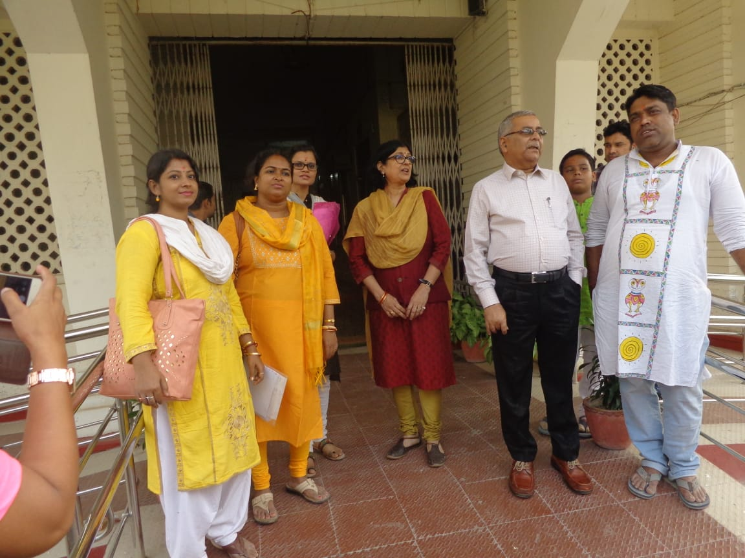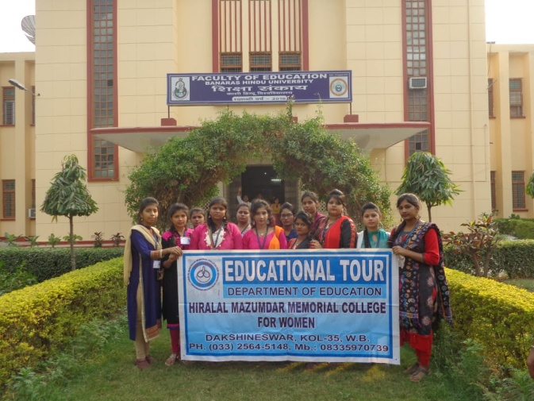

Visit to Benaras for Educational Excursion with students and teachers of the department

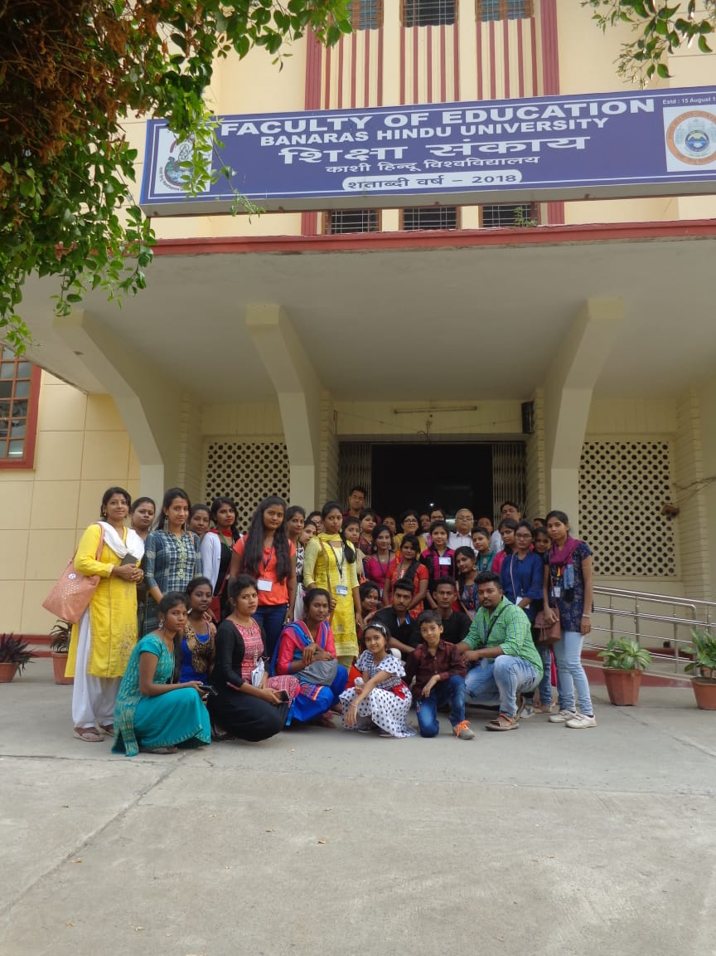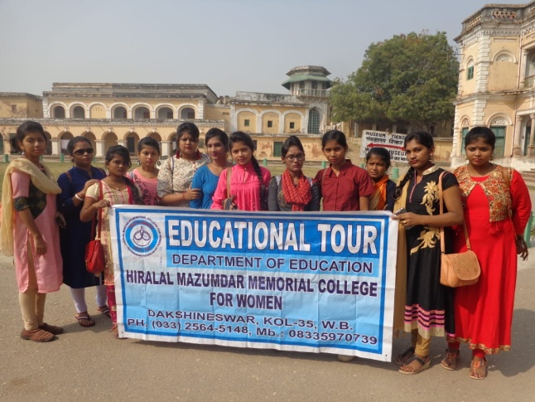

Visit to Benaras for Educational Excursion with students and teachers of the department

