EXCURSION(FIELD TOUR)
HMM College for Women

SESSION: July 2019-June 2020
DEPARTMENT: Education
EVENT NAME | DATE | NO.OF PARTICIPANTS | DESCRIPTION
Educational excursion | From 01.11.2019 to 05.11.2019 | 6 | Visit to Ranchi, Jharkhand for Educational Excursion with students and teachers of the department

CORRESPONDING PHOTOS WITH EVENT NAME:

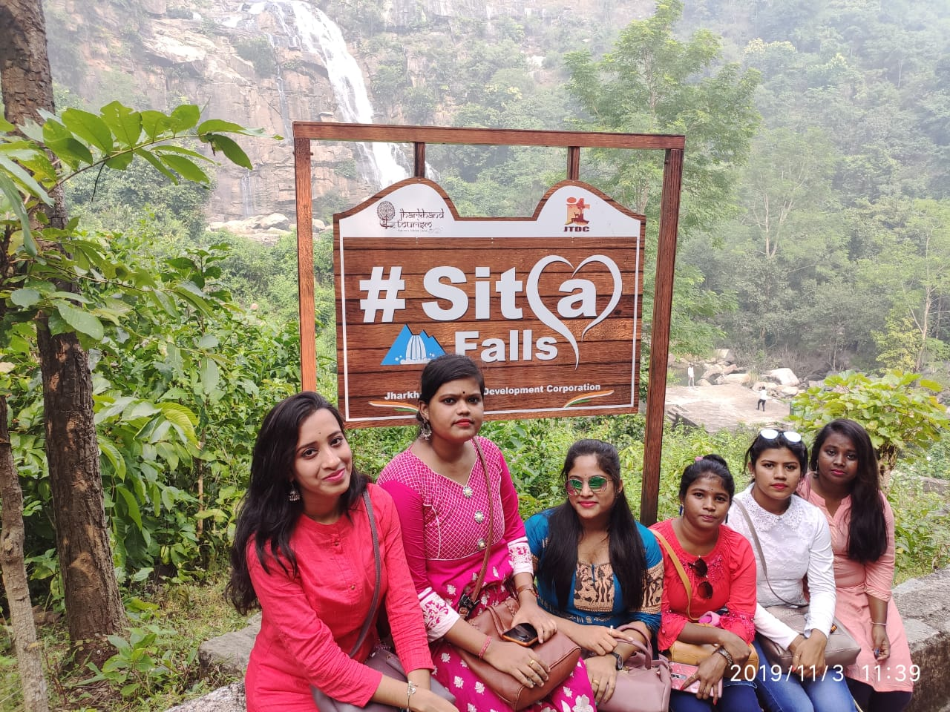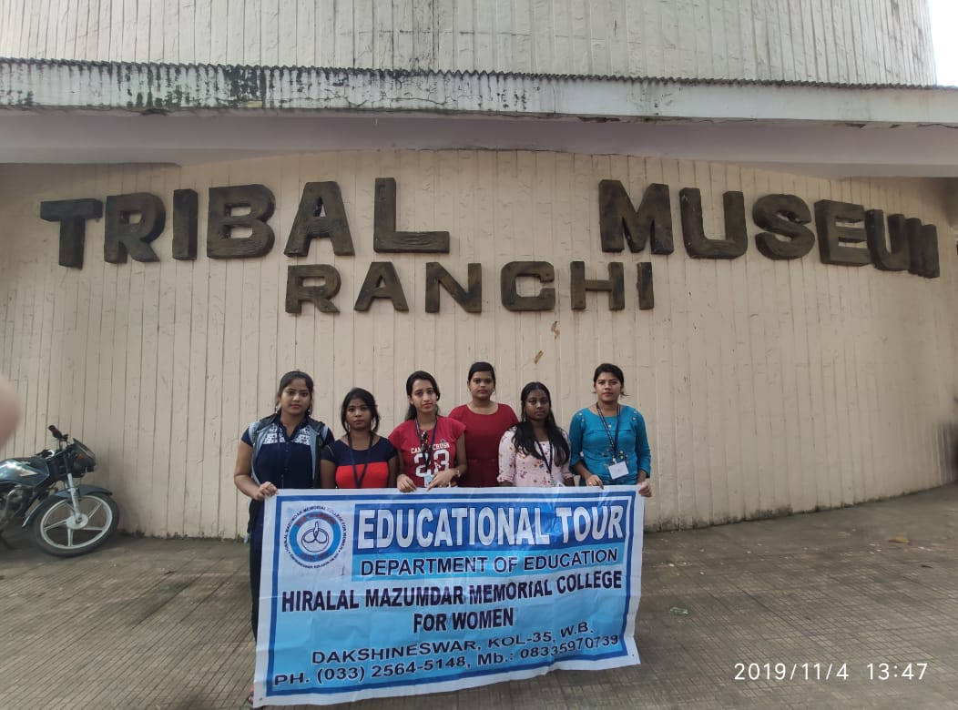
Visit to Ranchi, Jharkhand for Educational Excursion with students and teachers of the department

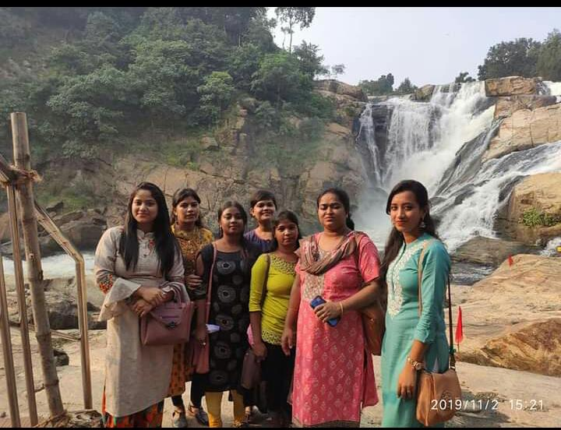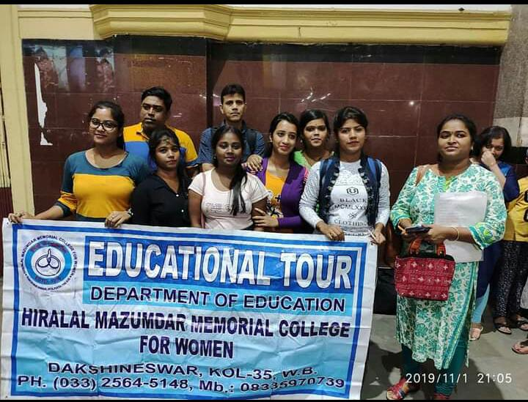
Visit to Ranchi, Jharkhand for Educational Excursion with students and teachers of the department

